Preparation of an organic liquid

Practice a wide range of experimental techniques in this experiment to synthesise an organic liquid. Watch a video of the whole procedure, plus find technician notes and more resources, at rsc.li/38LiKx6

Equipment (per group, for five different concentrations of H₂O₂)
- 1 x beaker 100 cm³ (to dispense the concentrated acid)
- 1 x measuring cylinder, 50 cm³
- 2 x conical flask, 250 cm³
- Mineral wool for plug (or use cotton wool)
- 1 x glass pipette
- 1 x separating funnel and stopper
- 3 x retort stands, bosses and clamps
- 1 x beaker, 250 cm³ (for collection of waste aqueous layer)
- 2 x filter funnel
- 1 x measuring cylinder, 10 cm³
- 2 x spatula
- 1 x filter paper
- 1 x pear shaped flask, 50 cm³ (or round bottomed flask)
- 1 x deionised water in wash bottle
- 1 x full apparatus for distillation which includes:
  - 1 x still head
  - 1 x thermometer
  - 1 x Liebig condenser
  - 1 x receiver
  - 1 x sample tube
  - 1 x beaker to use as water bath (large enough to contain the pear-shaped flask and water)
- 1 x kettle
- 1 x timer or digital stopwatch

- 2-methylpropan-2-ol (DANGER: flammable, corrosive, irritant, may cause drowsiness and dizziness)
- Concentrated hydrochloric acid (needs to be cold: refrigerate and supply just before use, or provide bottles kept in an ice bath) (DANGER: corrosive, irritant)
- 5% sodium hydrogen carbonate solution
- Anhydrous sodium sulfate, solid
- Anti-bumping granules, a quarter of a spatula

- Safety goggles (for first part of the experiment)
- Safety glasses
- Access to a fume cupboard
- Gloves (to handle the mineral wool only)

Safety
Wear eye protection throughout and gloves when handling the mineral wool. Wear gloves when dispensing concentrated hydrochloric acid if you have an open wounds or skin condition.

Work in a fume cupboard when using concentrated hydrochloric acid.

Keep chemicals away from fire.

Method

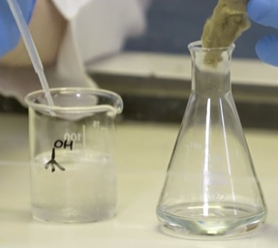
Part 1: preparation

Work in a fume cupboard.
- Measure 20 cm³ of cold concentrated hydrochloric acid and pour it in a conical flask.
- Gradually add the 2-methylpropan-2-ol, 1 cm³ at a time. Swirl the conical flask and place a mineral wool plug in the neck of the flask after each addition.
- Leave the flask for 20 minutes to allow the reaction to take place.

Part 2: separation
Separate the two layers in the conical flask.
- Pour the mixture into a separating funnel using a filter funnel.
- Open the tap to allow the aqueous layer to drain into a beaker. (Watch the video for tips on how to use the separating funnel.)
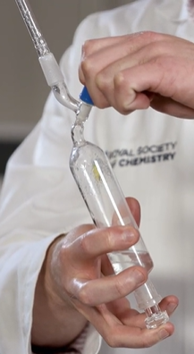

Part 3: purification I
- To remove any unreacted hydrochloric acid, add 10 cm³ of sodium hydrogen carbonate solution to the separating funnel.
- Put the stopper back onto the separating funnel, keep your finger on the stopper and invert it.
- Open the tap and swirl the solution (do not shake and make sure the tip is not pointing at anyone).
- Return the separating funnel to the stand and remove the aqueous layer at the bottom of the separating funnel into the waste beaker.
- Repeat steps 6–9, then collect the organic layer in a conical flask.

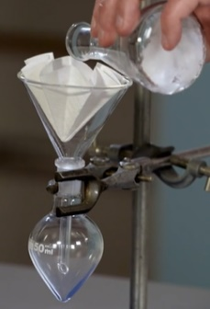
Purification II
- To remove any trace of water left in the sample, add half a spatula of solid anhydrous sodium sulfate and swirl. Repeat using half a spatula at a time until the sodium sulfate no longer clumps together.
- Filter the mixture into a pear-shaped flask.

Purification III
- Add anti bumping granules to the flask.
- Set up the distillation equipment as shown in the diagram below. Turn on the cooling water (you only need a slow flow through the equipment).
- Add boiled water from a kettle to heat the pear-shaped flask in a water bath to the desired temperature. Collect your sample between 49–52°C into a clean dry test tube.

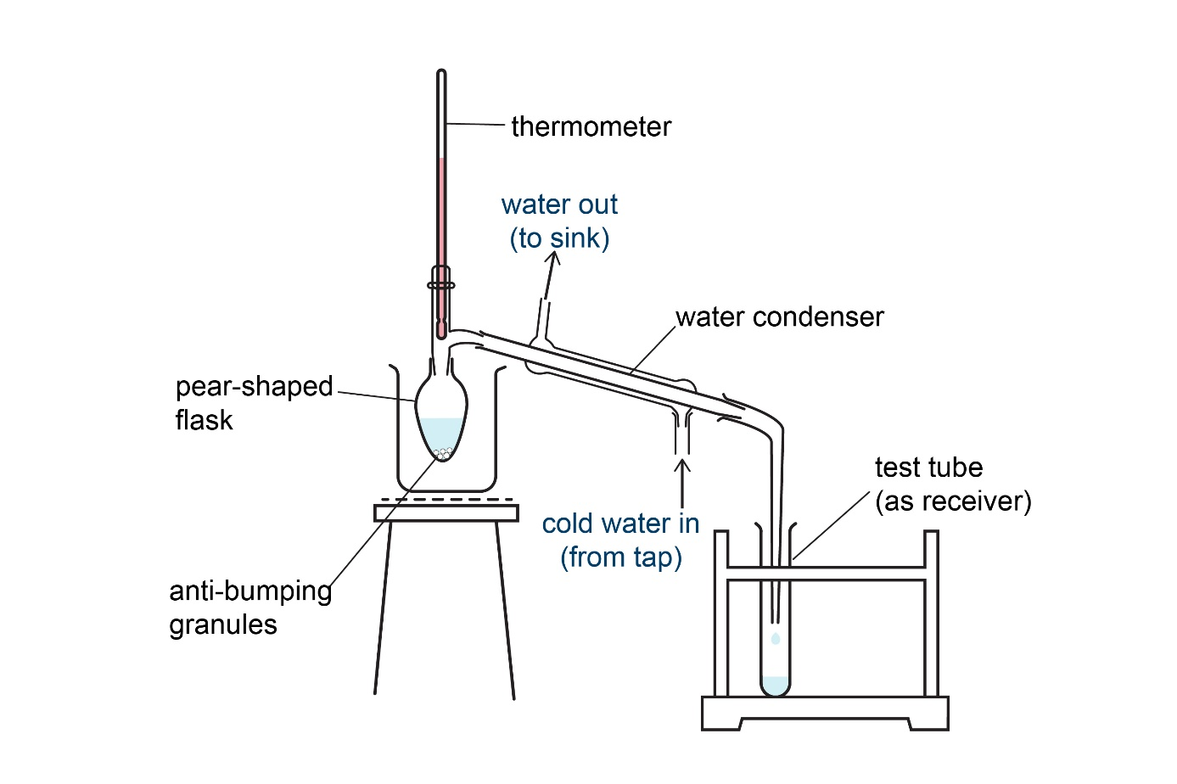

Disposal
- Always dispose of chemicals carefully following your teacher’s instructions.
- Any unreacted concentrated hydrochloric acid would have been neutralised by the sodium hydrogen carbonate solution but make sure equipment used to dispense it is rinsed in the fume cupboard.
- Flush the aqueous waste down a foul-water drain with plenty of water.

