Redox

Oxidation and reduction

Oxidation numbers

Work out the oxidation numbers for the bold elements in the compounds and perform the calculation.
Present your answer to your teacher. There is 1 mark for each correct oxidation number you have deduced.

Note: You are calculating the oxidation number of the element, not its overall contribution to the compound eg, CaCl₂ you would give the answer for Cl as -1, not as …Cl2 (-2).

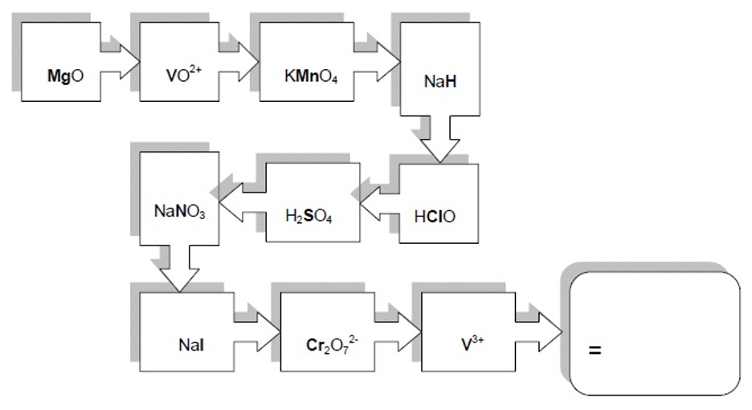

Writing half equations

Balance the half equations by balancing the atoms and adding

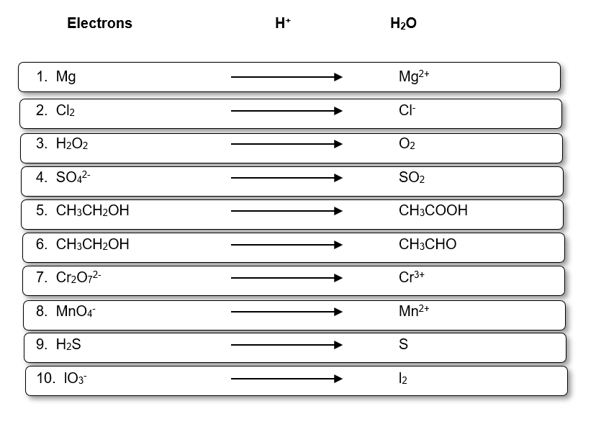

Half equations to overall equations
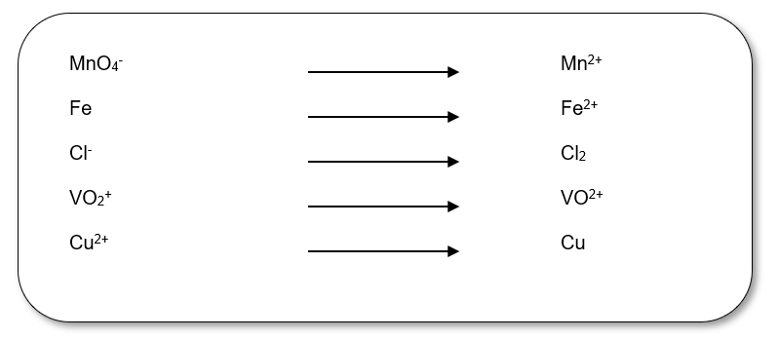
- Balance the half equations above
(5 marks)
- Using the equations you have balanced above, construct overall equations to show -
  - The reduction of manganate(VII) by chloride ions
(1 mark)
  - The reduction of copper(II) to copper by iron
(1 mark)
- Construct an overall equation to show how the VO2⁺ ion is reduced by zinc metal
(2 marks)
- The reaction above shows the oxidation of an aldehyde to a carboxylic acid using the dichromate ion.
- From this equation deduce the half equation for the dichromate reduction.
(1 mark)

Extraction of metals

Electrolysis of aluminium

1. The above equations show the transformations occurring during electrolysis of aluminium oxide, Al2O3.
Balance the equations for stoichiometry and charge.
- marks)
2. On first consideration the electrolysis process does not produce the greenhouse gas carbon dioxide.
Give 2 reasons why the process does in fact produce CO2.
- marks)
3. Why does the aluminium oxide have to be molten for electrolysis to occur?
- mark)
4. The cheapest method of metal extraction available is reduction with carbon. Why can aluminium not be extracted in this way?
- mark)
5. The melting point of bauxite, the main aluminium ore is 2050°C. How is the ore made into the molten state for the electrolysis process?
- mark)
6. Below is a simplified diagram of a cell used for aluminium electrolysis. Label the anode and cathode.
(2 marks)

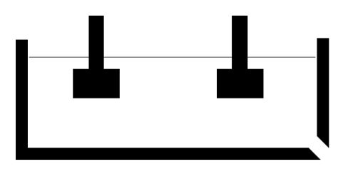

Extraction of other metals
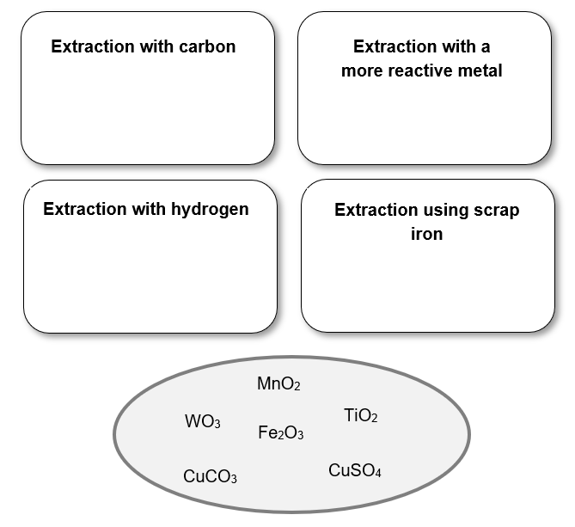

1. Place the ores above into the appropriate box showing the method used to extract the metal from them.
- marks)
2. For the metals that are extracted using a more reactive metal or with hydrogen, state why they cannot simply be extracted using carbon.
- marks)
3. Titanium is an abundant and useful metal and is extracted using a batch process in 2 stages. Outline the stages using equations and annotate the 2nd stage using oxidation numbers to show that it is a redox process.
- marks)
4. What is the main hazard with the use of hydrogen in metal extraction?
(1 mark)

The halogens

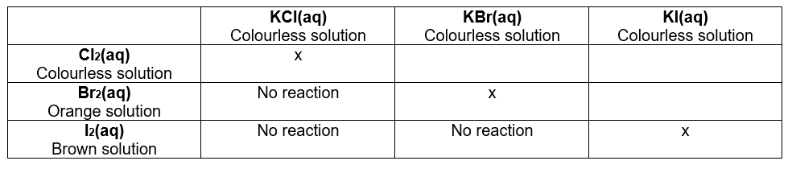
Displacement reactions
1. A more reactive halogen will displace a less reactive halide form its salt. The table above shows the results from displacement reactions of the halogens. Complete the table to show what you would see if you carried out the reactions.
- marks)
2. Write ionic equations for these displacement reactions.
- marks)
3. Using the reaction of Br2 with KI as an example, describe why displacement reactions are redox processes.
- mark)
4. When the halogens react they gain an electron. Explain why iodine is the least reactive halogen.
- marks)
5. If you were able to use a solution of fluorine water to react with the halide solutions shown above which ones would you expect to show a reaction?
(1 mark)

Ability to reduce sulfuric acid

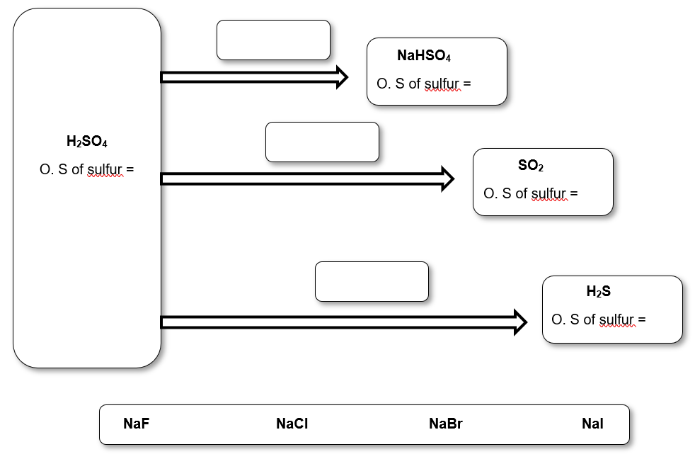
1. The above diagram illustrates how sulfuric acid, H2SO4 reacts with halides. Complete the diagram by showing the O.S of sulfur for each species and which halide salt(s) achieve each reaction.
- marks)
2. Which of the transformations is not a redox reaction?
- mark)
3. State the general trend in reducing ability of the halides and the 2 factors about the atoms that lead to this trend.
(2 marks)

Uses of chlorine and chlorate(I)

- Chlorination has been used for many years as a way of protecting public health by disinfecting water supplies thus preventing the growth of harmful microorganisms. Chlorination can be carried out by bubbling chlorine gas through water.

        - Write an equation to show how chlorine reacts with water
(1 mark)
        - Explain how this process is an example of a disproportionation reaction.
(2 mark)
Bacteria are killed by the chlorate(I) ion.
        - Show using an equation how the chlorate(I) ion is formed from a product of the reaction of chlorine with water.
(1 mark)
        - Give 2 reasons why people object to chlorination of drinking water.
(2 mark)
        - Given the objections to chlorination, why does the UK government continue to chlorinate drinking water?
(1 mark)

- Chlorine can also be used in the production of bleach.

        - Write an equation to show how chlorine is used to produce bleach. Indicate which compound in your equation is responsible for the ‘bleaching’ property and show that the reaction is another example of disproportionation.
(3 marks)

Halogens summary

A student carried out an experiment to identify some solid sodium halides. Below is his incomplete results table showing what he observed. Complete the results table with observations (take care to use suitable technical language) and identify the halide anion in the solids A, B, C.

Solid | Addition of AgNO₃/H⁺ to solution of the halide | Addition of dil. NH₃ to silver precipitate from test 1 | Addition of conc. NH₃ to tube from test 2 | Addition of conc. H₂SO₄ to the solid
A | White precipitate formed |  |  | Misty fumes seen which turn litmus paper red
B |  | No visible change, precipitate remains
C |  |  | No visible change, precipitate remains | Purple vapour visible and solid crystals seen on the top of the test tube

Redox - Answers

Oxidation numbers

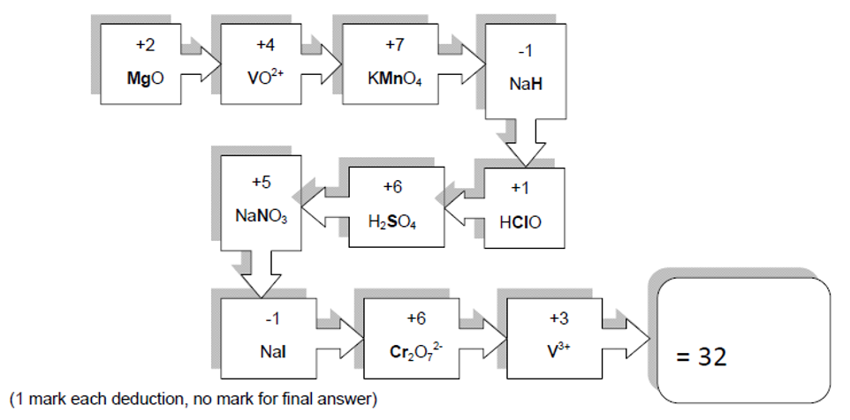
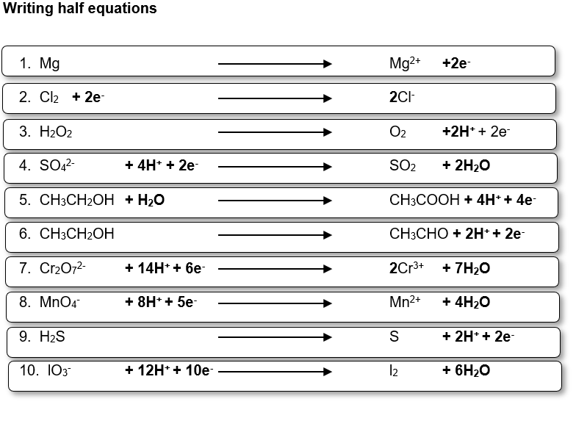

Half equations to overall equations

1.
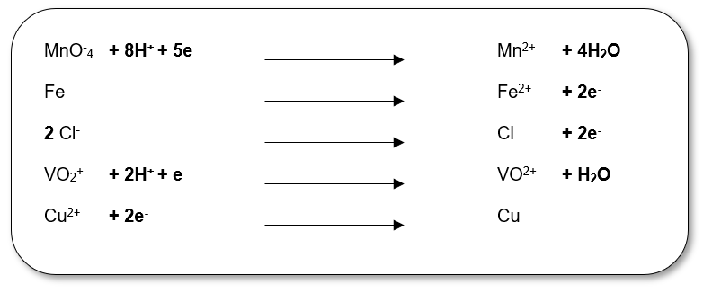

- (a) 2 MnO₄⁻ + 16H⁺ + 10Cl⁻ 5Cl₂ + 2Mn₂⁺ + 8H₂O
(b) Cu²⁺ + Fe Fe²⁺ + Cu
- 2VO₂⁺ + 4H⁺ + Zn 2VO²⁺ + 2H₂O + Zn²⁺
- Cr₂O₇²⁻ + 14H⁺ + 6e⁻ 2Cr³⁺ + 7H₂O

Electrolysis of aluminium

1.
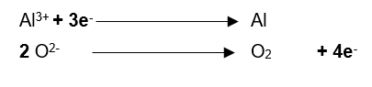
2. Electrodes are made of carbon and are oxidised to CO₂
Uses electricity which is generated from the burning of fossil fuels.
3. So the ions are free to move
4. It is more reactive than carbon
5. Dissolved in molten cryolite
6.
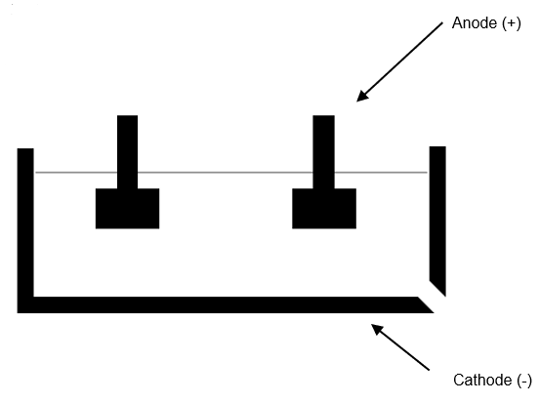

Extraction of other metals

1.
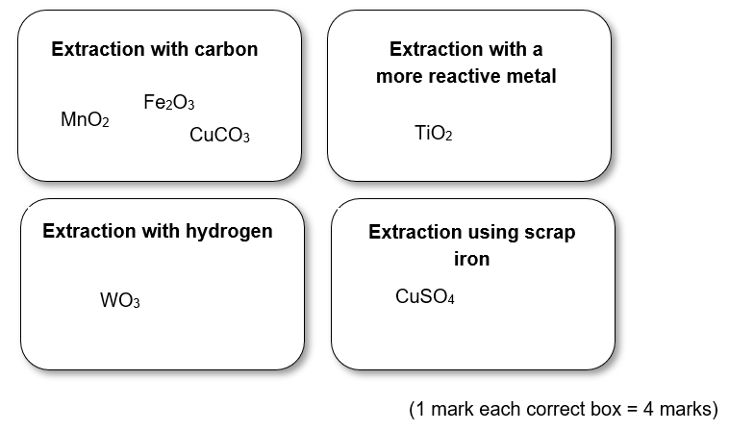
- Tungsten and titanium – Stable carbides are formed which make the metals brittle.
(2 marks)
- TiO₂ + 2Cl₂ + 2C TiCl₄ + 2CO
+4 0 0 +1
TiCl₄ + 4Na Ti + 4NaCl
OR with magnesium
+2
TiCl₄ + 2Mg Ti + 2MgCl₂
+4 0 0
- Hydrogen is flammable/explosion.

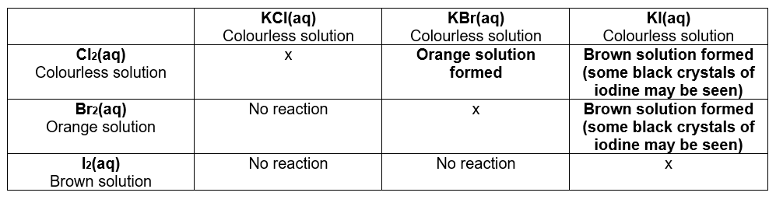
Displacement reactions
(1 mark each, iodide observation does not need observation of crystals for the mark)

2. Cl₂ + 2Br⁻ 2Cl⁻ + Br₂
Cl₂ + 3l⁻ 2Cl⁻ + l₂
Br₂ + 2l⁻ 2Br⁻ + l₂

3. The Br goes from an O.S of 0 in Br2 to -1 in KBr so it is reduced.
The I goes from an O.S of -1 in KI to 0 in I2 so it is oxidised.
(1 mark for either, must include bold)
4. Any one from the following for 1 mark
✓ Large atomic radius
✓ More shielding
Plus for the other mark
✓ Lower effective nuclear charge
- All of them.

Ability to reduce sulfuric acid
1.
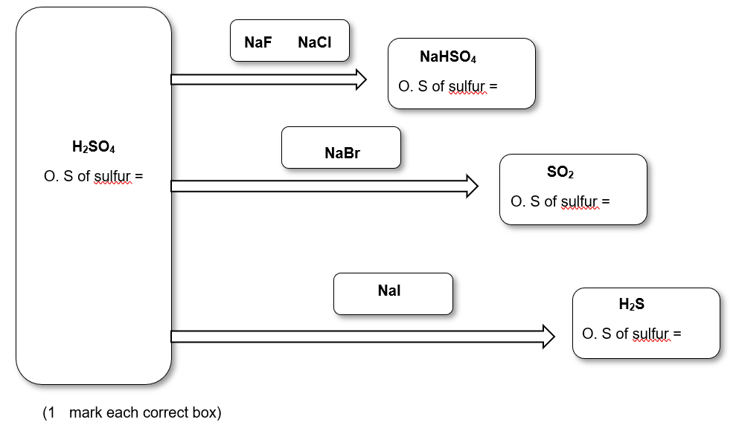
2. H2SO4 → NaHSO4 (the O.S of S does not change)
- mark)
3. Reducing ability increases down the group
(1 mark)
Atomic radius and shielding
(both needed for 1 mark or ½ mark each)

Uses of chlorine and chlorate(I)

1. (a) Cl₂ + H₂O → HClO + HCl
(1 mark)
        - Chlorine goes from an O.S of 0 in Cl₂ to +1 in HClO and -1 in HCl. It is both oxidised and reduced.
(1 mark for the O.S numbers, 1 for bold)
        - HClO + H₂O → ClO⁻ + H₃O⁺
(1 mark)
        - Any 2 from the following for 2 marks
✓ Chlorine can react with organic material in water to form carcinogens
✓ Chlorine gas is harmful
✓ No choice in it
        - The benefits outweigh the risks or WTTE.
- mark)
2. NaOH + Cl₂ → NaClO + NaCl + H₂O
(1 mark)
NaClO is the bleaching agent.
(1 mark)

Chlorine goes from an O.S of 0 in Cl₂ to +1 in HClO and -1 in HCl. It is both oxidised and reduced.
(1 mark)

Halogens summary
(1 mark for each correct box)
Solid | Addition of AgNO₃/H⁺ to solution of the halide | Addition of dil. NH₃ to silver precipitate from test 1 | Addition of conc. NH₃ to tube from test 2 | Addition of conc. H₂SO₄ to the solid
A | White precipitate formed | Precipitate dissolves/solution goes clear | No visible change | Misty fumes seen which turn litmus paper red
B | Cream coloured precipitate formed | No visible change, precipitate remains | Precipitate dissolves/solution goes clear | Brown solution formed/acrid fumes produced
C | Pale yellow coloured precipitate formed | No visible change, precipitate remains | No visible change, precipitate remains | Purple vapour visible and solid crystals seen on the top of the test tube

A = NaCl, B = NaBr, C = NaI (1 mark each)

