Chemistry in pharmacy
Education in Chemistry
October 2019
rsc.li/2pDaSug
The following questions explore situations where chemistry is essential for understanding how pharmaceutical drugs work.

Questions
1. While almost all drugs act in a reversible manner, one prominent exception is aspirin. Aspirin acetylates the enzyme cyclooxygenase by forming a covalent bond with a serine side chain.
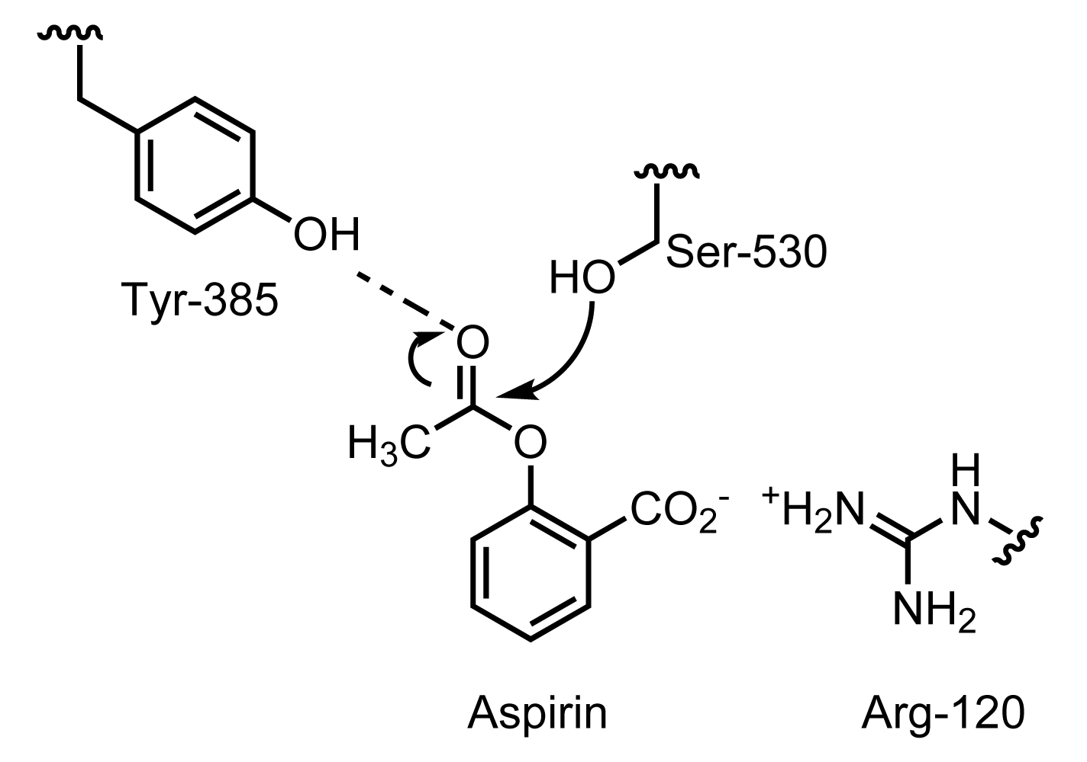
- What is the functional group in the serine side chain?
- The diagram shows three amino acids of the cyclooxygenase enzyme which are involved in the interaction with aspirin. Draw the product of the reaction of aspirin with the Ser-530 amino acid.
- What role might the Arg-120 residue play in the interaction of aspirin with the enzyme?
- What role might Tyr-385 play in the interaction of aspirin with the enzyme?
2. Using your understanding of intermolecular forces, explain why including a substance such as glycerol causes an increase in the viscosity of a syrup.
3. Almost all drugs interact with their target protein in a reversible manner – the drug binds to the receptor protein through multiple weak bonds. The greater the number of these interactions and the better the fit of the drug the more tightly the drug binds and the more slowly it dissociates from its receptor. Some larger drugs can bind with many points of interaction and have very tight binding that is only slowly reversible. This occurs with some hormones and antibodies. Suggest five different types of these intermolecular forces and put them in order from weakest to strongest energy of interaction.

4. Salbutamol was a great improvement, but there was still a desire for even longer acting drugs that would allow asthmatics to be able to sleep uninterrupted. Chemists worked on synthesising a variety of chemical structures and the result of this work was salmeterol, which could be given twice a day making it much easier for patients to use. Compare the chemical structures of salbutamol (left) and salmeterol (right) below.
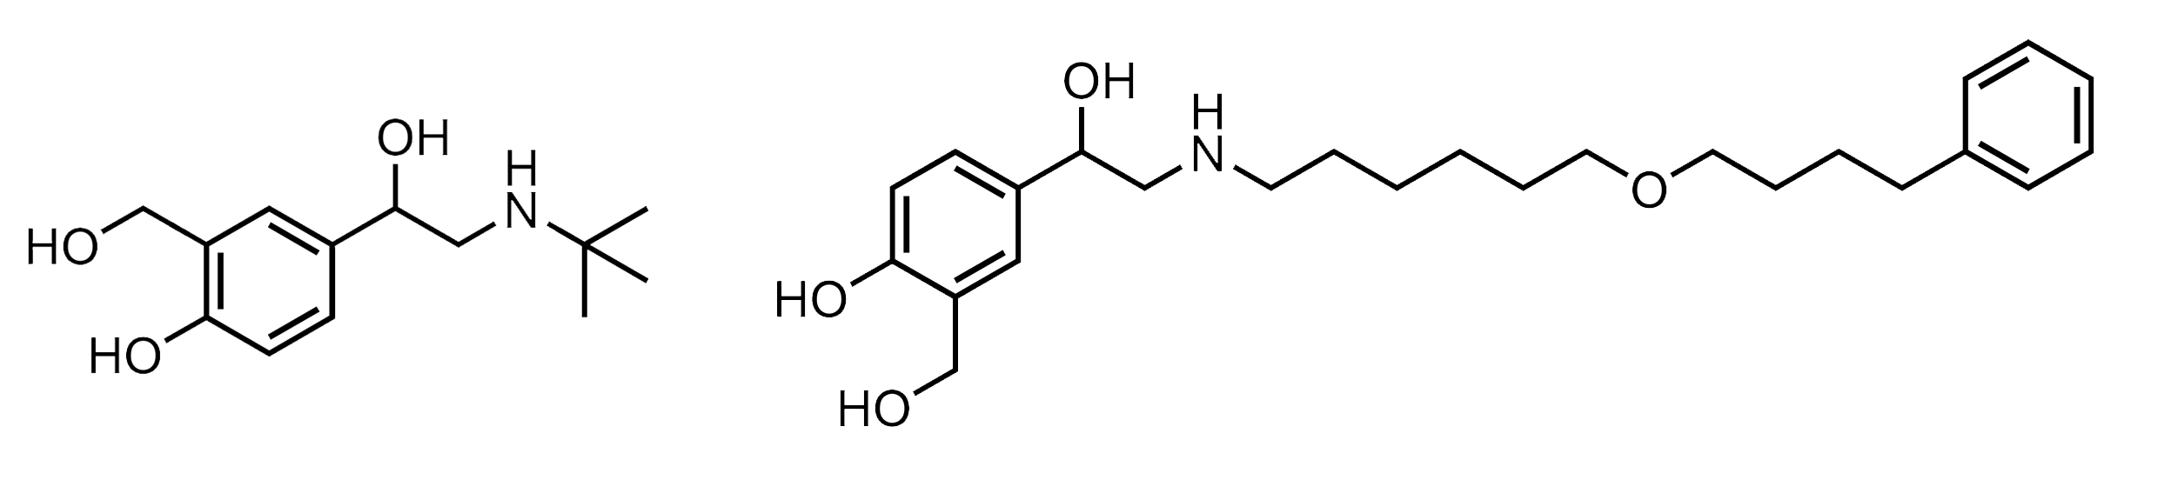
It is thought that the increased duration of action of salmeterol is due to its increased hydrophobicity, which increases its interaction with the hydrophobic parts of the phospholipids of the cell membrane. Identify which part of the salmeterol molecule is likely to be responsible for this mechanism. Carry out research to find the structures of phospholipids such as phosphatidycholine and phosphatidylserine that are components of the cell membrane. Which part of the phospholipid is likely to be responsible for these hydrophobic interactions?
5. Several very different species of plant can produce the same or very similar chemical structures which can be used in medicine. Western and central European medicine used hyoscine and hyoscyamine which were extracted from deadly nightshade and henbane. These plants produce the same active ingredients as Datura stramonium, found in Ayurvedic medicine and the Corkwood tree (Duboisia myoporoides) used by the Australian Aborigines. How do we know that these plants actually contain the same active ingredients?

Answers
- a) Hydroxyl, –OH
b)
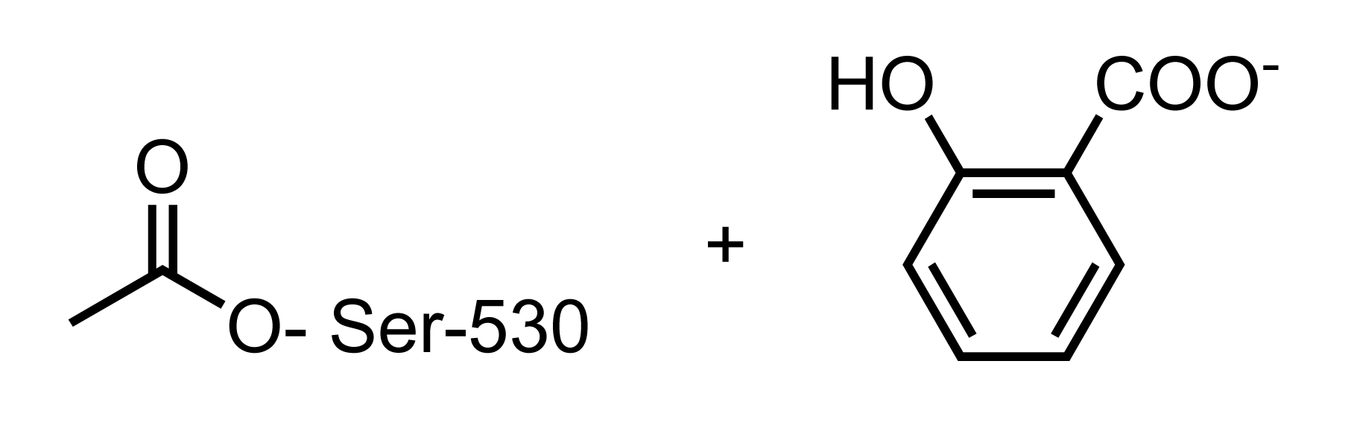
c) An ion pair forms between the negative charge on the aspirin and the positive charge on the amino acid.
d) The hydrogen bond could help to orient the aspirin molecule in the binding site.
2. Glycerol contains three hydroxyl groups which could form hydrogen bonds with water molecules and other glycerol molecules which means that for the molecules to flow past each other they must be continually making and breaking hydrogen bonds.
3. London dispersion forces (0.05–2 kJ/mol); dipole–dipole (1–5 kJ/mol); hydrophobic interactions (4–12 kJ/mol; ion-dipole (10–20 kJ/mol); hydrogen bonding (20–40 kJ/mol) and ionic.
4. Salmeterol’s long hydrocarbon chain and benzene ring are likely to interact with the hydrophobic parts of the cell membrane. Phosphatidylcholine contains a three carbon glycerol, of which two carbons link to two long hydrocarbon ‘tails’ and the third carbon links to a choline group with a charged amine group. The two hydrocarbon tails are hydrophobic and will interact with the hydrophobic part of the salmeterol molecule. The receptor protein that salmeterol binds to is embedded in the cell membrane and it is possible that the hydrophobic part of the salmeterol molecule interacts with hydrophobic amino acids in the receptor protein.
5. Techniques like high performance liquid chromatography can be used to separate the ingredients further and then mass spectrometry or spectroscopy (infrared or NMR) can be used to work out the chemical structure.

