The microscale synthesis of indigo dye – teacher notes

Topic
Colour chemistry, dyes. Organic chemistry – dyes, synthesis.

Timing
10 minutes

Apparatus
- Eye protection
- Test tube, or beaker, 10 cm³
- Small filter funnel
- Filter paper

Chemicals
Solutions should be contained in plastic pipettes. See the accompanying guidance on apparatus and techniques for microscale chemistry, which includes instructions for preparing a variety of solutions here https://rsc.li/3C0pipA

- Sodium hydroxide 0.5 mol dm^{–3}
- Deionised water
- Propanone
- 2-Nitrobenzaldehyde

Observations

2-Nitrobenzaldehyde dissolves in propanone to form a pale yellow solution. When sodium hydroxide solution is added the solution darkens after a few seconds and a purple precipitate of indigo forms.

The synthesis is very simple and quick to perform yet it is mechanistically complex involving a series of condensations, disproportionations and oxidations. The sequence of reactions is given in the Journal of Chemical Education and this, together with the structures of the two forms of indigo, is shown overleaf. There is one unusual step which produces ethanoic acid and what appears to be a hydroxy-derivative of indoxyl prior to the final oxidation to form indigo (indigotin).

It is worthwhile pointing out to students that it took Baeyer 14 years (from 1865 to 1879) to find a route for the original synthesis of indigo and even when he did it took him another four years to deduce the correct formula (in 1883).

The indigo can be filtered off and then dissolved in an alkaline solution of sodium dithionite to form the colourless, soluble form (leucoindigo). A piece of cotton cloth dipped into this solution and then exposed to air produces the indigo-dyed fabric – this is the procedure used in vat dyeing.

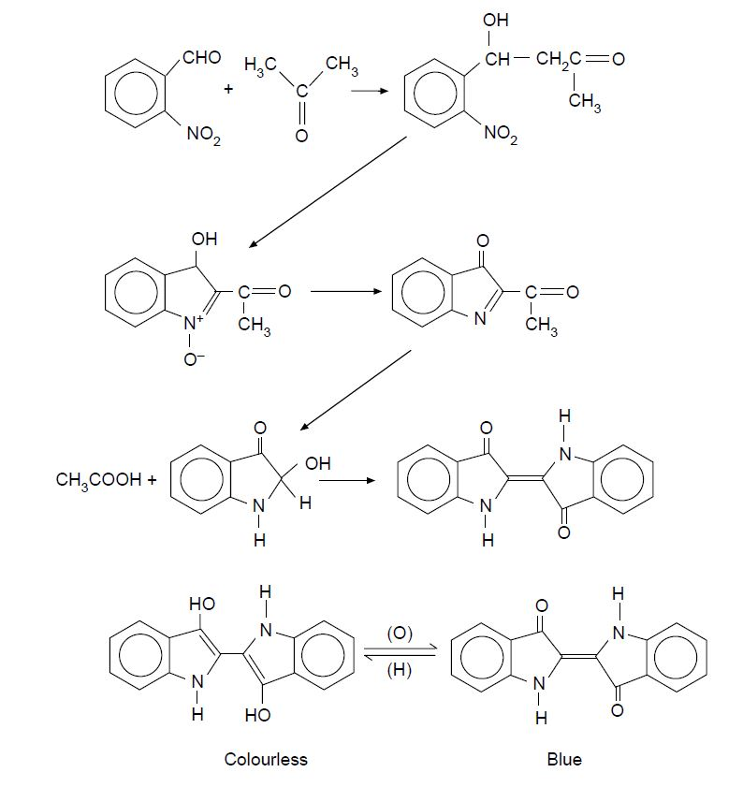
The preparation of indigo from 2-nitrobenzaldehyde and propanone

Health, safety and technical notes

- Read our standard health and safety guidance here https://rsc.li/3BXrM8v
- Students must wear suitable protection (Splash resistant goggles to BS EN166 3).
- Sodium hydroxide solution, 0.5 mol dm–3 NaOH (aq) is corrosive (see CLEAPSS Hazcard HC091a).
- Propanone is highly flammable, and an eye/respiratory irritant (see CLEAPSS Hazcard HC085a)
- 2-Nitrobenzaldehyde is Harmful if swallowed and a skin/eye and respiratory irritant (See ChemSpider10630).

