Chromatography: teacher guidance
This resource forms part of the Review my learning series from the Royal Society of Chemistry. The worksheets assess learner’s understanding of content from common 11–14 and 14–16 curriculums. They can be used to identify knowledge gaps and misconceptions once that part of the curriculum has been taught.
The Chromatography worksheets cover the following topics:
- terms used to describe paper chromatography
- preparing a chromatogram
- interpreting a chromatogram
- calculating R_{f} values
- using R_{f} values
- thin layer chromatography.
Scaffolding
Level 1 (*) is a scaffolded worksheet which supports learners in a variety of ways, such as selecting words from a word bank, providing answer options to choose from or completed examples. Level 2 (**) is a partially scaffolded worksheet with a reduced level of support, such as partially completed sentences or a wider range of answer options to select from. Level 3 (***) is an unscaffolded worksheet in which most of the tasks involve answering questions with a minimum of prompts.
Metacognition
The ‘What do I understand?’ page is common to all levels of worksheet and can be used both to identify areas needing whole class attention and as an indicator for learners to help guide their revision.
Below you will find model answers for each level and guidance on learners’ misconceptions. Learners can use the model answers to self- or peer assess.
When to use
The worksheets can be used in a variety of ways:
- To assess learners’ knowledge at the beginning or end of a period of teaching. Match the level of the worksheet to the support needs of the learners.
- To assess knowledge during a period of teaching once learners have completed the relevant topic.

- As part of revision.
- As a refresher exercise for teachers or non-subject specialists.
There is also scope to increase the level of worksheets used as learners progress through their curriculum.
Further support
For more resources to support teaching of this topic and address any misconceptions identified, go to rsc.li/4cclwej.

Answers

Chromatography: knowledge check
- (Level 1, 2 and 3)
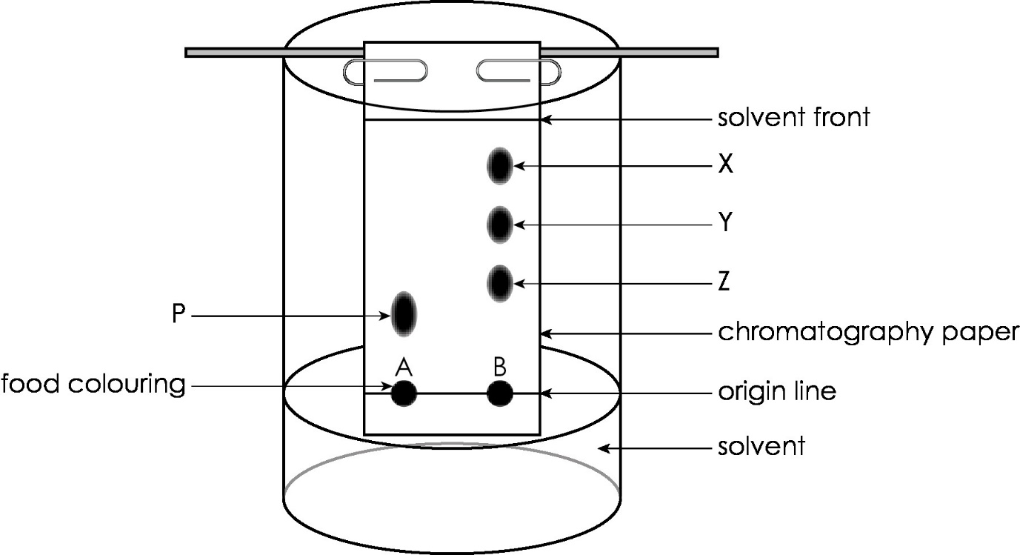

Guidance: This practical is included on specifications for many learners at this level and they should be familiar with the technique. Level 3 may alternatively label ‘solvent’ as ‘water’.

- (Level 1, 2 and 3)
These are the stages in the correct order.
1 | Draw an origin line in pencil about 1.5 cm from one end of the chromatography paper.
2 | Check the paper is the right length by lining it up on the outside of the beaker so that the water is below the origin line.
3 | Use a pipette to add small drop of food colourings A and B on the chromatography paper.
4 | Place the paper inside the beaker. Make sure it just touches the water and it is vertical.
5 | Allow the solvent to move through the paper, removing it before the solvent reaches the top.

Guidance: These are the typical steps learners would work through when carrying out this practical.
- (Level 1, 2 and 3)

stationary phase; mobile phase; solvent; rates; chromatography paper

Guidance: The reasons why different substances move at different rates on a stationary phase is complex and beyond this stage. It can be explained very simply to learners as a ‘tug of war’ between attractions to the solvent (mobile phase) and attractions to the chromatography paper (stationary phase).

Learners may misunderstand that the substance being tested is the mobile phase.

- (Level 1)
A substance that contains only one element or compound. | pure
A substance that contains two or more different elements or compounds. | impure
(Level 2 and 3)

compound; two or more; pure; three; impure

Guidance: Learners may confuse the terms ‘pure’ and ‘impure’. These have different meanings in chemistry and common use. In common use, milk may be considered to be pure but in chemistry, a pure substance contains one element or compound only.

Chromatography: test myself
- (Level 1)

mixtures of soluble substances
(Level 2 and 3)

separate mixtures of soluble substances/identify unknown substances
Guidance: Most learners will be familiar with chromatography as a separation technique, but many will omit the fact that the substances are soluble substances.
- (Level 1, 2 and 3)

The pure substances are the red, blue and yellow inks.

Guidance: Learners need to understand that a pure substance produces one spot only on a chromatogram.
- (Level 1)

It is used to identify unknown substances by comparing the R_{f} values.
(Level 2 and 3)
It is used to identify unknown substances by comparing the R_{f} values/comparing the R_{f} values with known values/comparing the colour and distance travelled by the substances.

Guidance: The best answer is ‘comparing the R_{f} values with known values’. These are values made under the same conditions.

- (Level 1, 2 and 3)
It replaces the chromatography paper.

Guidance: Not all specifications at 16 require knowledge of thin layer chromatography.
- (Level 1, 2 and 3)

The R_{f} value of the red substance is 0.2.

The R_{f} value of the blue substance is 0.8.

The R_{f} value of the purple substance is 0.6.

Guidance: Learners must ensure that the ‘f’ in R_{f} is written as a subscript.

Possible errors may include:
- selecting the wrong information from the chromatogram
- substituting the values incorrectly in the formula
- mathematical errors.
- (Level 1, 2 and 3)
The compound travels 9.6 cm
Guidance: See guidance for question 2.5. In addition, changing the subject of the formula will create problems for some learners.

Chromatography: feeling confident?
- (Level 1, 2 and 3)
My conclusion is that the black ink contains the same substances as blue ink and red ink. Black ink does not contain the same substance as orange ink and green ink.

Guidance: See guidance for question 2.2. This is asking learners to write a simple conclusion, as they are expected to do following the live practical.
- (Level 1, 2 and 3)
Substance | Distance travelled by the substance when the solvent travels 10 cm (cm) | R_{f} value
A | $$9.8$$ | R_{f} = $\frac{distance travelled by substance}{distance travelled by solvent}$ = $\frac{9.8}{10} =0.98$
B | $$5.9$$ | R_{f} = $\frac{5.9}{10}$ = $0.59$
C | $$0.42 × 10 = 4.2$$ | $$0.42$$

Guidance: See guidance for question 2.5.

Chromatography: what do I understand?
Mini-topic | Assessed via:
I can describe the process of paper chromatography. | 1.1, 1.3, 2.1
I can describe how to prepare a chromatogram. | 1.2, 2.4
I can define a pure substance and an impure substance | 1.4
I can interpret a chromatogram. | 2.2, 2.3
I can calculate R_{f} values. | 2.5
I can use R_{f} values. | 2.6
Feeling confident? topics | Assessed via:
I can interpret chromatograms of coloured inks. | 3.1
I can interpret and use information from chromatograms of chlorophyll. | 3.2

