Demonstrating the chameleon redox reaction with a lollipop

This resource accompanies the article Eye candy in Education in Chemistry which can be viewed at: https://rsc.li/3XRLtbN

I’m a sucker for sugar-related chemistry. It’s been eight years since I developed my optimised version of Beyond the blue bottle demonstration that relies on the reducing power of glucose. This reaction remains one of my most-commonly performed demonstrations. So, when Marisa Prolongo and Gabriel Pinto shared their idea to use a lollipop to reduce manganate(VII) through a range of colourful oxidation states (a variation of the reaction sometimes referred to as the chameleon), I knew I had to give it a try …

Equipment
- 200 cm³, 0.1M sodium hydroxide solution
- ≈ 0.02 g (a micro-spatula tip) of potassium manganate(VII) (Note: oxidising, harmful, dangerous for the environment)
- Lollipop or candy cane made from any reducing sugar (glucose, fructose, etc)
- Handheld battery-operated milk frother or magnetic stirrer
- Clamp and stand
- 250 cm³ conical flask

Preparation
The colour of the lollipop doesn’t seem to have a significant impact on the colour of the solution, but if you use purple or white one, this may mean students won’t get confused about the food colouring causing the colour changes. Fix the lollipop stick to the arm of the frother –nestle the ball of the lollipop head in the circular whisk head to support it as it rotates (Figure 1). Clamp the handle of the frother firmly and check the clamp remains stable when the whisk is operating.
Because the alkaline solution of manganate(VII) is not stable, ensure you create the solution for this reaction in front of the class.

In front of the class
Wear eye protection. Add approximately 200 cm³ of 0.1M sodium hydroxide solution to the 250 cm³ conical flask. Add a micro spatula or splint tip of the potassium manganate(VII) to the sodium hydroxide solution. Dip the head of the lollipop into the solution and activate the stirrer function to rotate the lollipop. The solution will quickly turn blue, and then green, yellow, and eventually orange over the next five minutes.

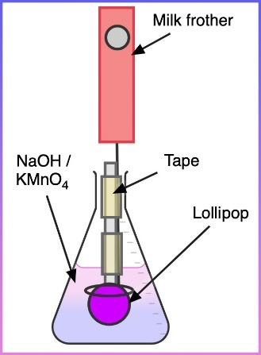

Teaching goal
This reaction is a suitable introduction to self-indicating redox titrations. The classic version of this type of reaction is the one used to determine iron content with a solution containing acidified potassium manganate(VII).
In the classic reaction, the iron(II) ion can reduce manganese all the way down to manganese(II), but this lollipop demonstration stops at MnO₂ (with manganese in a +4 oxidation state).
Students can practise formulating and balancing the relevant redox reactions, see examples in both alkaline and acidic conditions, and recognise the difference between MnO₂ and Mn(II). I’ve found this has caused some confusion for my students when answering exam questions, because both oxidation states can appear (seen in other examples, such as the ‘genie in the bottle’ reaction).

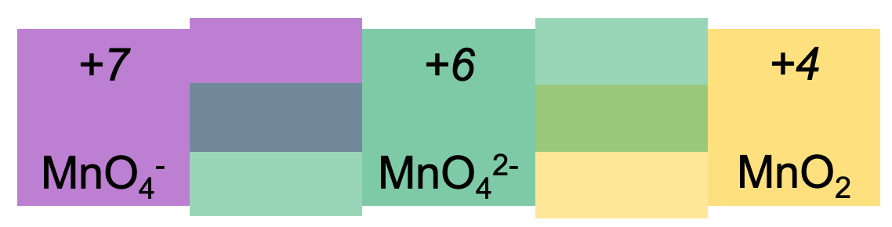
Figure 2a: images of the reaction as it proceeds; b: species in solution, the colours and combinations of their colours
In the first step, the MnO₄— ion (which is purple in solution) picks up an electron and is reduced to MnO₄^{2—} (which is green in solution).
MnO₄— (aq.) + e— MnO₄^{2—} (aq.)
Equation 1
Although Prolongo and Pinto suspected the presence of the blue MnO₄^{3—} ion, subsequent spectrochemical studies have ruled out the possibility that it’s present in any meaningful concentration. Rather, the blue intermediate step is the result of a mixture of the purple MnO₄— and green MnO₄^{2—} ions in the solution (Figure 2b).
The MnO₄^{2—} ion is further reduced to a solution of Mn(IV) (aq.), and then MnO₂ precipitates out as a colloidal suspension (Equation 2). Students may be more familiar with the brown-black insoluble MnO₂ powder used in catalysis experiments but, at these concentrations, the colloid appears orange.
MnO₄^{2—} (aq.) + 2e— + 2H₂O (aq.) MnO₂ (s) + 4OH— (aq.)
Equation 2

Alternative methods
You can alter this reaction to produce different effects. The reaction is (pseudo)-first order with respect to sugar and hydroxide ion, so it will tolerate a range of different concentrations. You could make up a variety of solutions with different sugars (sucrose, for example, reacts more slowly than glucose or fructose), or concentrations of one sugar set up next to each other with magnetitic stirrers so students can see the kinetic effects over time. You could also leave petri dishes out unstirred to let diffusion gradients produce a range of colours. And for some festive fun In December, you could consider trying a popular variation of this demonstration with a candy cane hooked over the side of a stirred beaker.

