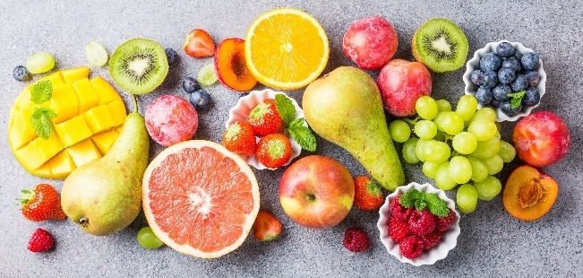
A flavour chemist wishes to make various flavourings for a new range of ice-creams.

She knows that the flavour or smell of an ester can be deduced if the original alcohol and carboxylic acid that make the ester are known.

How are esters named?
Source: Envato Elements

The first part of the ester name comes from the name of the alcohol. The second part of the name comes from the name of the carboxylic acid.

So, if the alcohol is methanol and the carboxylic acid is propanoic acid, the ester will be called:
methyl propanoate
From the carboxylic acid – propanoic acid
From the alcohol – methanol

- The table shows the alcohol being used (vertically) and the carboxylic acid being used (horizontally).
The fruity flavours are written into each box.
Complete the table by writing the name of the ester in each box.
One has been completed for you.
 | Propanoic acid | Butanoic acid | Pentanoic acid
Methanol | Apple  Methyl propanoate | Raspberry  Answer: Methyl butanoate. | Mixed fruit  Answer: Methyl pentanoate.
Ethanol | Pear  Answer: Ethyl propanoate. | Cherry  Answer: Ethyl butanoate. | Apple  Answer: Ethyl pentanoate
Butan-1-ol | Pear  Answer: Butyl propanoate. | Pineapple  Answer: Butyl butanoate. | Peach  Answer: Butyl pentanoate.

- Draw the structure of the alcohol, carboxylic acid and ester needed to make the following flavours.
Make sure you draw all of the chemical bonds in the molecule.
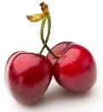
- Cherry

Structure of alcohol | Structure of carboxylic acid | Structure of ester
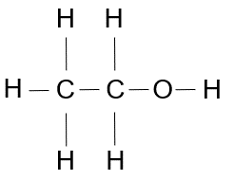 | 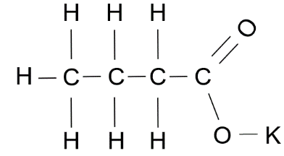 | 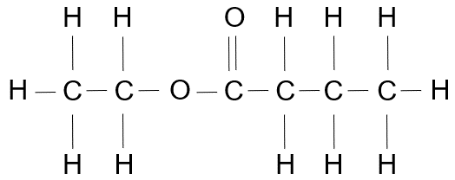

- Pineapple

Structure of alcohol | Structure of carboxylic acid | Structure of ester
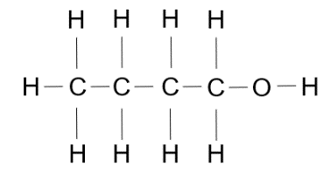 | 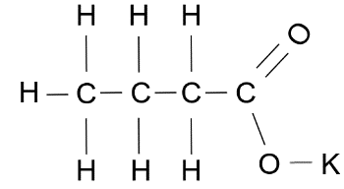 | 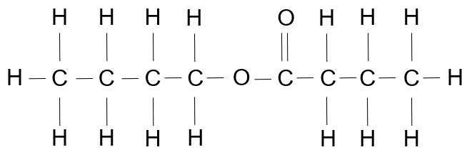

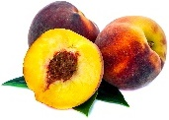
- Peach

Structure of alcohol | Structure of carboxylic acid | Structure of ester
 | 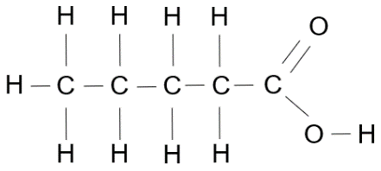 | 