The preparation of aspirin – student sheet

Introduction

In this activity you use ethanoic anhydride to convert 2-hydroxybenzoic acid into aspirin.

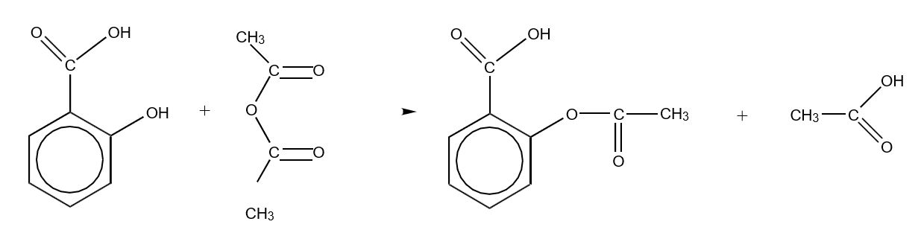

The reaction takes place easily in acidic solution but the product is formed as part of a mixture containing several other compounds. The product is formed in Stage 1 below and then separated from impurities in Stage 2.
Note that ethanoic anhydride reacts readily with water so all the apparatus must be dry.

Stage one
Take about 1 g of your sample of 2-hydroxybenzoic acid and weigh it accurately. Put it into a dry pear shaped flask and add 2 cm³ of ethanoic anhydride followed by 8 drops of concentrated phosphoric acid. Put a condenser on the flask.

In a fume cupboard, warm the mixture in a hot water bath, with swirling, until all the solid has dissolved and then warm for another 5 minutes.

Stage two
Carefully add 5 cm³ of cold water to the solution. Stand the flask in a bath of iced water until precipitation appears to be complete. It may be necessary to stir vigorously with a glass rod to start the precipitation process.

Filter off the product using a Buchner funnel and suction apparatus.

Wash the product with a little cold water, transfer to a weighed watch glass and leave to dry overnight. Weigh your product.

Results
Include the answers to the following questions in your write up.

- Calculate the relative molecular masses of 2-hydroxybenzoic acid and aspirin. What are the theoretical and actual yields?
- Calculate the percentage yield.
- How might material be lost at each stage? How could losses be minimised? Why might the apparent yield be too large?
- What would you expect to be the main impurities in your sample?

Chemical tests for purity
The addition of a chemical reagent to identify substances is a common procedure in chemical analysis. Often the reagent added forms a coloured compound with the substance under investigation. In this experiment iron(III) ions react with one of the possible impurities in the crude aspirin.
Carry out the following tests. Note carefully what you did and all your observations. Then answer the following questions.

- Add 5 cm³ of water to each of four test-tubes and label them A, B, C and D.
- Dissolve a few crystals of the following substances in water in the test-tubes.
- Phenol (NB Phenol is a toxic substance; avoid spillage and wash hands after use)
- 2-Hydroxybenzoic acid
- Crude product from Activity 3
- Pure aspirin
- Add 10 drops of a 1% iron(III) chloride solution to each test-tube and note the colour.

Questions
- Formation of an iron-phenol compound with Fe³⁺ gives a definite colour. Does the crude product contain any phenol type impurities?
- Draw the structural formulae of phenol, 2-hydroxybenzoic acid and aspirin. Identify the functional group most likely to be reacting with the Fe³⁺ ions.

