Bonding workshop
Covalent bonding and hydrocarbons
Download the teacher notes, PowerPoint presentation and student workbook that accompany this resource at rsc.li/3ASiknU.
Read our health and safety guidance, available from rsc.li/3IAmFA0, and carry out a risk assessment before running any live practical. The safety equipment suggested is in line with CLEAPSS requirements. For non-hazardous substances, wearing lab coats can help protect clothes. The safety rules might be different where you live so it is worth checking local and school guidance.

Acknowledgements
This resource was originally developed by Liverpool John Moores University to support outreach work delivered as part of the Chemistry for All project.
To find out more about the project, and get more resources to help widen participation, visit our Outreach resources hub: rsc.li/3CJX7M3.

Activity 1: hydrocarbons
No equipment required.
Activity 2: structure of hydrocarbons
Apparatus for room:
- Computer and projector
- Whiteboards and pens
Activity 3: simple molecules
- Molymod kit, available from: rsc.li/3GT6oVD
Activity 4: alkanes
Equipment per pair of learners:
- Molymod kits, available from: rsc.li/3GT6oVD
- Each kit needs to contain at least:
- 2 × Cl, 19 × H, 2 × O, 8 × C, 1 × N
- 30 single bonds
- 4 double bonds
Activity 5: reactions of alkanes
One set of equipment for the facilitator needed per demonstration.
Demonstration 1: Bunsen burner flame
- Bunsen burner
- Heatproof mat
- Matches/lighter

Demonstration 2: controlled explosion of methane
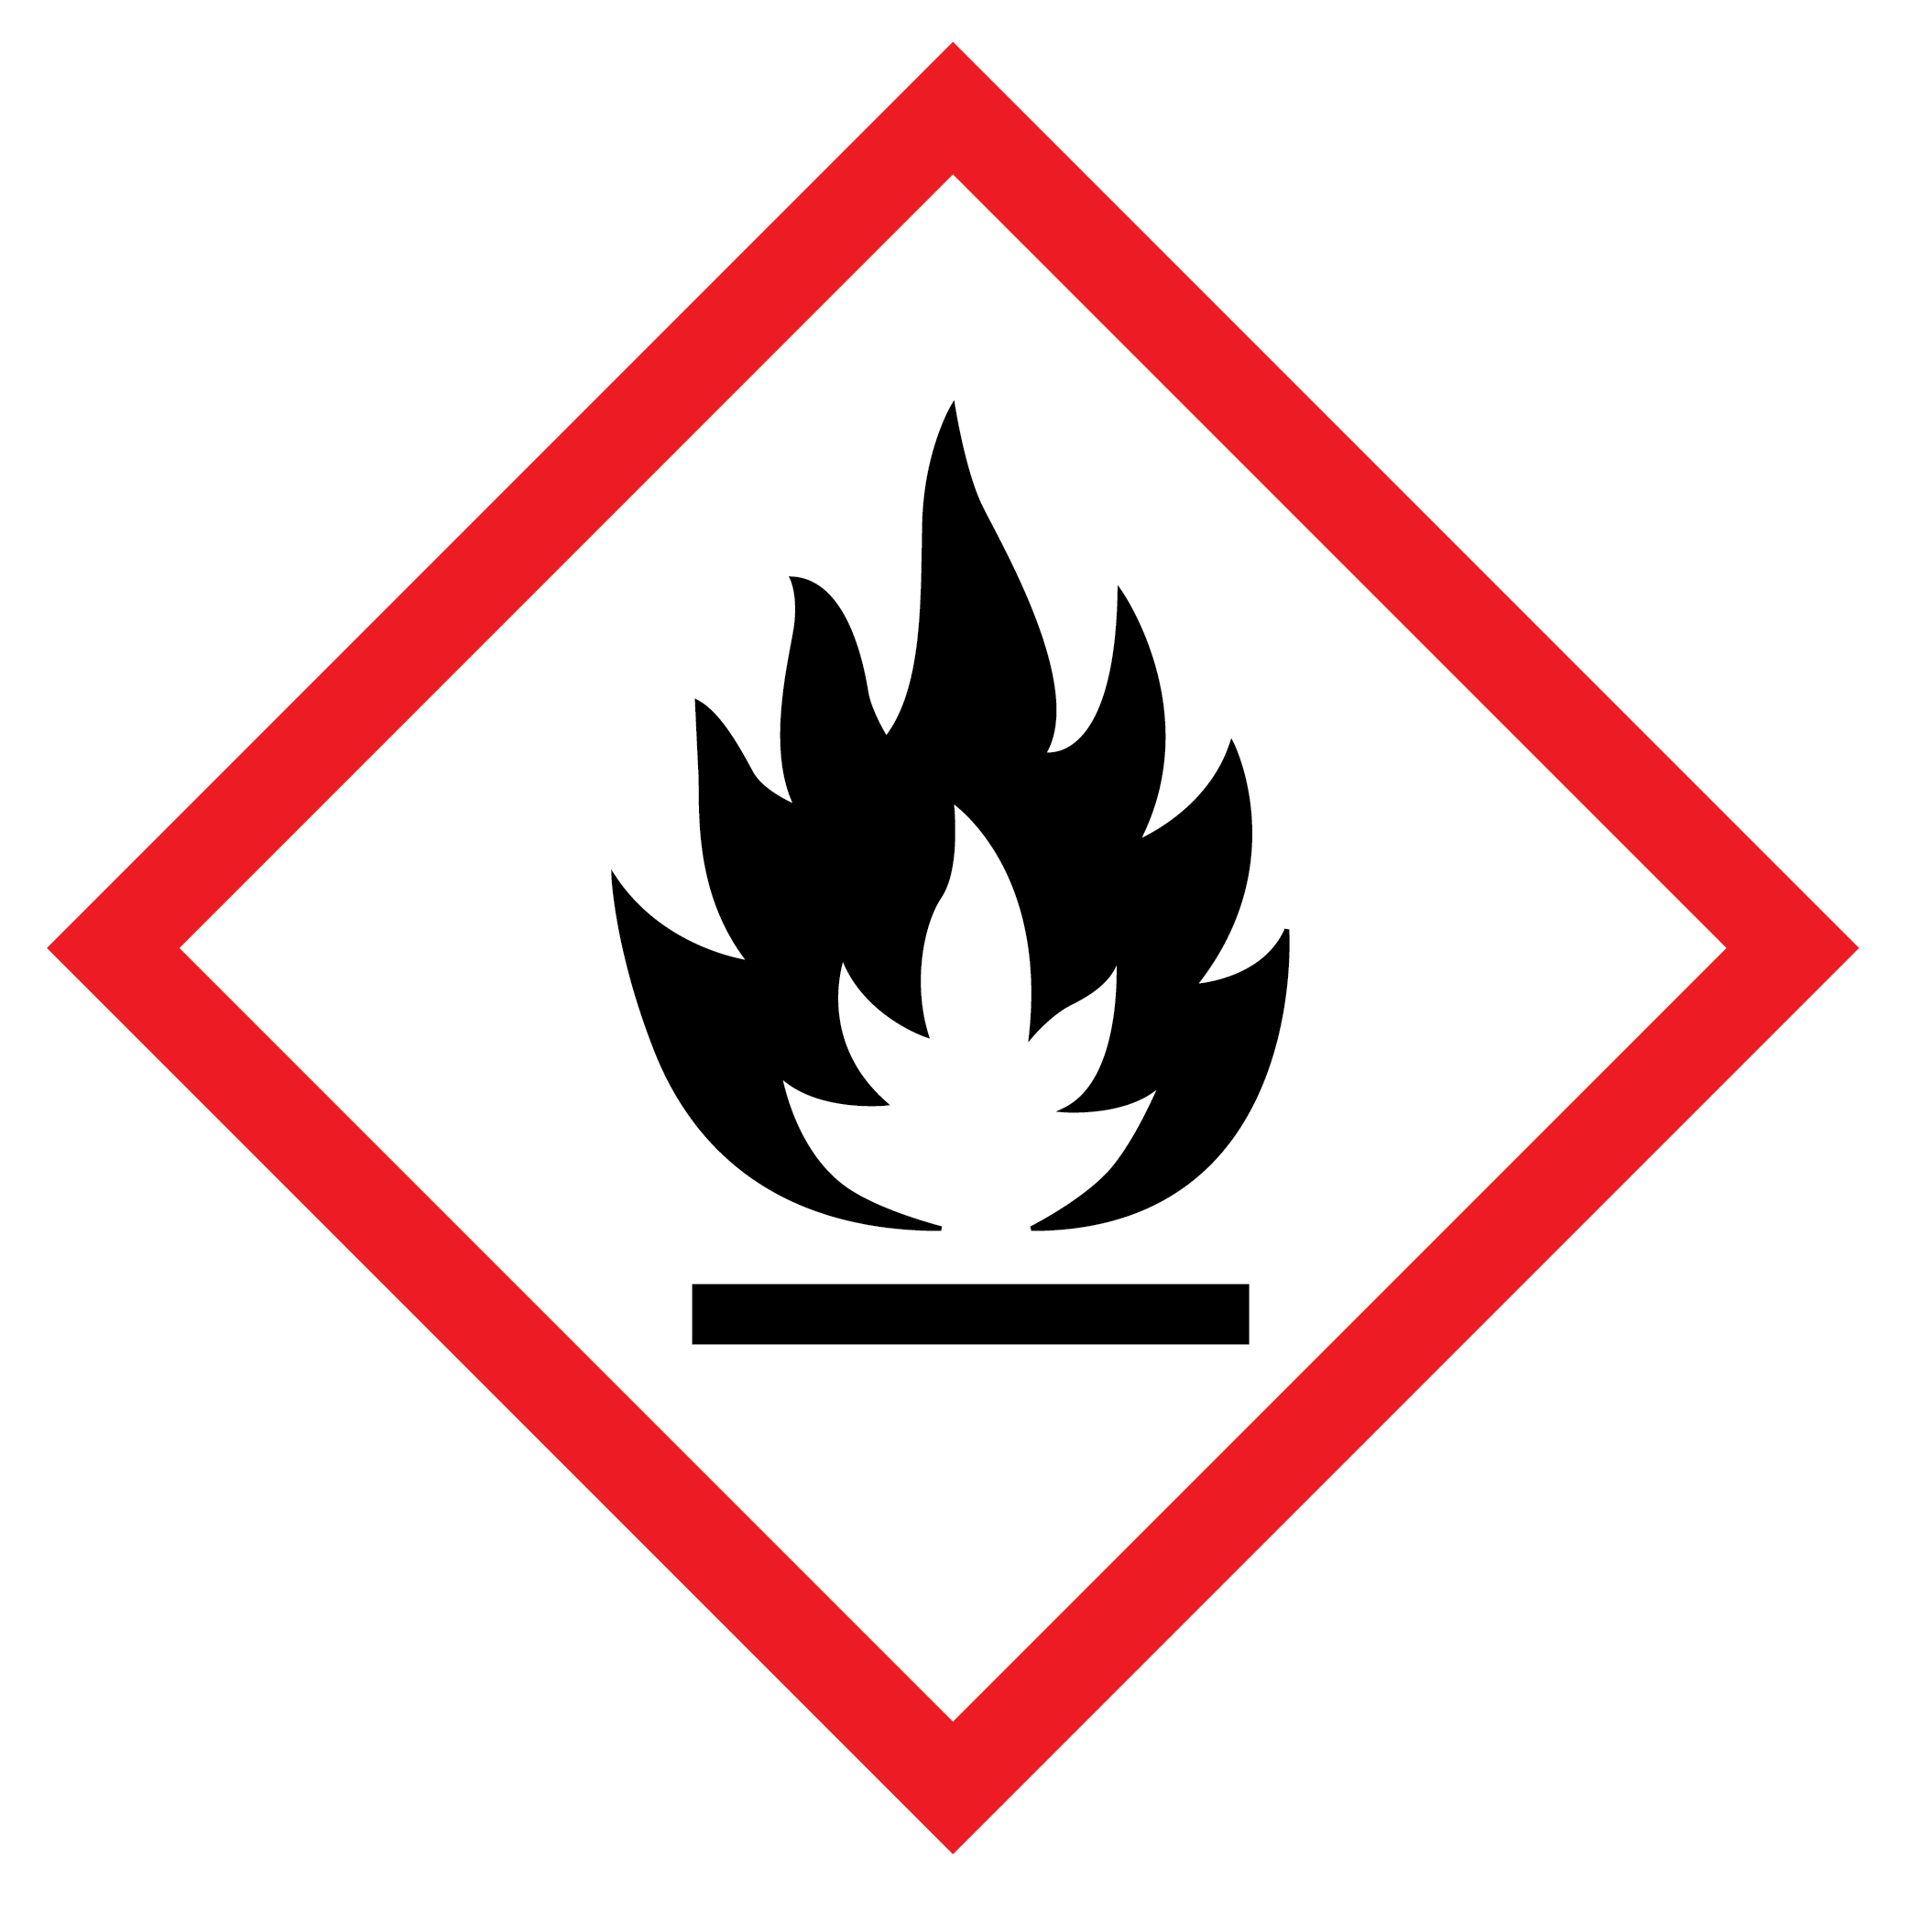
© Shutterstock
Read the safety notes and method for the Exploding a tin can using methane experiment, available from rsc.li/3vPcMqv, before demonstrating it.
Equipment
- Eye protection for the demonstrator
- Ear defenders
- Two safety screens
- A large tin with a press-on lid (A catering size (500–750 g) instant coffee tin works well.)
- Glass tubing, 2–3 cm in diameter, 30–50 cm long
- Epoxy resin adhesive (eg Araldite)
- Length of rubber tubing
- Boss, clamp and stand
- Wooden splints
Chemicals
- Methane (natural gas) supply (DANGER: extremely flammable)

Demonstration 3: methane bubbles
Read the safety notes and method for the Exploding soap bubbles experiment, available from rsc.li/3GqsNIs, before demonstrating it.
Equipment:
- Oxygen cylinder
- Methane – from gas tap
- Rubber tubing
- Metre rule
- Wooden splints
- Tape
- Plastic washing up bowl
- Washing up liquid
- Ear defenders
- Eye protection
- Warm water

Activity 6: alkenes
Equipment per pair of learners:
- Molymod kits
- Each kit needs to contain at least:
- 2 × Cl, 19 × H, 2 × O, 8 × C, 1 × N
- 30 single bonds
- 4 double bonds
Activity 7: reactions of alkenes
Class practical/demonstration: decolourisation of bromine water
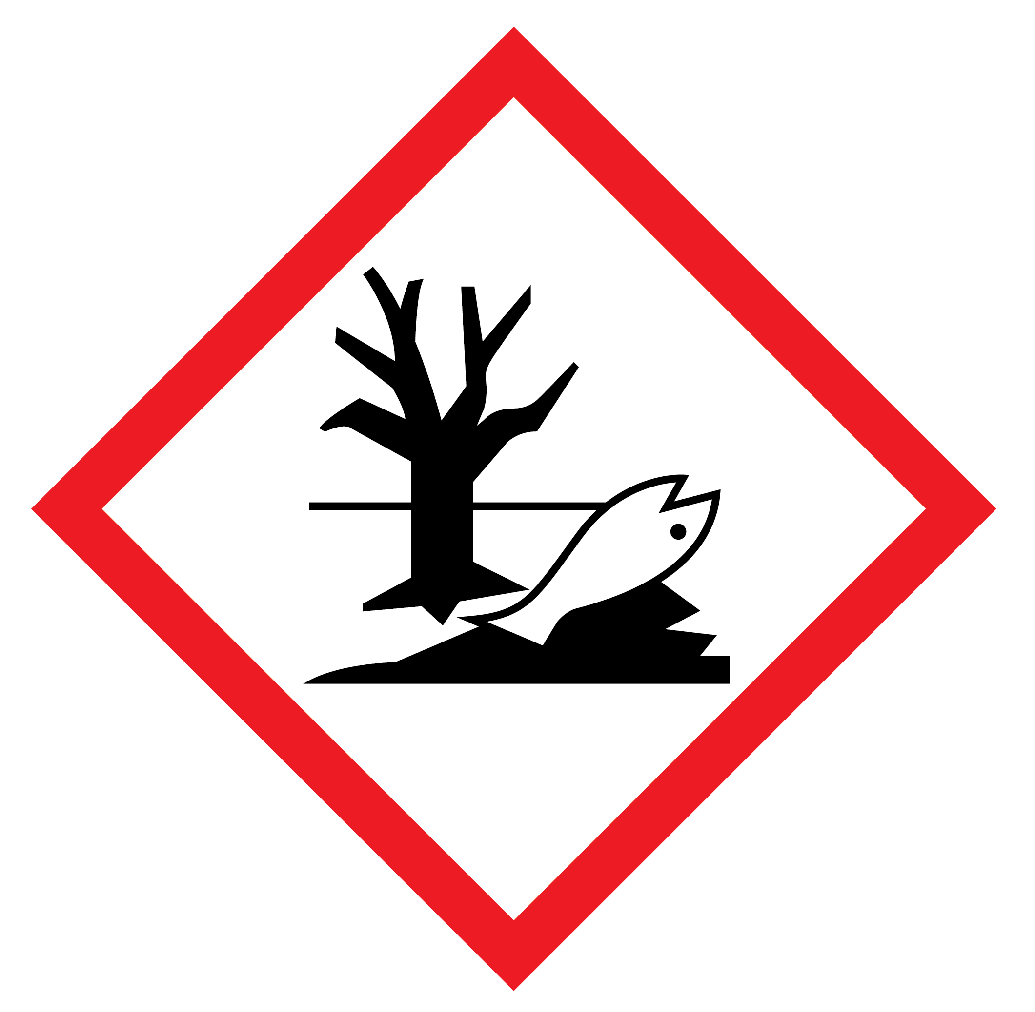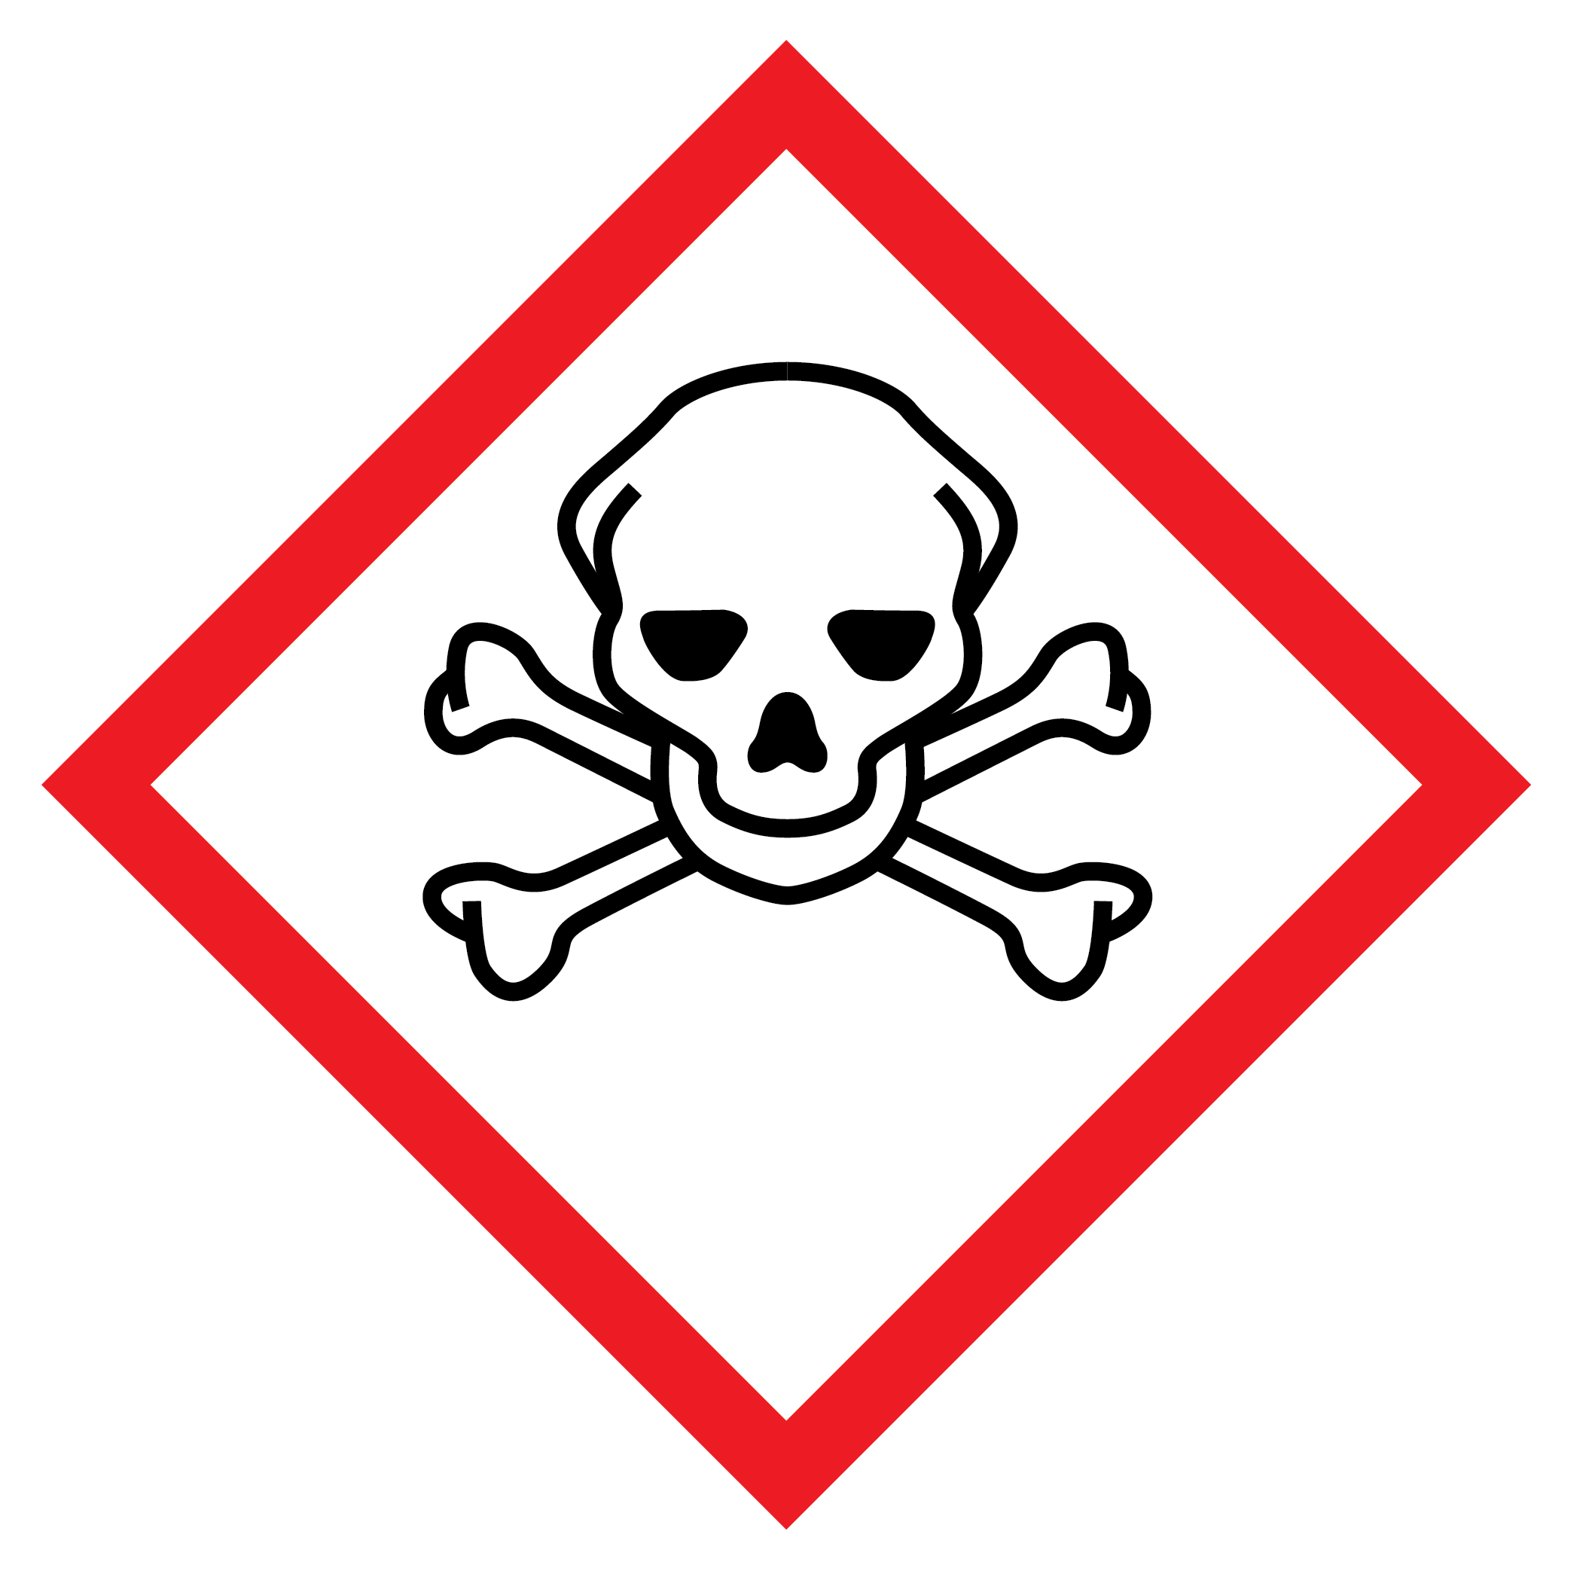
© Shutterstock
Required per group
Two stoppered test tubes containing 0.5 cm³ of 0.02 mol dm⁻³ bromine water in a test tube rack. (See CLEAPSS method for making bromine water, available from bit.ly/3vMyBqL.)
Required per three/four groups
Two dropping bottles – one containing hexane and one containing hex-1-ene.
Health and safety
Provide eye protection for each learner. The safety equipment suggested is in line with CLEAPSS requirements. For non-hazardous substances, wearing lab coats can help protect clothes. The safety rules might be different where you live so it is worth checking local and school guidance.

Please also see CLEAPSS Hazcards:
- 15A Bromine liquid, available from bit.ly/3Cz0gze (See also 15B: bit.ly/3vQ3VVw)
- 45B Hydrocarbons: aliphatic, saturated, available from bit.ly/3H0nlxv
- 45C Hydrocarbons: aliphatic & unsaturated, available from bit.ly/3vQ5h2y
Useful CLEAPSS protocols:
TL010 – unsaturation tests on hydrocarbons, available from bit.ly/3k5eEIT
Disposal: Place the test tubes, and contents, into a bowl of water in the fume cupboard.
Activity 8: functional groups
Equipment per pair of learners:
- Molymod kits
- Each kit needs to contain at least:
- 2 × Cl, 19 × H, 2 × O, 8 × C, 1 × N
- 30 single bonds
- 4 double bonds

