Scrutinising shampoo bottles

This resource accompanies the article Cosmetics: what’s on the label? in Education in Chemistry which can be viewed at: https://rsc.li/3pSWzOe

Learning objectives
- Categorise ingredients as mixtures and non-mixtures.
- Recognise the roles that ingredients play in personal cleaning products.
- Identify potential sources of allergens.
- Debate the importance of chemical names in ingredient lists.

Success criteria

Learners correctly answering question 2 will meet learning objective 1.

Learners correctly matching the ingredients and their purposes in question 1 will meet learning objective 2.

Learners correctly answering 5 (a) and 5 (b) will meet learning objective 3.

Learners will demonstrate that they have met learning objective 4 through a combination of their answers and contributions to questions 4, 5 and 6.

Answers
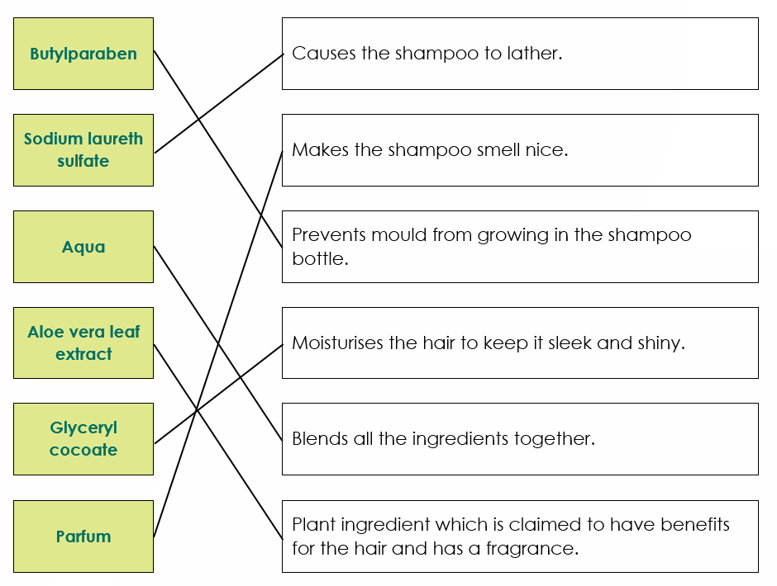

- Parfum and lavender oil are mixtures.

- The ‘all-natural’ brand does not comply with EU law.

Explanation

This is because the ingredients ‘aloe vera leaf extract’, ‘coconut oil’, ‘lemongrass herb oil’, ‘lemon peel’ and ‘lavender oil’ are not as they appear on the INCI list.
- Aloe vera leaf extract should be Aloe barbadensis leaf extract
- Coconut oil should be Cocos nucifera oil
- Lemongrass herb oil should be Cymbopogon flexuosus herb oil
- Lemon peel should be Citrus limon peel
- Lavender oil should be Lavandula angustifolia oil

- Sodium chloride and sodium lauryl sulfate.

Explanation
- Sodium chloride is listed using a chemical name. Sodium chloride is the chemical International Union for Pure and Applied Chemistry (IUPAC) name for common table salt.
- Sodium lauryl sulfate is also listed using it’s IUPAC chemical name. It is also known as sodium dodecyl sulfate.
- Aqua is Latin for water, it is not a chemical name. The simplest chemical name for water would be hydrogen oxide but the IUPAC also accepts oxidane and water.
- Citric acid is a common name. The IUPAC name for citric acid is 2-hydroxypropane-1,2,3-tricarboxylic acid.
- Coconut oil is also a common name. It is a mixture, so it does not have an IUPAC chemical name.

- None of the brands could be used without worry of irritation.
- The organic brand contains citral as a listed ingredient.
The all-natural brand contains lemon peel which is a citrus fruit. Citral is a main constituent of the peels of citrus fruits.

The high street brand contains parfum. Parfum is a mixture of chemicals which do not have to be listed separately. There is no way to tell from the ingredients list if this includes citral or not.

- Encourage learners to return to the article extract to support their contributions to the discussion. Some potential discussion points are listed here:
- Why does UK and EU law say that manufacturers should use official names on the INCI list instead of common names? Think about:
  - some ingredients may have multiple names for the same item,
  - the same ingredient may have different names in different countries and languages,
  - allergy sufferers may find it harder to identify allergens if the same name is not used consistently.
- Should companies be allowed to keep secrets to protect their fragrances and their products? What other options are there for allergy sufferers? There are products on the market advertised as ‘fragrance free’, are these more suitable for allergies and sensitivities?
- Are all of the ingredients in ‘organic’ certified products guaranteed to be organic? The ‘organic’ shampoo brand contains Cocos nucifera (coconut) oil, but it does not have an asterisk to say that it is from organic coconuts. Many of the other ingredients (sodium lauryl sulfate, glyceryl cocoate etc) also come from plants but are not listed as organic ingredients.
- How do we know that an ingredient is ‘safe’? Oak tree moss is an example of an ingredient that has only recently been added to a banned list in the EU, before that it was a common ingredient. Banned ingredients might not be the same in the UK, USA or in other areas. Individuals can react in different ways so an ingredient that is ‘safe’ during testing might not be ok for everyone in the wider population.
- What are chemicals? Does a chemical name mean that the ingredient is bad for you? Chemical names can be given to natural ingredients to identify them. Plant extracts and oils are mixtures of lots of chemicals which are not individually named on the ingredient list. Do you know what is in an extract and in what quantities?

