The preparation of 2-hydroxybenzoic acid

Learning objectives
- Use the following practical apparatus and techniques:
- Water bath or electric heater for heating.
- Quickfit® apparatus for heating under reflux.
- Filtration under reduced pressure.
- Safe handling of hazardous chemicals.
- Understand alkaline hydrolysis of esters.
- Calculate percentage yield.

Introduction

Many organic compounds are found in plants. 2-hydroxybenzoic acid (salicylic acid) can be made from methyl 2-hydroxybenzoate, which is obtained as oil of wintergreen by distillation from the leaves of Gaultheria procumbens.

Oil of wintergreen is 98% methyl 2-hydroxybenzoate. This oil can be hydrolysed by boiling with aqueous sodium hydroxide for about 30 minutes. The reaction produces sodium 2-hydroxybenzoate, which can then be converted into 2-hydroxybenzoic acid by adding hydrochloric acid.

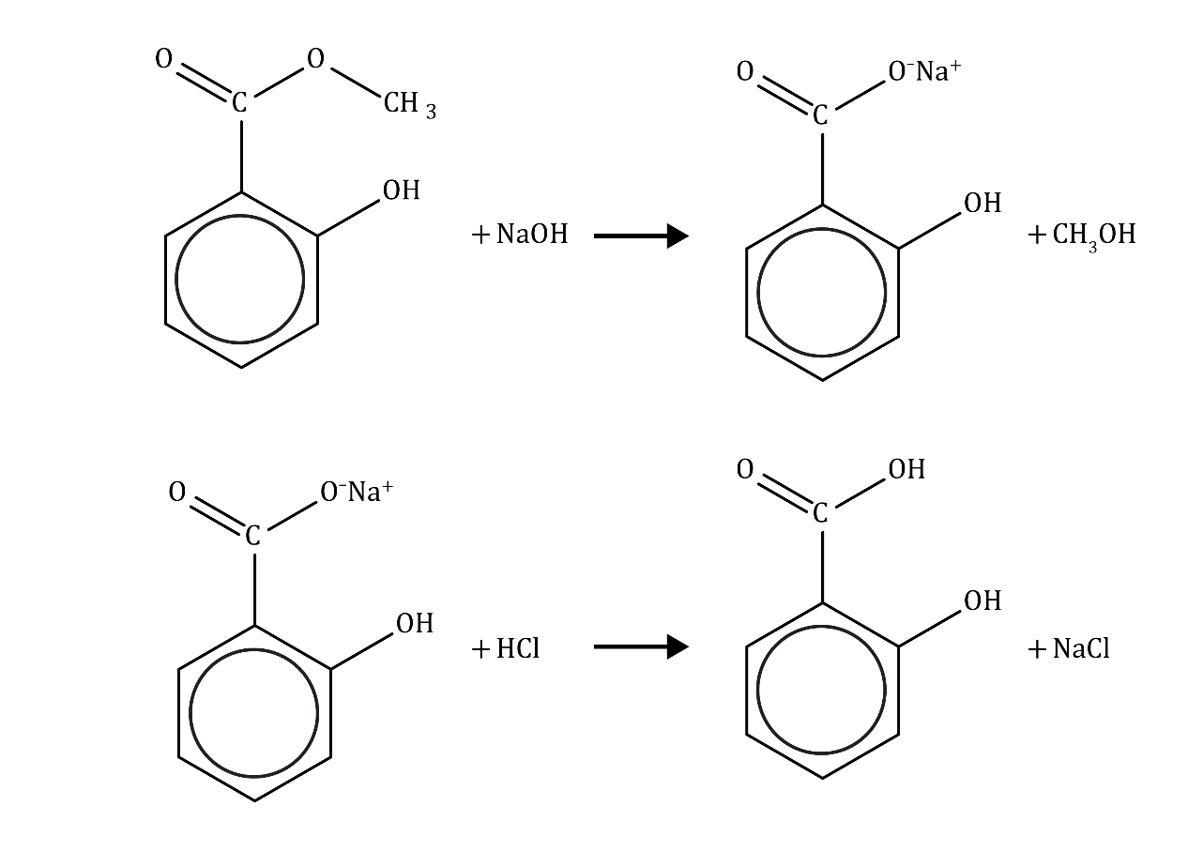

The process has three main stages:
- Heat the oil of wintergreen with aqueous sodium hydroxide. The reaction is quite slow, so you need to heat the mixture for 30 minutes. The heating is done under reflux to prevent the volatile reactants escaping. One of the products, methanol, is flammable so you cannot heat the flask directly with a naked flame.
- Neutralise the excess sodium hydroxide and convert the sodium salt of the product into the acid, which forms as a white solid.
- Separate the solid product from the reaction mixture and dry it.

Equipment

Apparatus
- 10 cm³ and 25 cm³ measuring cylinders
- Weighing balance, ±0.01 g
- 50 cm³ pear-shaped flask fitted with a reflux condenser
- Anti-bumping granules
- Water bath (eg 250 cm³ beaker) or an electric heater
- 100 cm³ beaker surrounded with ice and water in a larger container
- Dropping pipette
- Stirring rod
- Buchner flask and suction apparatus
- Watch glass

Chemicals
- Oil of wintergreen
- 2 mol dm^{–3} aqueous sodium hydroxide
- Concentrated hydrochloric acid
- Several pieces of litmus or universal indicator paper on a white tile
- Ice-cold water

Safety equipment
- Splashproof goggles
- Chemical resistant gloves should be available for anyone who may have a cut or graze on their hands and for all if necessary.

Ask your teacher and refer to CLEAPSS Student safety sheets SSS020, SSS026, SSS031, SSS065 for further details. These are available from bit.ly/3X8yi5A.

Check the risk assessment with your teacher and make sure that you fully understand it before you begin.

Procedure

Stage 1
- Set up the flask for heating using either a water bath or an electric heater.
- Attach the condenser vertically above the flask as shown in the diagram.

Get your teacher to check your apparatus and put on your safety goggles before you continue.

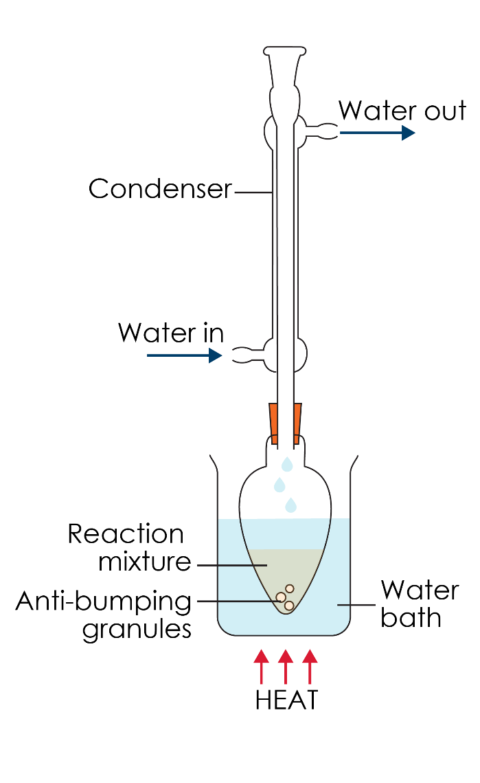
- Weigh a small measuring cylinder containing approximately 1.7 cm³ of oil of wintergreen.
- Detach the condenser, add the oil to the flask and then reweigh the empty measuring cylinder and calculate the exact mass of oil of wintergreen added (which should be about 2 g).
- Add approximately 25 cm³ of 2 mol dm^{–3} sodium hydroxide to the flask, taking care to avoid skin contact, along with a few anti-bumping granules.
- Reattach the condenser and check that the cooling water is on before heating gently under reflux for at least 30 minutes.
- Switch off the heat and allow the mixture to cool.

While the mixture cools make a list of the possible compounds present in the mixture.

Stage 2
- Pour the products into a small beaker surrounded by a mixture of ice and water.
- Add 2 mol dm⁻³ hydrochloric acid to the products dropwise, stirring all the time, until it is just acidic. Test for acidity by regularly touching the end of the stirring rod onto a piece of indicator paper.

Stage 3
- Weigh a clean watch glass and record the exact mass.
- Filter the product using a Buchner funnel and suction apparatus, as shown in the diagram.

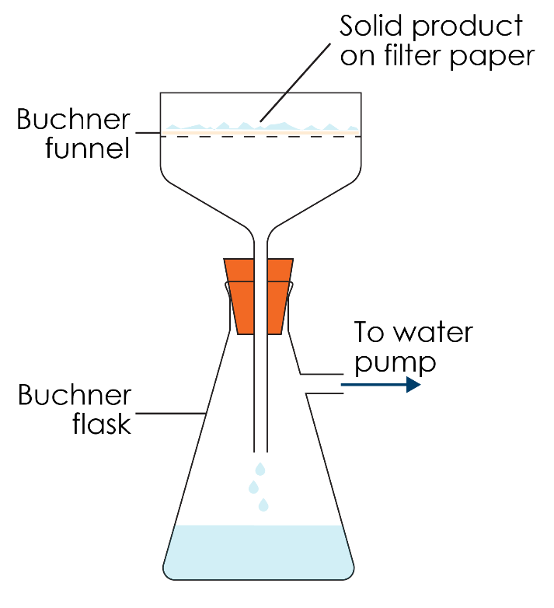
- Wash the product with a little ice-cold water and then transfer the solid to the watch glass.
- Allow to dry overnight.
- Reweigh the watch glass containing the dried product.

Questions

Include the answers to the following questions in your write up.
- How can you tell from observing the process in stage 1 that a new substance has been formed in the reaction?
- What has happened to the methanol formed in the reaction?
- Why do you need to keep the mixture cool while the acid is added in stage 2?
- What is oil of wintergreen used for nowadays? (You may recognise its smell.)
- Calculate the mass of oil of wintergreen used and the mass of product formed, which will allow you to calculate the percentage yield of 2-hydroxybenzoic acid.
- Suggest a method you could use to further purify the product and then check the purity of the final product.

