Equilibria

Dynamic equilibria

This question is about the equilibrium established between hydrogen, iodine and hydrogen iodide;
H₂ + I₂ ⇌ 2 HI
1.(a) If the system is at equilibrium, indicate whether the statements below are True or False; (6 marks)

The rate of the forward and backward reaction must be the same
……………………...……………….

The concentration of the reactants and products is the same
……………….

The equilibrium must have been established by reacting hydrogen with iodine
……………….

The system must be sealed
……………….

Iodine is purple in colour. Hydrogen and hydrogen iodide are colourless. Therefore as the iodine is used up, the colour of the system will gradually fade.
……………….

The pressure of the system will remain constant
……………….

(b) The diagram on the left below shows how the concentration of reactants and products changes when the equilibrium is established from an equimolar mixture of hydrogen and iodine. Draw an equivalent diagram on the axes on the right to show how the concentration of reactants and products would change if the equilibrium was established from pure hydrogen iodide under the same conditions.
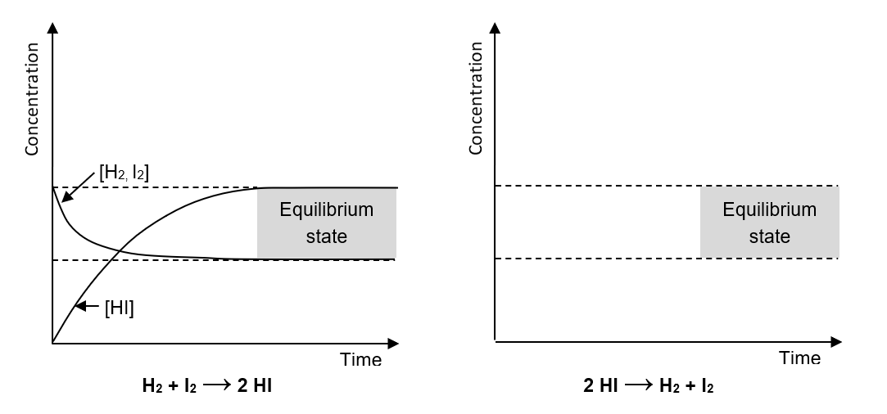
(4 marks)

Le Châtelier’s principle

Le Châtelier’s principle states that if a system at equilibrium is disturbed, the equilibrium moves in the direction that tends to minimise the disturbance.
Use Châtelier’s principle to suggest two disturbances that can be made to each of the equilibria below to bring about the desired changes;
(2 marks for each question)
1. Cl₂(aq) + H₂O(l) ⇌ HClO(aq) + HCl(aq)
Two disturbances which would result in a decrease in the concentration of chlorine are;

2. 4 HCl + O₂ ⇌ 2 Cl₂ + 2 H₂O ∆H –ive
Two disturbances which would result in an increase in the concentration of chlorine are;

3. PCl₅(g) ⇌ PCl₃(g) + Cl₂(g) ∆H +ive
Two disturbances which could be made without changing the amount of reagents or products in the system which would result in a shift of the equilibrium to the right are;

4. CH₂=CH₂(g) + H₂O(g) ⇌ CH₃CH₂OH(g) ∆H –46 kJ mol^{–1}
Two disturbances which would result in an increase in the percentage yield of ethanol are;

5. HCOOH + CH₃OH ⇌ HCOOCH₃ + H₂O ∆H 0 kJ mol^{–1}
Two disturbances which would result in no change in the position of the equilibrium are;

Equilibria and industry

A number of industrial processes involve reversible reactions. In these cases, Le Châtelier’s principle can be used to help find the best conditions for obtaining the maximum reaction yield.

- Decide which set of conditions A – C would result in the highest yield of the desired product for each of the equilibria (a) – (c) below;
(2 marks)
(a) Production of hydrogen iodide A: low temperature
H₂(g) + I₂(g) ⇌ 2 HI(g) ∆H +53 kJ mol^{–1} high pressure
(b) Making hydrogen B: high temperature
CH₄(g) + H₂O(g) ⇌ 3 H₂(g) + CO(g) ∆H +206 kJ mol^{–1} low pressure
(c) Production of methanol C: high temperature
CO(g) + 2 H₂(g) ⇌ CH₃OH(g) ∆H –91 kJ mol^{–1} pressure has no effect

- Another industrial process involving a reversible reaction is the production of sulphuric acid in the Contact Process. The first stage of the process is shown below;

2 SO₂(g) + O₂(g) ⇌ 2 SO₃(g) ∆H –196 kJ mol^{–1}
- i. Use Le Châtelier’s principle to explain why, at a given pressure, the percentage yield of sulfur trioxide increases with a lowering of the overall temperature.
(3 marks)

ii.To increase the rate of the reaction, a vanadium pentoxide catalyst is used. Explain what effect this has on the overall percentage yield of sulfur trioxide.
(2 marks)

- The reaction is run at pressures close to atmospheric pressure. Use Le Châtelier’s principle to explain why this choice of pressure is unexpected and give a possible explanation for why it is chosen.
(3 marks)

Equilibria – Answers

Dynamic equilibria
- (a)
- The rate of the forward and backward reaction must be the same – True
- The concentration of the reactants and products is the same – False (they remain constant)
- The equilibrium must have been established by reacting hydrogen with iodine – False
- The system must be sealed – True
- Iodine is purple in colour. Hydrogen and hydrogen iodide are colourless. Therefore as the iodine is used up, the colour of the system will gradually fade – False (the concentration of I₂ doesn’t change)
- The pressure of the system will remain constant – True (6 marks)
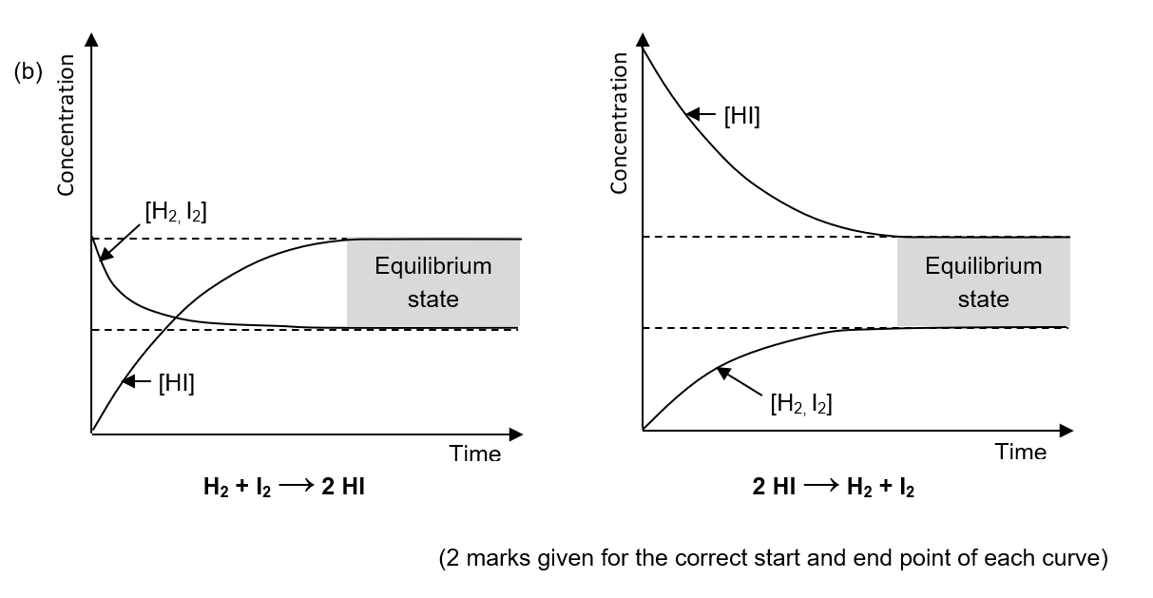
Dynamic equilibria
- Cl₂(aq) + H₂O(l) ⇌ HClO(aq) + HCl(aq)
Possible disturbances which would result in a decrease in the concentration of chlorine are removal of either of the products from the system or addition of water to the system.
(2 marks for any two)
- 4 HCl + O₂ ⇌ 2 Cl₂ + 2 H₂O ∆H –ive
Possible disturbances which would result in an increase in the concentration of chlorine are an increase in the concentration of either of the reactants, removal of water from the system or cooling the system.
(2 marks for any two)
- PCl₅(g) ⇌ PCl₃(g) + Cl₂(g) ∆H +ive
Two disturbances which could be made without changing the amount of reagents or products in the system which would result in a shift of the equilibrium to the right are increasing the temperature of the system or lowering the pressure of the system.
(2 marks for any two)
- CH₂=CH₂(g) + H₂O(g) ⇌ CH₃CH₂OH(g) ∆H –46 kJ mol^{–1}
Two disturbances which would result in an increase in the percentage yield of ethanol are a lowering of the temperature of the system or an increase in the pressure of the system.
(2 marks for any two)
- HCOOH + CH₃OH ⇌ HCOOCH₃ + H₂O ∆H 0 kJ mol^{–1}
Two disturbances which would result in no change in the position of the equilibrium are a change in system temperature or addition of a catalyst.
(2 marks for any two)

Equilibria and industry
- (a) Production of hydrogen iodide, Conditions C: high temperature and pressure has no effect
H₂(g) + I₂(g) ⇌ 2 HI(g) ∆H +53 kJ mol^{–1}
- Making hydrogen, Conditions B: high temperature and low pressure
CH₄(g) + H₂O(g) ⇌ 3 H₂(g) + CO(g) ∆H +206 kJ mol^{–1}
- Production of methanol, Conditions A: low temperature and high pressure
CO(g) + 2 H₂(g) ⇌ CH₃OH(g) ∆H –91 kJ mol^{–1}
(1 correct, 1 mark; all 3 correct, 2 marks)

- (a) i. The reaction is exothermic in the forward direction (1 mark). Therefore lowering the temperature of the system shifts the equilibrium in favour of the forward, exothermic reaction (1 mark) to return the temperature to its original value (1 mark). Therefore the percentage yield of sulfur trioxide is increased.
ii. Addition of a catalyst has no effect on the position of the equilibrium and therefore does not affect the overall yield (1 mark). This is because the catalyst speeds up the rate of both the forward and reverse reaction equally (1 mark).
(b) At low pressures the equilibrium is shifted to the side with the highest number of moles of gas (1 mark) in order to return the pressure to its original value (1 mark). Therefore at atmospheric pressures the yield of sulfur dioxide would be low. Higher pressures are not used because of the expensive equipment costs associated with running reactions at high pressures (1 mark).

