The chemistry of food
Contents
- Learning objectives
- Career link
- Activity 1: identifying food colourings in soft drinks
- Career link
- Activity 2: finding the vitamin C content of fruit juices
- Career link
- Activity 3: finding the iron content of food
- Career link
- Challenge questions

Acknowledgements
This resource was originally developed by Liverpool John Moores University to support outreach work delivered as part of the Chemistry for All project.
To find out more about the project, and get more resources to help widen participation, visit our Outreach resources hub: rsc.li/3CJX7M3.
Unless explicitly stated, all images are © Royal Society of Chemistry.

Learning objectives
By the end of this session, you will be able to:
- Carry out at least two analytical procedures successfully to obtain reliable results.
- Use a minimum of one set of results to calculate an unknown quantity.
- Summarise at least two careers linked to food that use chemistry.
Food technology
Food technologists research and develop new foods and drinks. Sometimes they improve the quality of existing products. They may also develop the processing, packaging, storage and safety of food in line with government and industry standards.
Flavourist and innovation director
Watch the video on slide 3 of the PowerPoint (also available from rsc.li/40V9mkh) of flavourist and innovation director, Claire. She uses her chemistry knowledge to develop flavours and technologies to make new food and beverage products.

Activity 1: identifying food colourings in soft drinks
To do
- Follow the method sheet to find the R_{f} values of the food colouring using thin layer chromatography (TLC). Complete the table with your results.
To calculate the R_{f} value for each food colouring you need to divide the distance travelled by the sample (spot) by the distance travelled by the solvent.
Food colouring | E number | Distance travelled by sample (D) | Distance travelled by solvent (S) | R_{f} value  (D$÷$S)
Tartrazine | E102
Brilliant blue | E133
Carmoisine | E122
Sunset yellow | E110
Patent blue V | E131
Green S | E142
Erythrosine | E127
Now you know the R_{f} values of the commonly used food colourings, you can test a range of soft drinks to see if these colourings are being used.

- Run a second TLC plate with extracts from the three soft drinks. Complete the results table to show which E numbers are present in each drink.
Soft drink name | Colours of spots present | Distance travelled by spot (D) | Distance travelled by solvent (S) | R_{f} value  (D$÷$S) | E number(s) present

- Write an email to the manufacturer of one of the soft drinks. Describe and explain the tests you carried out as a food analyst and what you found out about the food colourings present in their drink.
EMAIL
TO: ___________________________________________________________
FROM: ___________________________________________________________
SUBJECT: Artificial food colourings in a variety of drinks

Research and development
Learn about research and development careers by meeting Giorgia. Her job profile on slide 8, also available from rsc.li/3yaWIRc, explains how she uses her chemistry skills and knowledge to improve food safety and reduce food waste.

Activity 2: finding the vitamin C content of fruit juice
A juice manufacturer claims that their juice contains at least 25 mg (0.25 g) of vitamin C in every 100 cm³ juice. You are going to test this claim.
To do: titration
- Follow the method sheet to find the vitamin C content of the juice. Record your results in the table.
Type of juice tested ______________________________________
Volume of juice in conical flask (cm³) ______________________________________
Concentration of iodine solution ______________________________________ mol dm⁻³
Volume readings from burette | Trial run | Titre 1 | Titre 2 | Titre 3 | Titre 4 | Titre 5 | Titre 6
Start volume
(cm³)
Final volume
(cm³)
Total volume used (final $–$start) (cm³)

- Select three titres within $±$0.1 cm³ of each other and calculate the average titre value.
Titre (cm³) | Titre (cm³) | Titre (cm³)

Average titre value (cm³) | Average titre value (dm³)
To answer: calculating the molecular mass of vitamin C
- To find the relative formula mass (M_{r}) of a substance, you add together the relative atomic mass (A_{r}) for all the atoms shown in its chemical formula.
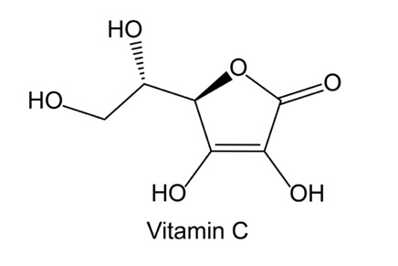
The molecular formula of vitamin C is C₆H₈O₆

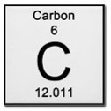
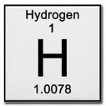
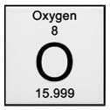
- Use the table to calculate the molecular mass of vitamin C.
(Note: all symbols are © Shutterstock)
Use these images from the periodic table to find the relative atomic masses (A_{r}) for each element and total mass of each element in vitamin C. Calculate the relative formula mass (M_{r}) of vitamin C by adding the total masses of each element together.
Name of atom | Number of atoms present | Relative atomic mass (A_{r}) | Total mass  (number of atoms × A_{r})
Carbon
Hydrogen
Oxygen
Relative formula mass (M_{r}) of vitamin C
- Complete these values:
M_{r} of vitamin C = ______________________________________
Concentration of I₂ = ______________________________________ mol dm^{–3}
Volume of I₂= ______________________________________ dm^{–3}

- Use the equation triangle to calculate the number of moles of iodine used in your titration:
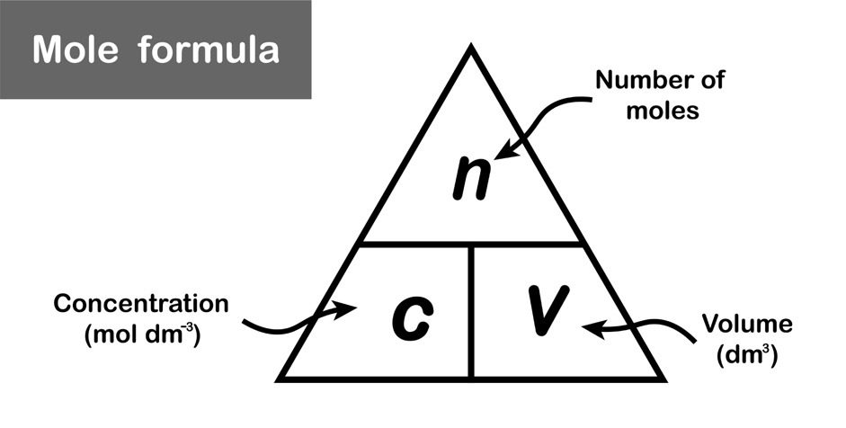

© Shutterstock

- First rearrange the equation:
number of moles of iodine (n) = _____________________ × _____________________
- Now insert the values from your titration into the equation:
number of moles of iodine (n) = _____________________ × _____________________
- Use the equation to find the reacting ratio of iodine to vitamin C molecules:
C₆H₈O₆(aq) + I₂(aq) → C₆H₆O₆(aq) + 2H⁺(aq) + 2I⁻(aq)
Ratio = _____________________ : _____________________
- Use the ratio to calculate the number of moles of vitamin C present in the 100 cm³ sample of juice used in your titration:
_____________________ moles

- Use the equation triangle to calculate the mass of vitamin C in 100 cm³:
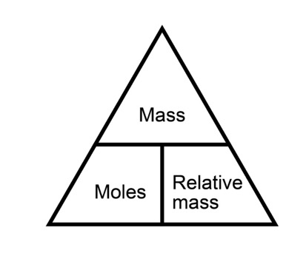

- First rearrange the equation:
mass of vitamin C = _____________________ $×$ _____________________
- Now insert the known values into the equation:
mass of vitamin C = _____________________ $×$ _____________________
= _____________________ mg vitamin C in 100 cm³
- Is the concentration of vitamin C in the juice in line with the manufacturer’s claim that it contains ‘at least 25 mg (0.25 g) of vitamin C in every 100 cm³ juice’?
Write the manufacturer an email to describe what you did and explain what you found in your investigation.

EMAIL
TO: ___________________________________________________________
FROM: ___________________________________________________________
SUBJECT: Finding the vitamin C content of fruit juice

Associate principal scientist
Watch the video job profile of associate principal scientist, Robert, on slide 13 of the PowerPoint or at rsc.li/3YmUlFS. He builds computer models to predict the effect of different chemicals on the taste and texture of sweet foods.

Activity 3: finding the iron content of food
You will find out how much iron is present in a range of foods by completing an analysis by visible absorption spectroscopy.
To do
- Follow the method sheet to measure the absorption of light (absorbance) in standard iron(III) chloride (FeCl₃) solutions.
Record your results in the table.
Dial position | Concentration of standard solution of FeCl₃ × 10^{–4} (mol dm^{–3}) | Absorbance (%)
B | 0
1 | 0.5
2 | 1.0
3 | 1.5
4 | 2.0
5 | 2.5

- Use your results to produce a calibration curve.
Calibration curve for standard FeCl₃ solutions
Absorbance (%)

Concentration (mol dm⁻³)

- Use the table to work out how much iron was in the food samples provided.
Food sample | Absorbance | Concentration  of iron  (× 10^{–4} mol dm^{–3}) | Conversion factor to use to find concentration  of iron in mg per  100 g of food | Concentration  of iron  (mg per 100 g  of food)
Broccoli |  |  | × 200 × 55.85
Spinach
Peas
To answer
- What do you think should be in the ‘blank’ cuvette, which is recorded as 0 mol dm^{–3} FeCl₃ solution?

- The recommended average daily iron intake in children and teens aged 12–19 is 13.7–15.1 mg per day. Do you think you are reaching this level? Give a reason for your answer.

- The table below shows the food eaten by a 14 year-old girl during a typical day.
 | Food | Iron content (mg)
Breakfast | 30 g Coco pops | 2.4
Lunch | Two slices of white bread with butter and jam  One banana | 1.8  0.31
Dinner | 100 g chicken  100 g French fries  50 g green peas | 1.3  0.8  0.75
Snacks | Chocolate bar  100 g potato crisps | 0.0  1.6
The recommended daily intake of iron for a 14 year-old girl is 15 mg.
- Calculate the current daily intake of iron for the 14 year-old girl. Is she eating the recommended daily amount?

- Use your experimental results, along with the table showing the iron content in foods, to design a diet plan for the girl to help her increase her daily intake of iron and reduce the risk of anaemia.
Think about the types of food she could add or swap for breakfast, lunch and dinner and the amount of iron these foods would provide.
Food | Serving / mass (g) | Iron content (mg)
Breakfast
Lunch
Dinner
Snacks

Iron content in food
Foods | Serving / mass (g) | Iron content (mg)
Cornflakes | 1 cup / 30 g | 3.6
Boiled egg | 1 / 50 g | 0.6
Wholemeal bread | 1 slice / 30 g | 1.0
White bread | 1 slice / 30 g | 0.9
Wholemeal pasta | 1 cup / 91 g | 3.3
Sweet potato | 1 potato / 130 g | 0.8
Brown rice | 1 bowl / 200 g | 1.0
White rice | 1 cup / 100 g | 1.6
Chicken | 230 g | 1.3
Lean beef | One palm-sized piece / 90 g | 2.8
Lentils | 1 cup / 180 g | 6.6
Nuts | ½ cup / 65 g | 5.0
Raisins | ½ cup / 70 g | 1.35
Spinach | 1 cup / 30 g | 1.5
Dried fig | 10 pieces / 85 g | 3.6
Pumpkin seeds | 28 g | 2.5
Dried longan (Chinese fruit) | ½ cup / 65 g | 3.5
Market development
Learn about Vikki’s role as a market development manager on slide 20 or at rsc.li/3moUx9I. She uses her chemistry skills and knowledge to develop food packaging materials that make food last longer, are more sustainable and help to reduce waste.

Challenge questions
- Titration question
A student carried out a titration to find the concentration of a solution of hydrochloric acid. A volume of 25.0 cm³ of hydrochloric acid solution was neutralised exactly by 34.0 cm³ of a potassium hydroxide solution with a concentration of 2.0 mol dm^{–3}.
The equation for the reaction is:
KOH(aq) + HCl(aq) → NaCl(aq) + H₂O(l)
- Describe the experimental procedure for the titration carried out by the student.

(4 marks)
- Calculate the number of moles of potassium hydroxide used.

Number of moles = ___________________________________________________
(2 marks)

- Calculate the concentration of the hydrochloric acid in mol dm⁻³.

Concentration = ___________________________________________________ mol dm^{–3}
(3 marks)
(Total = 9 marks)
- Chromatography question
Food colourings contain one or more food dyes. A student used paper chromatography to separate the dyes contained in food colourings. They placed three spots of three known food colourings (E, F and G) and one unknown food colouring (H) on the chromatography paper.
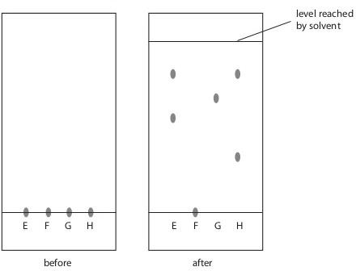
The diagram shows the appearance of the paper before and after the experiment.

- Describe how the student should complete the experiment after placing four spots on the plate.

(3 marks)
- Suggest why food colouring F did not move during the experiment.

(1 mark)
- How many food dyes are there in food colouring E?

(1 mark)
- How many known food dyes are there in food colouring H?

(1 mark)
Dyes are often identified by their R_{f} values:
R_{f} value = distance moved by dye $÷$ distance moved by solvent
- Record the results for dye G and calculate its R_{f} value.
Distance moved by dye (mm)
Distance moved by solvent (mm)
R_{f} value of dye G
(3 marks)
(Total = 9 marks)

