Fractional distillation and hydrocarbons: knowledge check
- The diagram shows crude oil being separated into fractions in a fractionating column.

Label the diagram to identify each of the fractions produced.

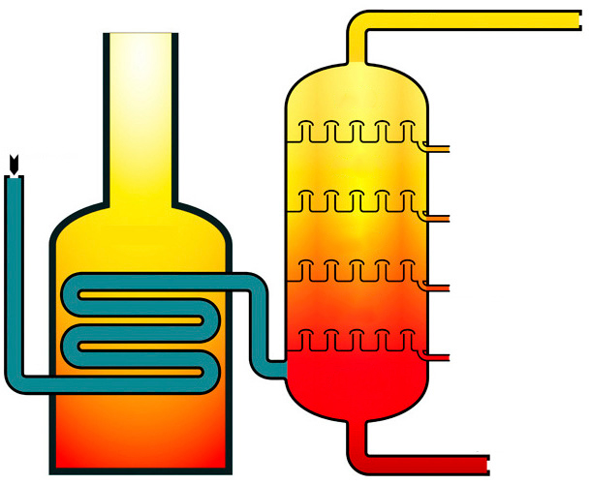
hot
cool
gas
furnace
crude oil

- Write a suitable ending for each of these sentence starters.
Crude oil contains __________________
Fractional distillation is used to separate __________________
During fractional distillation, the hydrocarbon fractions __________________
The hydrocarbons are separated according to their different __________________
The fractionating column is hotter at __________________
For questions 1.3 and 1.4 add the correct word or words to complete the sentences.
- The mixtures of hydrocarbons collected from the fractionating column are called __________________ .

Hydrocarbons are compounds containing __________________ and __________________ only.

The hydrocarbons in crude oil are mostly alkanes, which have the general formula __________________ .

For example, a molecule of ethane, which contains __________________ carbon atoms, has the formula __________________ .
- Small alkane molecules have weak ______________________________________ and low boiling points. They do not __________________ in the fractionating column and leave as ______________________________________________________________ .

Larger alkane molecules have __________________ intermolecular forces. Energy is needed to break the intermolecular forces, so alkanes with larger molecules have __________________ boiling points.
Fractional distillation and hydrocarbons: test myself
Answer questions 2.1 and 2.2 by circling the correct answer(s). There may be more than one correct answer in each question.
- Which two of the following formulas represent a hydrocarbon?
HCl
CO₂
C₂H₄
CH₃OH
C₆H₁₂O₆
CH₃COOH
C₅H₁₂
- Which alkane has the highest boiling point?
butane propane
ethane methane
- The hydrocarbons in the liquified petroleum gas fraction contain between one and four carbon atoms.

Give two properties of these hydrocarbons.

- Name two products that are produced in the incomplete combustion of methane.

- Write the general equation representing the complete combustion of a hydrocarbon.

- Propane, C₃H₈(g), undergoes complete combustion with oxygen gas, O₂(g). Write the balanced symbol equation, including state symbols, representing this combustion reaction.

Fractional distillation and hydrocarbons:
feeling confident?
- The diagram shows the apparatus used by learners during the fractional distillation of a crude oil alternative. During the experiment, the learners collected four different fractions.
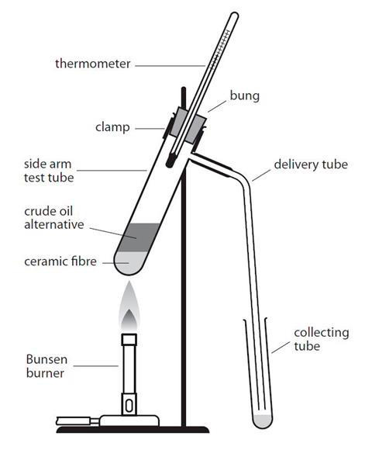

The table shows some of the observations recorded by the learners when they tested the properties of each fraction.
Fraction | Temperature range over which the fraction was obtained/°C | Colour | Viscosity | Ease of ignition
1 | 20–100 | very pale yellow
2 | 100–150
3 | 150–200 |  | doesn’t flow very easily | difficult to ignite
4 | 200–250 | brown

Make predictions about the missing observations and complete the gaps in the table.

- The table includes some of the names, molecular formulas and displayed formulas for the first four alkanes. Complete the table by adding the correct names, molecular formulas and displayed formulas.
Alkane | Molecular formula | Displayed formula
methane | CH₄ | 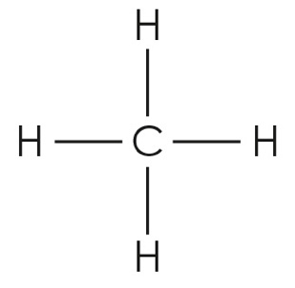
ethane
propane
butane | C₄H₁₀

Fractional distillation and hydrocarbons:
what do I understand?
Think about your answers and confidence level for each mini-topic. Decide whether you understand it well, are unsure or need more help. Tick the appropriate column.
Mini-topic | I understand  this well | I think I understand this | I need more  help
I can describe the process of fractional distillation.
I can explain why crude oil can be separated into fractions.
I can identify a hydrocarbon from its molecular formula.
I can write the general and molecular formulae for alkanes.
I can describe how the length of the hydrocarbon chain affects its boiling point.
I can compare the physical properties of the fractions.
I can compare complete and incomplete combustion.
Feeling confident? topics | I understand  this well | I think I understand this | I need more  help
I can predict the results of an experiment in which a crude oil alternative undergoes fractional distillation.
I can give the molecular and displayed formulas of the first four alkanes.

