Bonding

The nature of chemical bonds

Covalent dot and cross

Draw dot and cross diagrams to illustrate the bonding in the following covalent compounds. If you wish you need only draw the outer shell electrons;
(2 marks for each correct diagram)
1. Water, H₂O

2. Carbon dioxide, CO₂

3. Ethyne, C₂H₂

4. Phosphoryl chloride, POCl₃

5. Sulfuric acid, H₂SO₄

Draw dot and cross diagrams to illustrate the bonding in the following ionic compounds.
(2 marks for each correct diagram)

1. Lithium fluoride, LiF

2. Magnesium chloride, MgCl₂

3. Magnesium oxide, MgO

4. Lithium hydroxide, LiOH

5. Sodium cyanide, NaCN

Which type of chemical bond

There are three types of strong chemical bonds; ionic, covalent and metallic.

- Sort the compounds below into groups within the circles below according to their chemical bonding;

sodium chloride, NaCl | magnesium, Mg | magnesium oxide, MgO
methane, CH₄ | oxygen, O₂ | barium iodide, BaI₂
aluminium, Al | ammonia, NH₃ | caesium, Cs

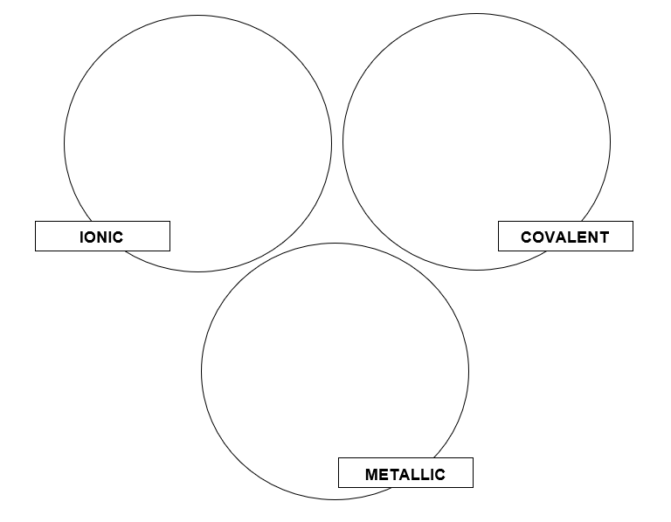

2. For each of the types of compound, indicate if you would expect them to;
(a) have a high or a low melting point
(b) conduct electricity

Bonding summary

A student has written the revision cards below to help her prepare for the exam. However she has made a number of mistakes. Can you correct her cards to make sure she has accurate information to revise from;
(1 mark for each correct correction made)

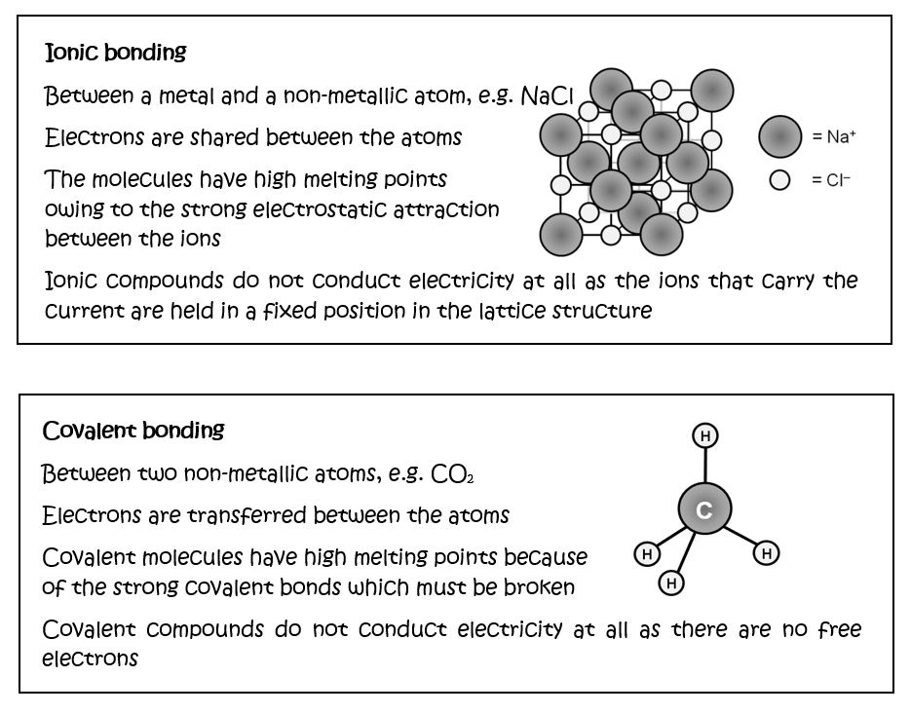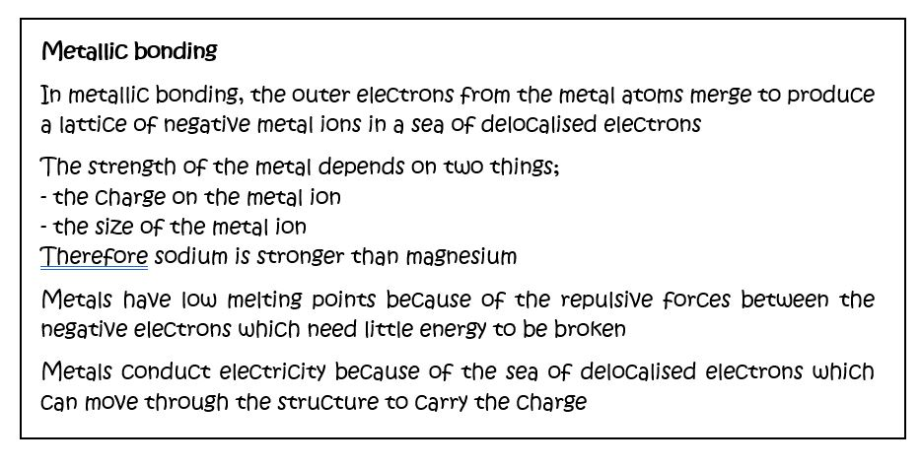

Co-ordinate bonding

By drawing dot and cross diagrams, decide which of the species below contain a co-ordinate or dative covalent bond in which both electrons in one of the covalent bonds is provided by a single atom.

1. H₂S (2 marks)

2. NH₄⁺ (2 marks)

3. H₃NBF₃ (2 marks)

4. CO (2 marks)

5. PF₃ (2 marks)

Electronegativity and polarity

A polar bond is a bond in which the electrons between the atoms that are bonded together covalently are shared unequally. The unequal share of electrons is usually shown by a δ+ and a δ– sign. If a molecule contains more than one polar bond, the effect of the polarity of all the bonds in the molecule may result in the molecule having a dipole moment.

Use the table of the Pauling electronegativity of different elements to identify any polar bonds in the molecules below. Then use these polar bonds to decide if the molecule has a dipole moment (this can be shown by an arrow with a line through it ; the head of the arrow points towards the negative end.)

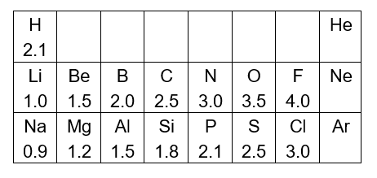
(2 marks per molecule)

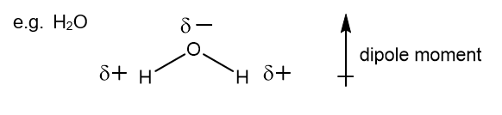
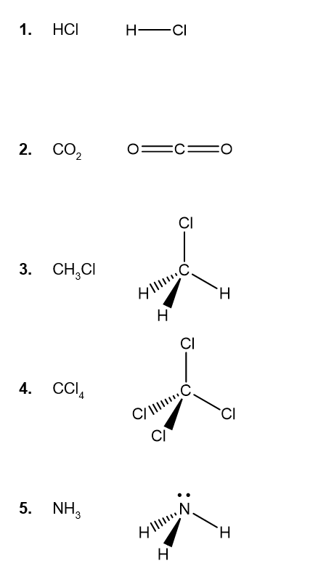

Intermolecular forces

Molecules are attracted to each other by weak intermolecular forces. There are three types of intermolecular force;
- Van der Waal’s forces
- Dipole-dipole forces
- Hydrogen bonding

For each group of molecules below, identify the strongest type of intermolecular force present in each molecule (1 mark) and then use this information to order the molecules according to their boiling point, from lowest to highest (1 mark).

1. CH₄ SiH₄ SnH₄

2. NH₃ PH₃ AsH₃

3. HF HCl HBr

4. CH₃F CH₃Cl CH₄

5. HF H₂O NH₃

Shapes of molecules

For this activity you need to work with a partner. The diagrams below show the 3 dimensional shapes of some different molecules. Your job is to describe the diagrams to your partner such that they can draw exact copies without seeing the original diagram. Good luck!
(2 marks awarded for each diagram your partner draws)

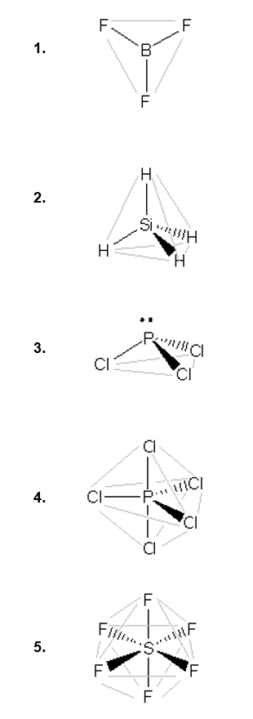

Properties and bonding

Match the compound on the left to its correct structure from the middle bank of statements and one or more statements from the column on the right. Aluminium has been done for you.

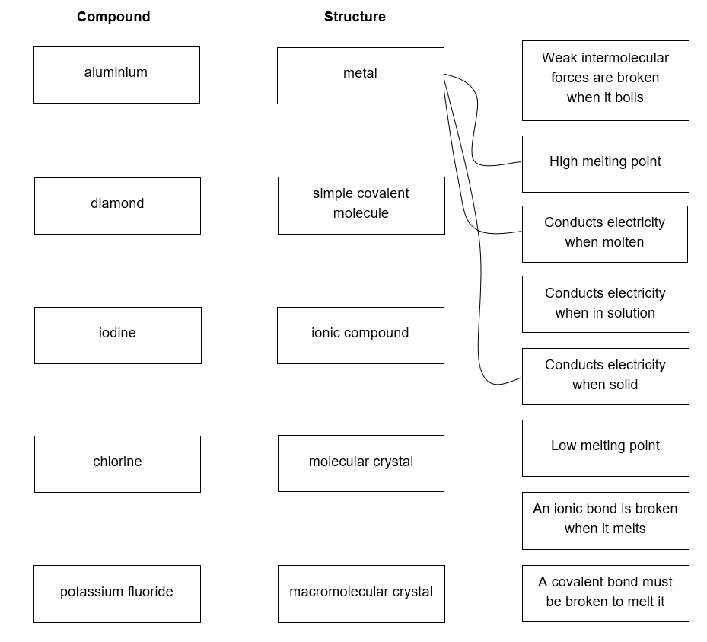

BONUS MARK Sketch the arrangement of molecules in a crystal of iodine

Bonding – Answers

The nature of chemical bonds

Covalent dot and cross

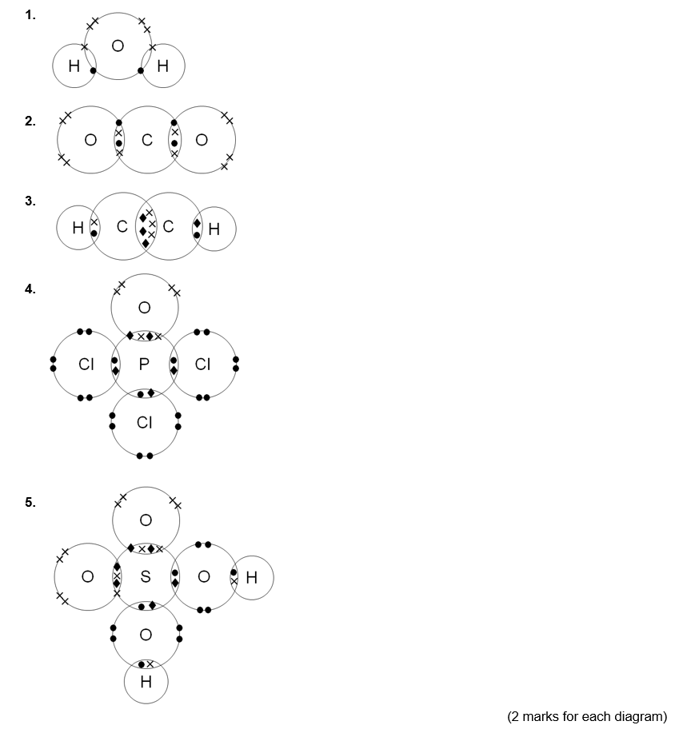

Ionic dot and cross
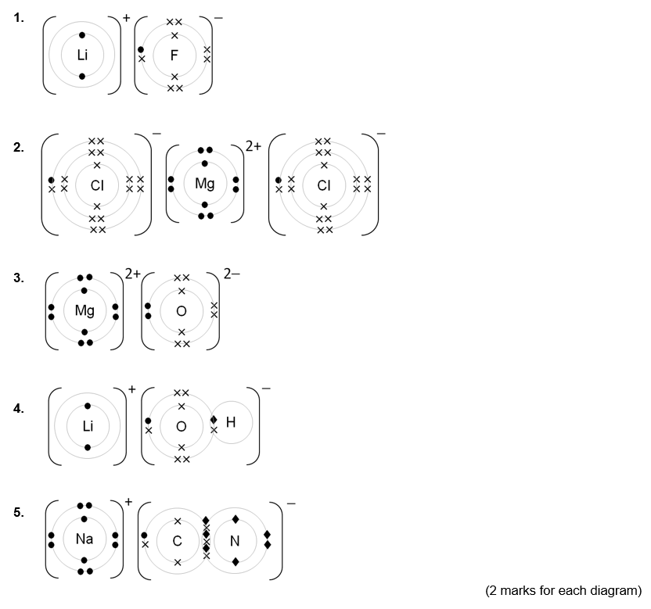

Types of chemical bond
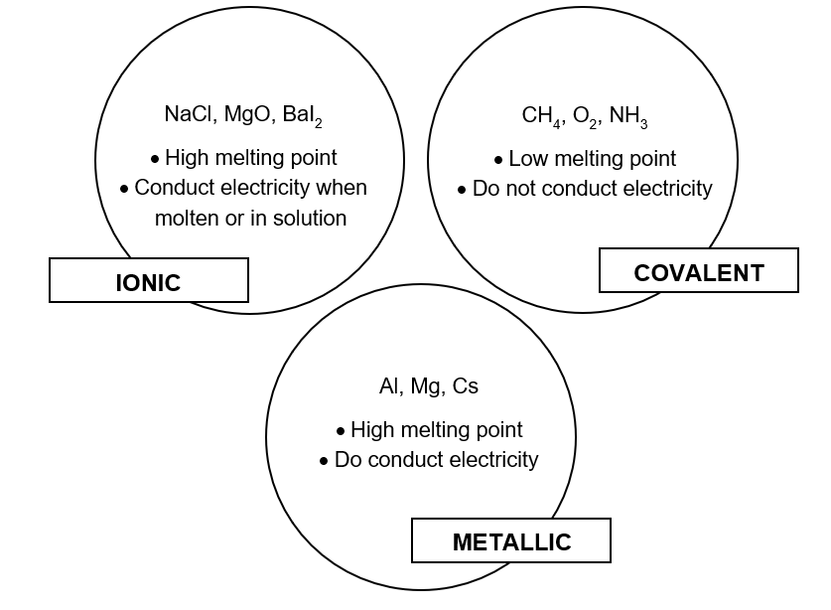
(1 mark for all three of each type correctly identified;
1 mark for each of the six comments relating to melting point / conductivity;
1 bonus mark for clarifying that ionic compounds only conduct when molten or in solution)

Bonding summary
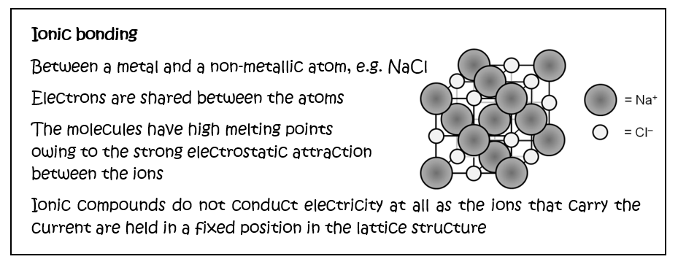
Corrections;
(1 mark) In the diagram the Na⁺ ion should be smaller than the Cl⁻ ion
(1 mark) Electrons are not shared but transferred between the atoms
(1 mark) Ionic compounds are NOT molecules
(1 mark) Ionic compounds can conduct electricity when molten or in solution

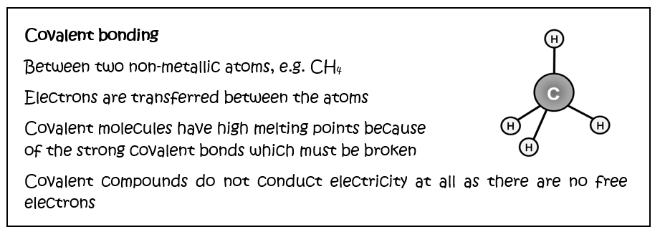
Corrections;
(1 mark) Electrons are shared between atoms not transferred
(1 mark) Covalent molecules have low melting points because……
(1 mark) Only weak intermolecular forces need to be broken (clarification of correction above)

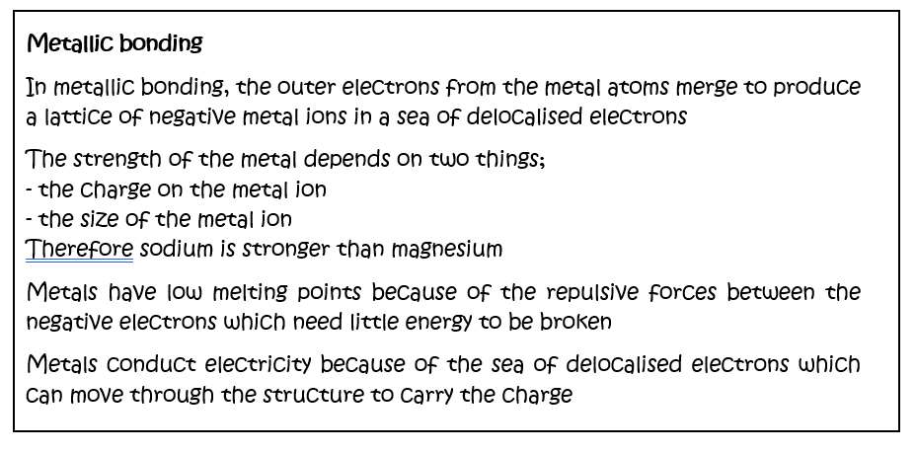
Corrections;
(1 mark) The metal ions are positive not negative
(1 mark) Sodium is weaker than magnesium (following on from the points raised)
(1 mark) Metals have high melting points because of the attractive forces between the positive metal ions and the delocalised sea of electrons.

Covalent bonding

Coordinate bonding

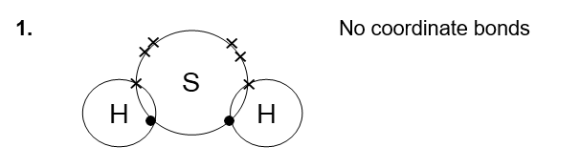
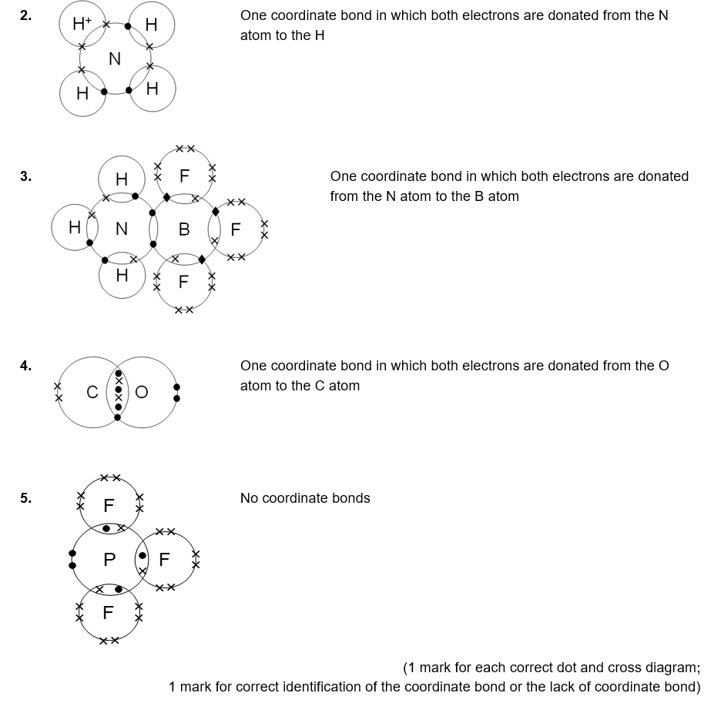

Electronegativity and polarity

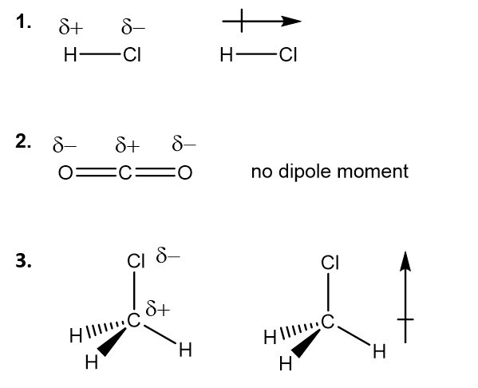
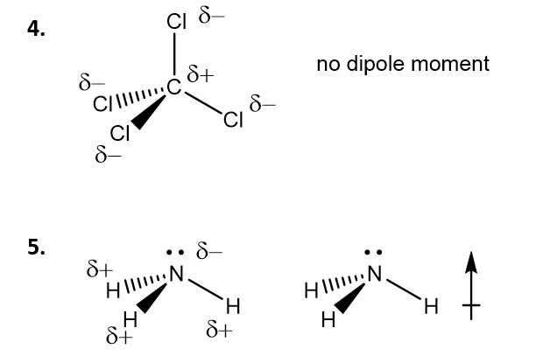

(1 mark for the correct placement of the δ+ and δ−;
1 mark for correct identification of the dipole moment)

Intermolecular forces
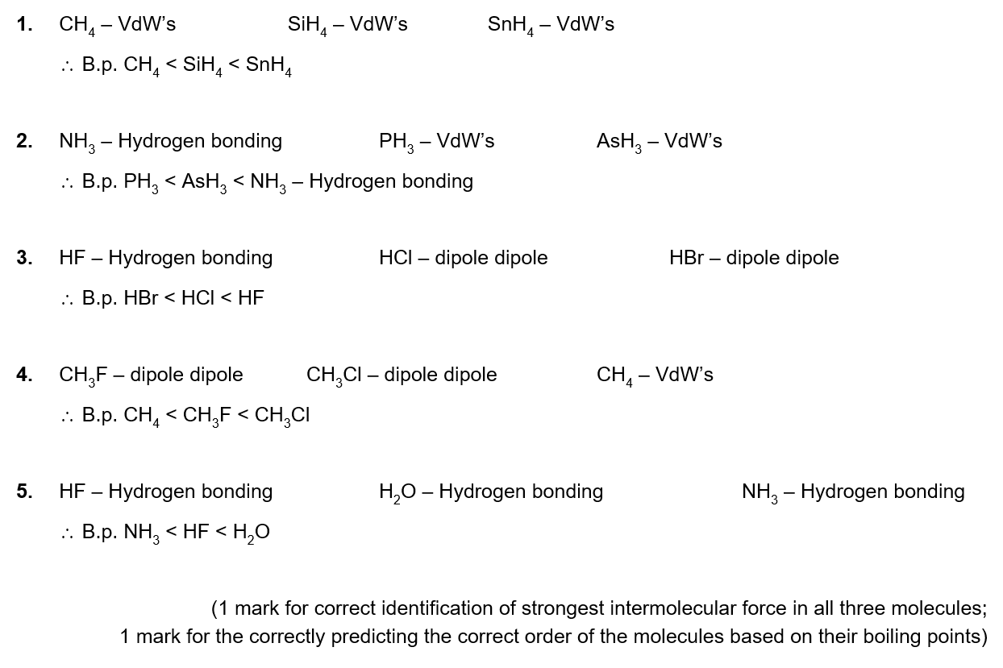

Shapes of molecules
2 marks allocated for the drawing of each molecule.

Properties and bonding
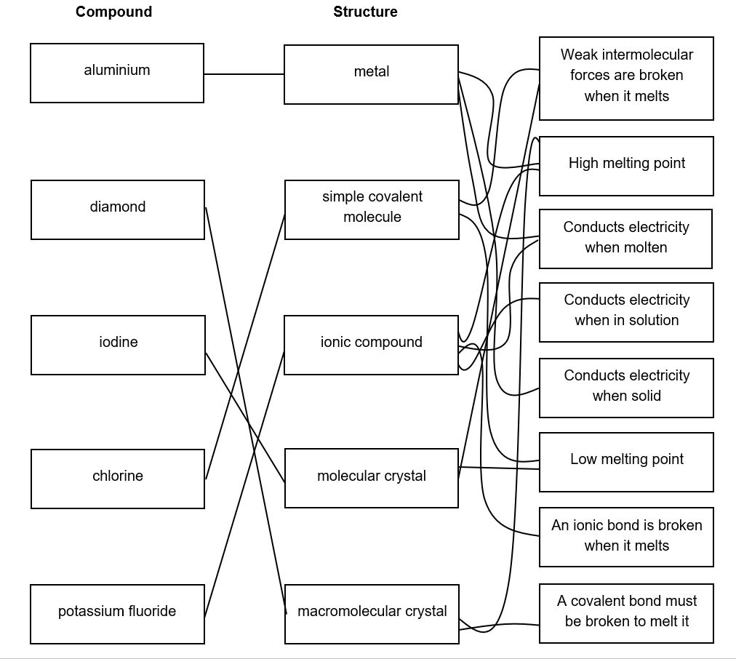

4 marks for the correct identification of the structure of each compound
5 marks for the correct statements (1 mark each for the correct identification of 2 correct statements for diamond, iodine and chlorine, 2 marks for the 4 correct statements for potassium fluoride)

1 Bonus mark;