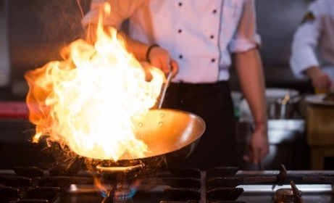
Flames in the kitchen!
Source: Envato Elements
This image shows a chef doing a flambé.

The chef does a flambé because it looks spectacular to watch, and it may add extra flavour to the meal. You can watch a video at https://youtu.be/Dt3vNIHntJY.

To carry out a flambé, a chef adds a drink that contains alcohol (ethanol) like a brandy or cognac to the pan. The high temperature of the pan causes the ethanol to evaporate and then catch fire.

It is important to select a drink that contains at least 40% by volume ethanol.
However, drinks with very high alcohol content are considered too dangerous to use by professional chefs.

Answer the questions below.
- The term flambé is a French word meaning to make a flame.
Complete the sentences to explain how a flame is made when carrying out a flambé.
Select the words from the box.
Words may be used more than once, once, or not at all.
evaporates liquid solidifies vapour ignites reacts heated

Answer: As the ethanol is heated, it evaporates to make ethanol vapour.
The ethanol vapour then is heated by the hot pan.
It then ignites or catches fire.
- The structure of an ethanol molecule is shown below.
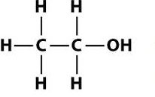

- State the names of the three elements that make an ethanol molecule.
Answer: Carbon, hydrogen and oxygen.
- State how many of each atom of each element is in an ethanol molecule.
Complete the table.
 | C atom | H atom | O atom
Number of atom type | Answer: 2. | Answer: 6. | Answer: 1.
- Use your answer to part b) to state the molecular formula of an ethanol molecule.
Answer: C₂H₆O
- Calculate the percentage of the atoms in a molecule of ethanol that are carbon atoms.
Give your answer to 1 decimal place.
Show your working.
Answer: Percentage of carbon atoms = $\frac{2}{9}$ × 100 = 22.2%
- In a flambé, which of the following reaction types takes place?
Tick one answer.

 |  | Tick one answer
A | Neutralisation
B | Decomposition
C | Combustion | Answer:
D | Condensation

- Complete the following equations that show what happens to ethanol in a flambé.
- A word equation
Answer: Ethanol + oxygen carbon dioxide + water

- A chemical equation
Answer: C₂H₆O + 3O₂ 2CO₂ + 3H₂O
- A chef wishes to use some cognac for her flambé.
The cognac contains 45% ethanol, by volume.
The volume of cognac in the bottle is 700 cm³.

Calculate the volume of ethanol in the bottle of cognac.
Show your working.
Answer: Volume of ethanol = $\frac{45}{100}$ × 700 = 31.5 cm³

Questions 6–10 are about the investigation below.
A student wishes to investigate how much heat energy is released when two different alcohols burn.
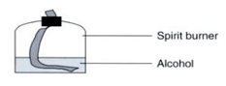
Her two alcohols are ethanol and propanol.

She uses each alcohol in a spirit burner like the one shown in the image.

Here is a list of the apparatus she uses:
- Spirit burners, one with ethanol and the other with propanol
- Thermometer
- Conical flask
- Tripod and gauze
- Measuring cylinder
- Balance

- Describe an investigation she could carry out that would enable her to work out which alcohol (ethanol or propanol) produces more heat energy.
You must use the equipment in her list, as well as any other extra equipment she may need.
You should also draw a diagram of how the equipment should be used and describe each step.

Answer:
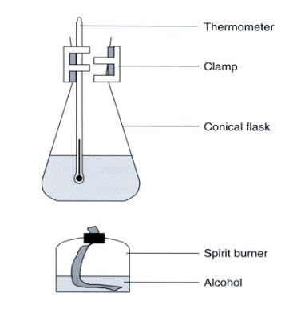
- She could record the mass of a spirit burner before and after burning.
- She could record the mass of a spirit burner before and after burning.
- Place the spirit burner underneath a tripod and gauze.
- Measure out a known volume of water and place into the conical flask.
- Record the start temperature of the water.
- Ignite the alcohol in the spirit burner.
- Allow the temperature of the water to increase by approximately 10 °C.
- Extinguish the flame on the spirit burner.
- Record the new mass of the spirit burner.

- Place the spirit burner underneath a tripod and gauze.
- Measure out a known volume of water and place into the conical flask.
- Record the start temperature of the water.
- Ignite the alcohol in the spirit burner.
- Allow the temperature of the water to increase by approximately 10 °C.
- Extinguish the flame on the spirit burner.

- Record the new mass of the spirit burner.

- She summarises her mass readings in the table below.
Complete the table.
 | Mass of spirit burner before in g | Mass of spirit burner after in g | Change in mass in g
Ethanol | 32.45 | 31.27 | Answer: 1.18.
Propanol | 33.56 | Answer: 32.19. | 1.37

- Her temperature measurements are recorded in the table below.
Complete the table.
 | Start temperature in °C | Final temperature in °C | Change in temperature in °C
Ethanol | Answer: 20.2. | 30.6 | 10.4
Propanol | 20.3 | Answer: 33.5. | 13.2

- She then concludes that propanol produces the most heat energy as it produced a larger temperature change.
Is she correct? Give a reason.
Answer: She is not correct.
She needs to take account of the mass burned of each fuel, so that a valid comparison can be made.

- a) Calculate the temperature change per gram of alcohol burned.
Use the two tables in questions 7 and 8 to help you.

Use the equation:

Temperature change per gram (in °C / g) = $\frac{temperature change in °C}{mass of alcohol in g}$

Give each answer to 1 decimal place.
For ethanol | Answer: Temperature change per gram = $\frac{10.4}{1.18}$= 8.8 °C / g
For propanol | Answer: Temperature change per gram = $\frac{13.2}{1.37}$= 9.6 °C / g

b) State which alcohol is the better fuel.
Explain your answer.
Answer: Propanol produces more heat per gram, so it would be the better fuel.

