Laser focus on early Earth’s oxygen

Original article by Kate Tustain. Adapted by Nina Notman.

Volcanic sulfur dioxide linked to rise in oxygen level in Earth’s early atmosphere

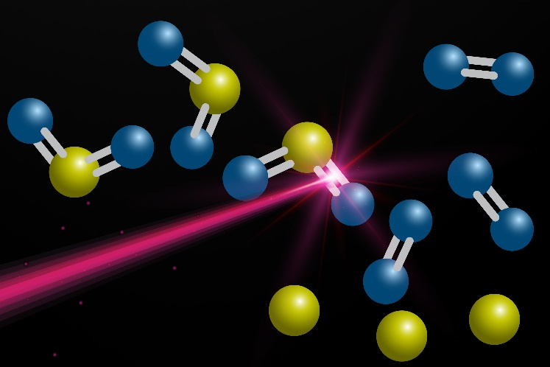
Firefighter clothing, spacecraft Volcanic eruptions that took place before the great oxidation event, during a period known as the Archean eon, produced large amounts of gaseous sulfur dioxide. While the possibility of this breakdown to produce oxygen has been studied before, its importance in relation to our current atmosphere was unclear. Kaijun Yuan and his team conducted extensive experiments using the intense vacuum ultraviolet free electron laser at the Dalian Coherent Light Source in China. This unique tool was instrumental in helping researchers precisely understand how molecules dissociated.

Source: Composite image including elements from © Getty Images and © Shutterstock

Recreating prehistoric ultraviolet radiation played a crucial role in understanding the formation of Earth’s early atmosphere

The scientists’ experiments showed that the dissociation of sulfur dioxide into oxygen and a sulfur atom was possible in the atmospheric conditions of that time. The team estimates that around 4.3% of our current atmospheric oxygen came from volcanic sulfur dioxide.

These findings may also have implications for our understanding of how sulfur dioxide behaves in the atmospheres of other planets and moons in our solar system.

This is adapted from the article Volcanic sulfur dioxide linked to oxygen level rise in Earth’s early atmosphere in Chemistry World. Read the full article: rsc.li/3RezdBs

