- This question is about the molecules in the table.
 | 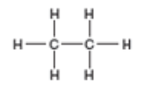 | 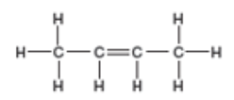 | 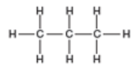
Alkane or alkene
Name of molecule
Molecular formula of molecule
- What do all of these molecules have in common?

Write your answers to parts b), c) and d) into the table.
- State which are alkanes and which are alkenes.

- Name each of the molecules.

- Write down the molecular formula of each molecule.

- Which molecule(s) react using addition reactions?

- What is the general formula for an alkene?

- This question is about ethane and ethene.
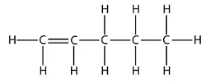
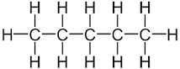
The structures of these molecules are shown below.
Pentene

Pentane

Which of these statements are true or false about these molecules?
Write your answers into the box – ‘T’ for true, and ‘F’ for false.
- The molecular formula for pentene is C₅H₁₀.

- Pentene is a saturated molecule.

- Bromine water can be used to distinguish between these two molecules.

- Pentene burns with a smokier flame than pentane.

- The carbon double bond in pentene makes it more reactive than pentane.

- Hydrogen gas will react with pentene to make pentane.

- Pentene could react with steam, in the presence of a catalyst, to form an alcohol called pentanol.

- When pentene reacts, its carbon double bond turns into a carbon single bond.

- This question is about the use of bromine water for testing for the presence of a carbon double bond.

Indicate the colour change seen when these molecules are added, separately, to bromine water.

Draw a straight line between the molecule and the correct colour change.
Colour change of bromine water
Butene

Stays orange
C₆H₁₄

Orange to colourless
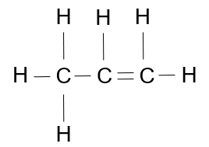

Colourless to orange

