The grand end of term quiz: answers
Education in Chemistry
January 2021
rsc.li/3pRcEmd

Round 1: science fiction

None of these chemicals are real, but who cares?
Q1. What colourful device would you power with a kyber crystal? A lightsaber
Q2. Captain America’s shield is made from which element? Vibranium
Q3. What can you make with lacewing flies, leeches, bicorn horn, knotweed, fluxgrass, boomslang skin and a strand of hair? Polyjuice potion from Harry Potter
Q4. What famous starship is powered by dilithium? USS Enterprise and many of the spaceships from Star Trek
Q5. Which upcoming movie starring Timothée Chalamet is about a battle over the spice Melange? Dune

Round 2: what’s happening?

Test your knowledge with these GCSE questions.
Q1. A hydrogen and a chlorine atom bond together, each contributing one electron to a shared pair. What type of bonding has occurred? Covalent
Q2. One atom of one isotope of calcium has an atomic number of 20 and a mass number of 42. How many protons does it have? 20
Q3. Chlorine has a boiling point of −35°C and a melting point of −101.5°C. What state would it be in if I cooled it to −20°C? Gas
Q4. How many times smaller is 1nm relative to 1cm? 10 million
Q5. Why do metals conduct electricity? They have delocalised electrons.
(In case you have covered different areas of the syllabus so far…)
Bonus questions
Q6. I need to separate two different coloured substances from each other. What technique should I use? Chromatography
Q7. I pour a solution through filter paper. What is the term for the particles left on the filter paper? Residue

Round 3: chememojis

Can you work out what term is lurking behind these symbols?

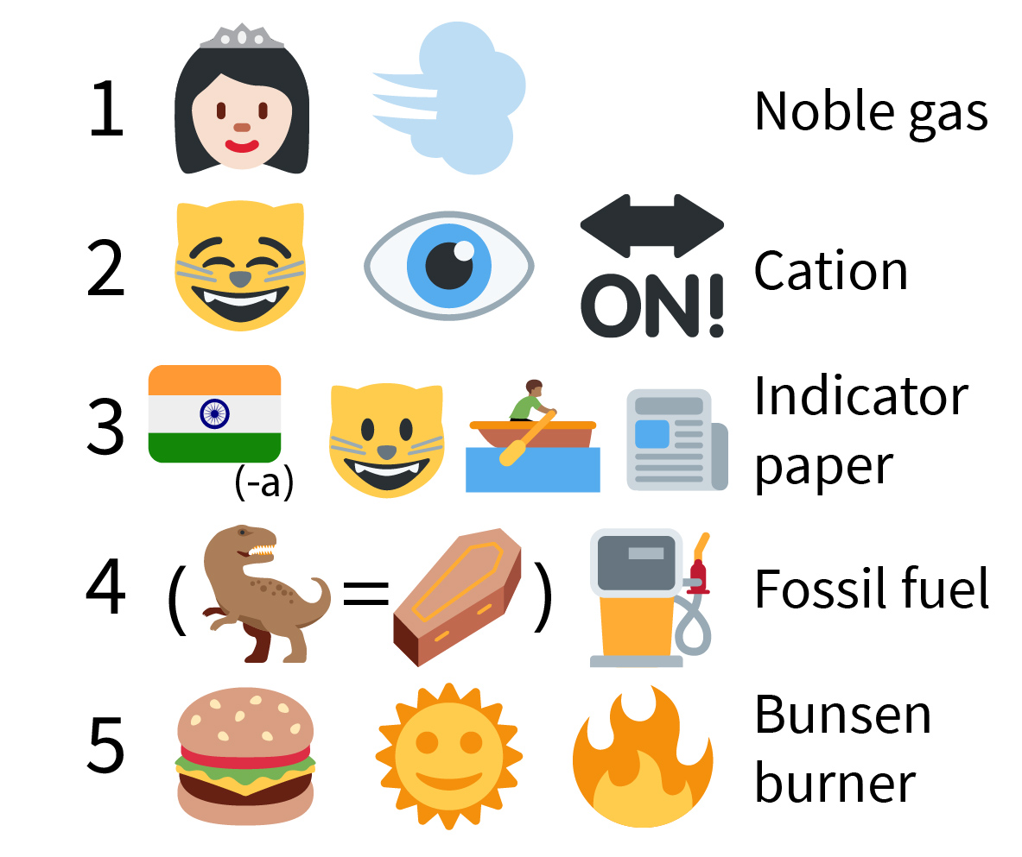

Round 4: name that element

Name the element being described in the question.
Q1. When combined with iron, I make mild steel. Carbon
Q2. I’m the most abundant element in the universe. Hydrogen
Q3. When two of me bond to oxygen, I make you laugh. Nitrogen
Q4. My chemical symbol is K, although the letter isn’t in my name! Potassium
Q5. When exposed to oxygen, I turn green. Copper

Round 5: current science

Have you been paying attention to science news?
Q1. In September, scientists found phosphine in a planet’s atmosphere, which could be evidence of alien life. On what planet did they make the discovery? Venus
Q2. What disease is caused by SARS-CoV-2? Covid-19 or coronavirus
Q3. Two letters of the alphabet aren’t in the name of any element on the periodic table. Name either of them. J and Q
Q4. What brand of washing powder shares its name with the European Space Agency's new space telescope? Ariel
Q5. 2019’s Nobel prize for chemistry was won for batteries typically used in laptops and smartphones. What chemical element do these batteries use? Lithium

Bonus round: musical elements

For advanced students only! Can you work out the artists sounded out by these elements’ symbols?
Q1. Lanthanum – Dysprosium – Gallium – Gallium LaDy GaGa – Lady Gaga
Q2. Tantalum – Yttrium – Lawrencium – Sulfur – Tungsten – Hafnium – Tellurium TaYLr SWHfTe – Taylor Swift
Q3. Sulfur – Americium – Samarium – Iodine –Thorium Sam SmITh – Sam Smith
Q4. Carbon – Argon – Dysprosium – Boron CArDyB – Cardi B
Q5. Boron – Tennessine BTs – BTS

