Plastics in energy-saving homes: context-based questions
This resource accompanies the article The science behind sustainable home insulation in Education in Chemistry which looks into the advantages and disadvantages of using plastics in our homes and can be viewed at: rsc.li/3GAhIoV

Learning objectives
- Review your knowledge and understanding of the synthesis and use of addition and condensation polymers.
- Review your knowledge and understanding of other linked topics: naming and formulas of organic compounds, environmental concerns from the use of organohalogen compounds, nucleophilic reaction mechanisms and intermolecular forces.
- Practise answering context-based questions using your knowledge, as well as unfamiliar information given in the question.
The questions are designed to be of a similar style to those learners meet in examinations at this level. A full mark scheme is provided below, although it is not an actual exam mark scheme, so it has not been checked against every response that might be worth some credit.

How to use this resource
This resource is based on the chemistry of the polymers and other compounds discussed in the article The science behind sustainable home insulation.
The resource is designed for learners to assess their current level of knowledge and understanding of polymers, as well as the other topics listed in the learning objectives. You can also adapt it as a starter assessment for more advanced learners who have studied some aspects of the topic in pre-16 courses.
Learners can attempt the worksheet individually or as a group (for example as a ‘think-pair-share’ activity). You can use the activity as exam practice, with a recommended time limit of 30 minutes.

Scaffolding
The questions cover a range of levels of demand. You can edit or replace any that do not match the required level of challenge or support for the learners in your class.
It is helpful if learners read the article before attempting the questions as this sets the context. However, any essential information not expected from their prior knowledge of chemistry is given in the questions.

Answers
Question |  | Answer | Notes | Marks
 | (a) |  | Allow delocalised benzene structure throughout.  Ignore brackets or ‘n’, as long as partial bonds are shown. | 1
 | (b) | 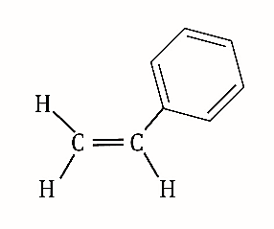 |  | 1
 | (c) | Addition. |  | 1

 | (a) | Any two of:  - CFCs produce chlorine radicals.  - Chlorine radicals catalyse/cause depletion of (stratospheric) ozone.  - Stratospheric ozone depletion allows harmful UV radiation to reach the earth’s surface. |  | 2
 | (b) | 1,1,1,2-tetrafluoroethane |  | 1
 | (c) |  |  | 1

Question |  | Answer | Notes | Marks
 | (a) | Electron pair donor (to an electron deficient carbon). |  | 1
 | (b) | 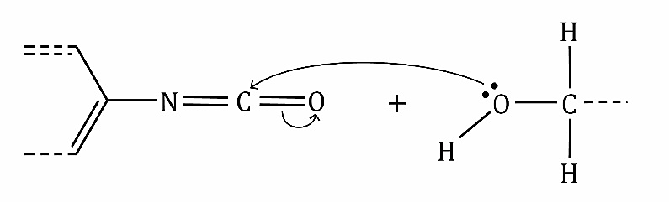  Lone pair on O.  Curly arrow from lone pair on O to C.  Curly arrow breaking C=O (or C=N) double bond. | Ignore any partial charges, intermediates or products. | 1  1  1

 | (a)  (i)  (ii) | Hydrogen bond(s).  Induced dipole-dipole/dispersion/London (forces). | Allow van der Waals’ forces. | 1  1
 | (b) | 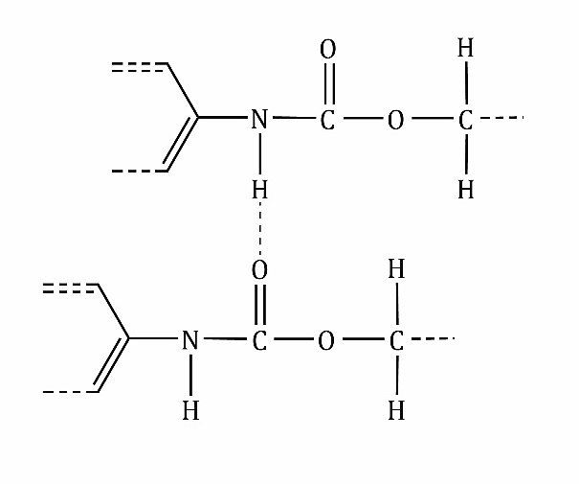 | Any bond from H of  C–H negates the mark.  Allow H of N-H to the singly bonded O.  Allow N–H --- O=C not in a straight line as long as not more than 45°. | 1

Question |  | Answer | Notes | Marks
 | (a) | 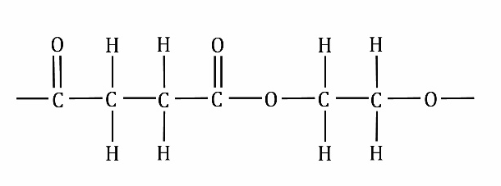  Ester linkage.  Rest of the structure. | Allow the singly bonded O at either end.  Ignore brackets or ‘n’, as long as partial bonds are shown. | 1  1
 | (b) | (Ester group) can be hydrolysed. |  | 1
 |  | Any three of:  Advantages of incineration:  - Produces some useful energy.  - Requires relatively little sorting of materials.  Disadvantages of incineration:  - Can release toxic gases into the atmosphere.  - Releases CO₂ and other global warming substances into the atmosphere.  - Uses up non-renewable raw materials, so not sustainable. | Allow any reasonable advantages or disadvantages.  For two or three marks, there must be at least one advantage and disadvantage given. | 3
 |  |  | Total marks | 20

Source: © Horners’ Charity Fund

