Acids and bases
pH and K_{w}

- Complete the table below showing some numbers and their common logarithmic values; (1 mark)
Number (n) | log₁₀ n
0.001 | ………..
0.1 | ………..
……….. | 0
……….. | 3

2. Calculate the pH (to 2 dp) of each of the solutions below: (3 marks)
[H⁺] =
3.50 × 10^{–3}
mol dm^{–3}
[H⁺] =
0.200 × 10^{–2}
mol dm^{–3}
[H⁺] =
1.00 × 10^{–10}
mol dm^{–3}
pH =
(c)
(b)
pH =
pH =
(a)

3. As water is always slightly ionised, we can write the following equilibrium for water;

H₂O(l) ⇌ H⁺(aq) + OH–(aq) ΔH = +ive

As only a very small amount of the water is ionised, we define a new equilibrium constant for this equilibrium called the ionic product of water, K_{w};

K_{w} = [H⁺(aq)] [OH–(aq)]

Like any other equilibrium constant, the value of K_{w} depends on the temperature of the equilibrium.

(a) Predict what effect increasing the temperature will have on the pH of pure water.
(1 mark)

(b) Calculate the pH of pure water (to 2 dp) at each of the temperatures below;
(i) 10 °C, K_{w} = 0.29 × 10^{–14} mol² dm^{–6}

(ii) 25 °C, K_{w} = 1.01 × 10^{–14} mol² dm^{–6}

(iii) 40 °C, K_{w} = 2.92 × 10^{–14} mol² dm^{–6}

(3 marks)
(c) Complete the paragraph below;

As the temperature decreases, water becomes (more acidic / less acidic / remains neutral).
Explain your answer
(2 marks)

pH and acids

1. Identify the species formed when the following act as acids;
(a) HCl x
(b) NH₄⁺ x
(c) HCO₃⁻ x
(3 marks)
2. Calculate the pH (to 2 dp) of the following acids;
(a) 0.25 mol dm^{–3} HCl (1 mark)
(b) 0.004 mol dm^{–3} NaHSO₄, K_{a} of HSO⁻₄ = 1.00 × 10^{–2} mol dm^{–3}
(2 marks)

3. Calculate the concentration of the following acids given their pH.
(a) HCl, pH 0.65 (1 mark)
(b) H₂SO₄, pH 2.61 (1 mark)
(c) CH₃COOH, pH 3.40, K_{a} 1.7 × 10^{–5} mol dm^{–3}
(2 marks)

pH and bases

1. Define;
(a) a Brønsted-Lowry acid

(1 mark)
(b) a Brønsted-Lowry base

(1 mark)

2. In the following acid-base reactions identify the reactant species (ion or molecule) acting as a Brønsted-Lowry base;
(a) 2 NH₃ + H₂SO₄ → (NH₄⁺)₂SO₄²⁻
(b) Ca(OH)₂ + H₂CO₃ → CaCO₃ + 2 H₂O
(c) Na₂CO₃ + 2 HCl → 2 NaCl + H₂O + CO₂
(3 marks)

3. Calculate the pH (to 2 dp) of the following basic solutions (take K_{w} to be 1.00 × 10^{–14} mol² dm^{–6});
(a) 0.150 mol dm^{–3} NaOH

(1 mark)
(b) 0.261 mol dm^{–3} Mg(OH)₂

(1 mark)

4. Calculate the concentration of the following basic solutions (take K_{w} to be 1.00 × 10^{–14} mol² dm^{–6});
(a) KOH, pH 11.00

(1 mark)
(b) Ca(OH)₂, pH 10.45

(1 mark)

5. Ethylamine is a weak base. Draw a curly arrow on the diagram below to show how the ethylamine acts as a base.
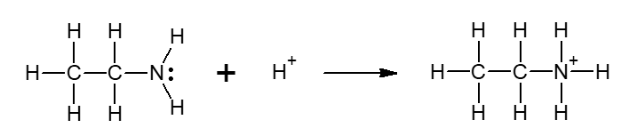

Acid-base tritrations
Some students are carrying out an investigation into the neutralisation reactions between strong acids and bases and weak acids and bases.
They titrate 25 cm³ samples of four different bases against four different acids as shown in the table below.
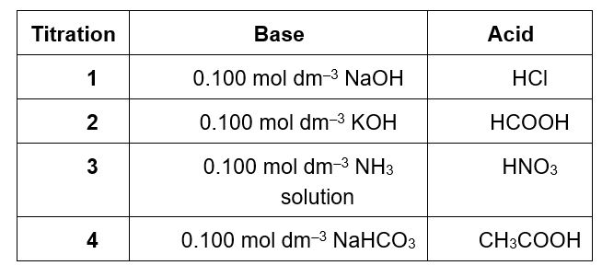
For each of the titrations 1 - 4;
(a) Choose the correct titration curve from those shown below,
(b) Name a suitable indicator for the titration,
(c) For titrations 1 and 2, calculate the concentration of the acid.

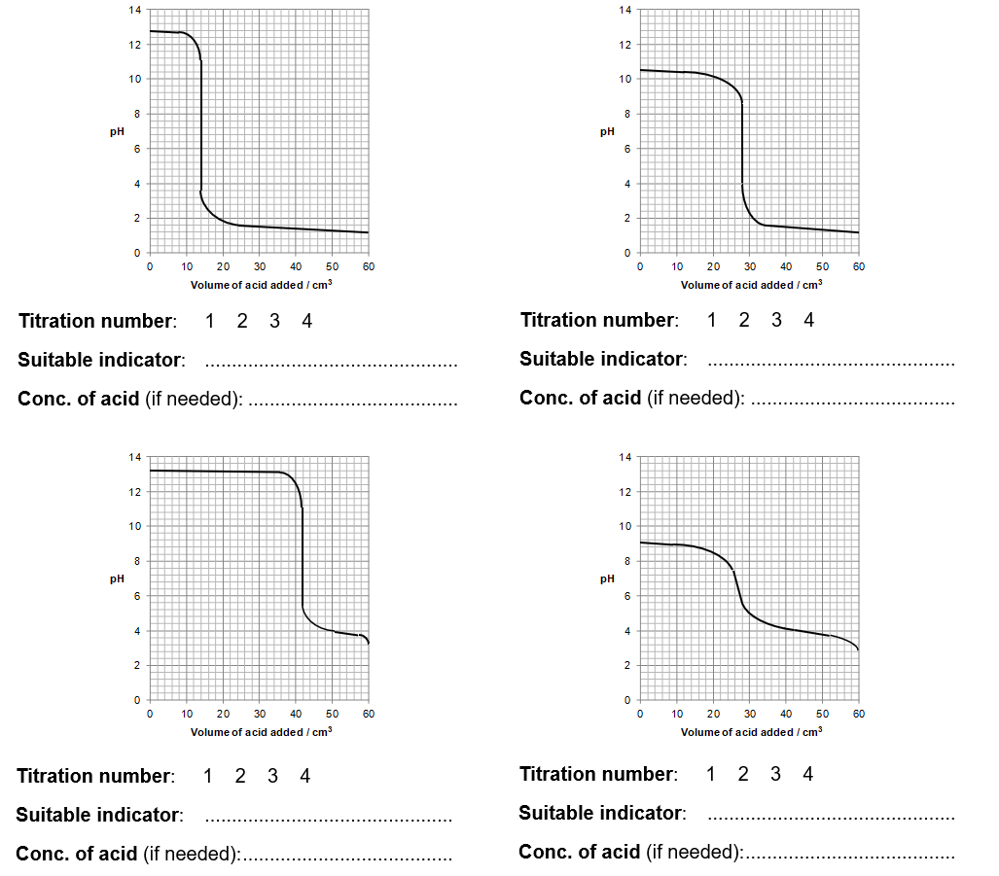

Buffer solutions

A buffer solution is a solution that resists a change in pH when a small quantity of acid or base is added.

1. (a) A buffer solution is made by mixing 0.510 mol of methanoic acid with 0.450 mol of sodium methanoate in 500 cm³ of water.
(i) Write an equation to represent the equilibrium established in the buffer solution.
(1 mark)

(ii) Calculate the pH of the buffer solution formed. (pK_{a} for methanoic acid = 3.75)
(3 marks)

(b) Explain how this buffer resists change in pH on;
(i) addition of a small quantity of acid.
(1 mark)

(ii) addition of a small quantity of base.
(1 mark)

2. Mark and Karen are carrying out a science project on the application of buffer solutions in the human body. They have discovered that a buffer of carbonic acid (H₂CO₃) and hydrogen carbonate (HCO₃⁻) is present in blood plasma to maintain a pH of between 7.35 and 7.45.

- They would like to recreate a similar buffer solution in the laboratory. In what proportions should they mix 0.150 mol dm⁻³ solutions of carbonic acid and sodium hydrogen carbonate to give a buffer solution with a pH of 7.40? (K_{a} for H₂CO₃ is 4.5 × 10⁻⁷ mol dm⁻³).
(2 marks)

- Why do you think buffer solutions are needed in the human body?
(2 marks)

More complex buffer calculations
Scientists wish to investigate whether certain bacteria can adapt to live in acidic conditions.
1. The scientists make up a buffer solution, by mixing 15.0 cm³ of a
0.100 mol dm⁻³ aqueous solution of NaOH with 35.0 cm³ of a
0.150 mol dm⁻³ solution of propanoic acid. Calculate the pH of the buffer solution formed.
(K_{a} for propanoic acid has the value 1.35 × 10⁻⁵ mol dm⁻³)

(4 marks)
2. The scientists wish to test if the solution formed is indeed a buffer solution and will resist change in pH on the addition of small quantities of acid or base possibly formed by the bacteria. They take two separate 10 cm³ aliquots of the buffer solution formed in question 1 and add;
(a) 0.5 cm³ of a 0.05 mol dm⁻³ solution of hydrochloric acid to one of the aliquots, and
(b) 0.5 cm³ of a 0.05 mol dm⁻³ solution of calcium hydroxide to the other aliquot.
Calculate the pH of each of the new solutions formed.

(6 marks)

Acids and bases – Answers

Number (n) | log₁₀ n
0.001 | –3
0.1 | –1
1 | 0
1,000 | 3
1. (1 mark for all numbers correct)

2. (a) pH = 10.00
(b) pH = 2.70
(c) pH = 2.46
(3 marks, 1 mark for each correct answer given to 2 dp)

3. (a) Ionisation of water is endothermic (ΔH +ive) so increasing the temperature will favour the forward reaction and hence the [H+(aq)] will increase. As a result the pH of the water will decrease as the temperature is increased.
(1 mark)
(b)
(i) 10 °C, K_{w} = 0.29 × 10^{–14} mol² dm^{–6}; [H⁺(aq)] = 5.39 × 10^{–8} mol dm^{–3} ∴ pH = 7.27
(ii) 25 °C, K_{w} = 1.01 × 10^{–14} mol² dm^{–6}; [H⁺(aq)] = 1.00 × 10^{–7} mol dm^{–3} ∴ pH = 7.00
(iii) 40 °C, K_{w} = 2.92 × 10^{–14} mol² dm^{–6}; [H⁺(aq)] = 1.71 × 10^{–7} mol dm^{–3} ∴ pH = 6.77
(3 marks)
- As the temperature decreases, water remains neutral
(1 mark)
Water is always neutral as [H⁺(aq)] = [OH–(aq)] and so there is always an equal number of H⁺ ions and OH– ions.
(1 mark)

pH and acids
1. (a) HCl → H⁺ + Cl–
(b) NH₄⁺ ⇌ H⁺ + NH₃
(c) HCO₃⁻ ⇌ H⁺ + CO₃²⁻
(3 marks)

2. (a) pH = –log[0.25] = 0.60
(1 mark)

(b) K_{a} = [H⁺][SO₄²⁻] = [H⁺]² ∴ [H⁺]² = (1.0 × 10^{–2}) × 0.004 = 4 × 10^{–5}
[HSO₄⁻] [HSO₄⁻] [H⁺] = 6.32 × 10^{–3} mol dm^{–3}
∴ pH = –log[6.32 × 10^{–3}]
∴ pH = 2.20
(1 mark for K_{a} expression, 1 mark for pH)

3. (a) [H⁺] = 10^{−0.65} ∴ [H⁺] = 0.22 mol dm^{–3} ∴ [HCl] = 0.22 mol dm^{–3} (1 mark)
(b) [H⁺] = 10^{−2.61} ∴ [H⁺] = 2.45 × 10^{–3} mol dm^{–3}
H₂SO₄ → 2 H⁺ + SO₄²⁻ and ∴ [H₂SO₄] = [H⁺]/2 = 1.23 × 10^{–3} mol dm^{–3}
(1 mark)

(c) CH₃COOH ⇌ H⁺ + CH₃COO– ∴ K_{a} = [H⁺][CH₃COO–] = [H⁺]²
[CH₃COOH] [CH₃COOH]
pH = –log[H⁺], ∴ [H⁺] = 10^{−3.40}, ∴ [H⁺] = 3.98 × 10^{–4} mol dm^{–3}
(1 mark)
∴ 1.7 × 10^{–5} = [3.98 × 10^{–4}]² / [CH₃COOH]
∴ [CH₃COOH] = 9.32 × 10^{–3} mol dm^{–3}
(1 mark)

pH and bases

1. (a) A Brønsted-Lowry acid is a proton donor
(1 mark)
(b) A Brønsted-Lowry base is a proton acceptor
(1 mark)
2. (a) 2 NH₃ + H₂SO₄ → (NH₄⁺)₂ SO₄²⁻ Basic species = NH₃
(b) Ca(OH)₂ + H₂CO₃ → CaCO₃ + 2 H₂O Basic species = OH–
(c) Na₂CO₃ + 2 HCl → 2 NaCl + H₂O + CO₂ Basic species = CO₃²⁻
(3 marks)
3. (a) [NaOH] = 0.150 mol dm^{–3} and ∴ [OH–] = 0.150 mol dm^{–3}
∴ 1 × 10^{–14} = [H⁺][0.150] and so, [H⁺] = 6.67 × 10^{–14} mol dm^{–3}
∴ pH = – log[6.67 × 10^{–14}] = 13.18
(1 mark)
(b) [Mg(OH)₂] = 0.261 mol dm^{–3} and ∴ [OH–] = 0.261 × 2 = 0.522 mol dm^{–3}
∴ 1 × 10^{–14} = [H⁺][0.522] and so, [H⁺] = 1.92 × 10^{–14} mol dm^{–3}
∴ pH = – log[1.92 × 10^{–14}] = 13.72
(1 mark)
4. (a) 11.00 = – log[H⁺] and ∴ [H⁺] = 1.00 × 10^{–11} mol dm^{–3}
∴ 1.00 × 10^{–14} = [1.00 × 10^{–11}][OH–] and so, [OH–] = 1.00 × 10^{–3} mol dm^{–3}
∴ [KOH] = 1.00 × 10^{–3} mol dm^{–3}
(1 mark)
(b) 10.45 = – log[H⁺] and ∴ [H⁺] = 3.55 × 10^{–11} mol dm^{–3}
∴ 1.00 × 10^{–14} = [3.55 × 10^{–11}][OH–] and so, [OH–] = 2.82 × 10^{–4} mol dm^{–3}
Since 1 mol of Ca(OH)₂ contains 2 mol OH–, [Ca(OH)₂] = 1.41 × 10^{–4} mol dm^{–3}
(1 mark)
5.
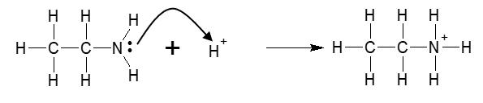 (1 mark)

Acid-base titrations
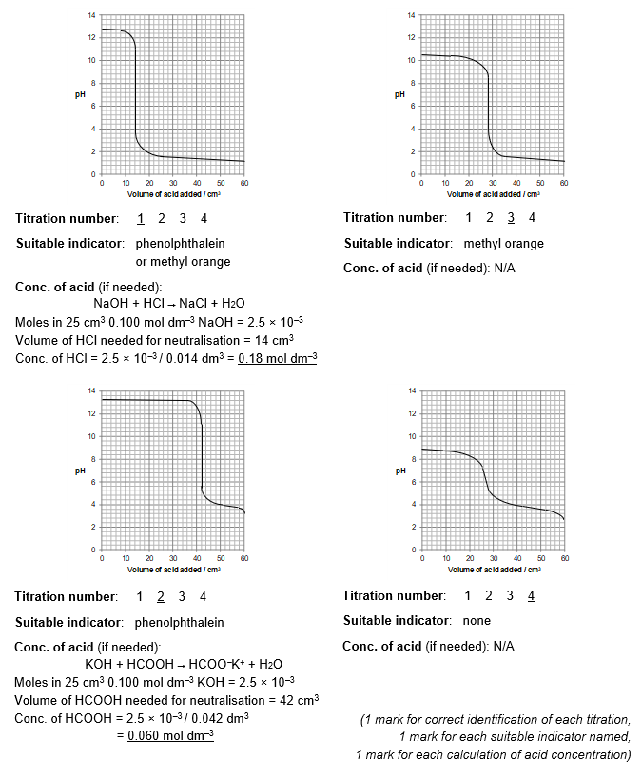

Buffer solutions

1. (a) (i) HCOOH(aq) ⇌ HCOO⁻(aq) + H⁺(aq)
(1 mark)
(ii) pK_{a} = − log K_{a}, ∴ K_{a} = 10^{−3.75} = 1.78 × 10⁻⁴ mol dm⁻³
(1 mark)
K_{a} = [HCOO⁻(aq)][H⁺(aq)]
[HCOOH(aq)]

[HCOO⁻(aq)] = 0.450 mol / 0.5 dm³ = 0.90 mol dm⁻³
[HCOOH(aq)] = 0.510 mol / 0.5 dm³ = 1.02 mol dm⁻³
Substituting these values in we get, 1.78 × 10⁻⁴ mol dm⁻³ = 0.90 × [H⁺(aq)] / 1.02
∴ [H⁺(aq)] = 2.02 × 10⁻⁴ mol dm⁻³
(1 mark)
∴ pH = 3.70
(1 mark)

(b) (i) On the addition of H⁺ ions, according to Le Châtelier’s principle, the equilibrium shifts to the left to remove the extra H⁺ ions added and maintain the pH approximately constant.
(1 mark)

(ii) On the addition of OH⁻ ions, the OH⁻ ions react with the HCOOH to produce water molecules and more HCOO⁻;
HCOOH + OH⁻ → HCOO⁻ + H₂O
This removes the OH⁻ and so the pH remains approximately constant.
(1 mark)

2. (a) H₂CO₃(aq) ⇌ HCO⁻₃(aq) + H⁺(aq)
pH of desired buffer = 7.40, so [H⁺(aq)] = 10^{−7.40} = 3.98 × 10⁻⁸ mol dm⁻³
(1 mark)
K_{a} = [HCO₃⁻(aq)][H⁺(aq)]
[H₂CO₃(aq)]

∴ [HCO₃⁻(aq)] = K = 4.5 × 10⁻⁷ mol dm⁻³ = 11.3
[H2CO3(aq) [H+(aq)] 3.98 × 10−8 mol dm−3 1

Since both stock solutions are of an equal concentration they should mix the two in a ratio of
11.3 : 1 HCO₂⁻ : H₂CO₃

(b) Many reactions in the human body rely on enzymes. Enzymes work only under very precise conditions. If the pH moves outside of a narrow range, the enzymes slow or stop working and can be denatured. Hence maintaining a constant pH is essential.
(2 marks)

More complex buffer calculations

- CH₃CH₂COOH + NaOH → CH₃CH₂COO–Na⁺ + H₂O
Moles of NaOH = 0.015 dm³ × 0.100 mol dm⁻³ = 1.5 × 10⁻³ mol
(1 mark)
∴ moles of CH₃CH₂COOH will decrease by 1.5 × 10⁻³ mol and moles of CH₃CH₂COO–Na⁺ will increase by 1.5 × 10⁻³ mol.
(1 mark)

 | CH₃CH₂COOH | ⇌ | CH₃CH₂COO– | + H⁺
Initial moles | 0.035 dm³ × 0.150 mol dm^{–3}  = 5.25 × 10⁻³ mol |  | 0 mol | 0 mol
Change in moles | − 1.5 × 10⁻³ mol |  | + 1.5 × 10⁻³ mol | ?
Equilibrium moles | 3.75 × 10⁻³ mol |  | 1.5 × 10⁻³ mol | ?

K_{a} = [CH₃CH₂COO–][H⁺] = (1.5 × 10⁻³ mol / 0.05 dm³) × [H⁺] = 1.35 × 10⁻⁵ mol dm^{–3}
[CH₃CH₂COOH] (3.75 × 10⁻³ mol / 0.05 dm³)
∴ [H⁺] = 3.38 × 10⁻⁵ mol dm^{–3}
∴ pH = 4.47
(1 mark)

- In a 10 cm³ aliquot (= 1/5 th) of the buffer solution made above;
moles of CH₃CH₂COOH = 7.5 × 10^{–4} mol; moles of CH₃CH₂COO– = 3.0 × 10⁻⁴ mol
(a) No. of moles of acid added = 0.0005 dm³ × 0.05 mol dm^{–3} = 2.5 × 10^{–5} mol
CH₃CH₂COO– + H⁺ → CH₃CH₂COOH
∴ moles of CH₃CH₂COOH will increase by 2.5 × 10^{–5} mol and moles of CH₃CH₂COO– will decrease by 2.5 × 10^{–5} mol.
(1 mark)

 | CH₃CH₂COOH | ⇌ | CH₃CH₂COO– | + H⁺
Initial moles | 7.5 × 10^{–4} mol |  | 3.0 × 10⁻⁴ mol
Change in moles | + 2.5 × 10⁻⁵ mol |  | – 2.5 × 10⁻⁵ mol | ?
Equilibrium moles | 7.75 × 10⁻⁴ mol |  | 2.75 × 10⁻⁴ mol | ?

∴ 1.35 × 10⁻⁵ mol dm^{–3} = (2.75 × 10⁻⁴ mol / 0.0105 dm³) × [H⁺]
(7.75 × 10⁻⁴ mol / 0.0105 dm³)
∴ [H⁺] = 3.80 × 10^{–5} mol dm^{–3}
∴ pH = 4.42
(1 mark)

(b) No. of moles of Ca(OH)₂ added = 0.0005 dm³ × 0.05 mol dm^{–3} = 2.5 × 10^{–5} mol
∴ no. of moles of OH– added = 2 × 2.5 × 10^{–5} mol = 5.0 × 10^{–5} mol
(1 mark)
CH₃CH₂COOH + OH– → CH₃CH₂COO– + H₂O
∴ moles of CH₃CH₂COOH will decrease by 5.0 × 10^{–5} mol and moles of CH₃CH₂COO– will increase by 5.0 × 10^{–5} mol.
(1 mark)
 | CH₃CH₂COOH | ⇌ | CH₃CH₂COO– | + H⁺
Initial moles | 7.5 × 10^{–4} mol |  | 3.0 × 10⁻⁴ mol
Change in moles | – 5.0 × 10⁻⁵ mol |  | + 5.0 × 10⁻⁵ mol | ?
Equilibrium moles | 7.0 × 10⁻⁴ mol |  | 3.5 × 10⁻⁴ mol | ?
∴ 1.35 × 10⁻⁵ mol dm^{–3} = (3.5 × 10⁻⁴ mol / 0.0105 dm³) × [H⁺]
(7.0 × 10⁻⁴ mol / 0.0105 dm³)
∴ [H⁺] = 2.7 × 10^{–5} mol dm^{–3}
∴ pH = 4.57
(1 mark)

