Electrolysis of brine in an improvised cell
Education in Chemistry
January 2018
rsc.li/EiC118-preciouswater
Class experiment, ages 14–16
In this experiment pupils work in pairs to construct a cell to carry out electrolysis as discussed in the article ‘Precious water’.
An improvised cell is easy to construct using margarine tubes, corks and carbon rods, and is very effective.
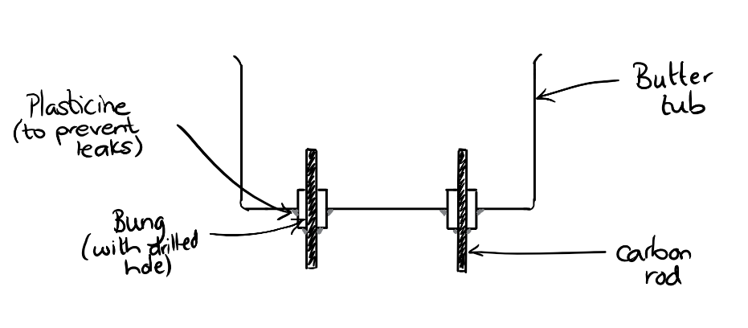
Materials needed:
- Butter/margarine tub
- 2 corks with pre-drilled holes
- 2 carbon rods
- Plasticine or a glue gun
- Circuit apparatus: power pack or battery (6 V is usually sufficient); wires; crocodile clips
- Brine
Pupils should run the electrolysis of brine solution for a few minutes and make their observations. Take care to make sure pupils turn off their power packs or disconnect their circuits to prevent large amounts of chlorine being released.
A further guide to the electrolysis of brine can be found on Learn Chemistry: rsc.li/Electrolysis-brine
Theory
- Ions are attracted to the opposite electrode. After the initial electrostatic attraction, the ion movement is actually due to diffusion.
- As water is present in the solution, this is also electrolysed giving H⁺ and OH– ions.
- Both Na⁺ and H⁺ ions are attracted to the negative electrode. However, the element with the lower position in the reactivity series is the one discharged. So, hydrogen gas is produced.
- At the negative electrode, 2H⁺ + 2e– H₂. The presence of H₂ can be confirmed with a lit splint in the ignition tube of gas.
- At the positive electrode, 2Cl– Cl₂ + 2e–. The presence of Cl₂ can be confirmed by a characteristic smell. It is not advised to collect the gas.
The theory of electrolysis can be difficult for pupils. This activity might highlight many misconceptions from earlier work on atomic structure, reactivity and bonding.
Further details on chemicals from salt can be found on Learn Chemistry.
Historical context about salt mining in the UK can be found on the site of the Winsford salt mine.

Debate cards
Once they have had chance to make their own observations, provide lab partners with debate cards containing statements that represent ideas about what is happening in the cell. These ideas may be present in a class but perhaps not articulated. Then, discussing the ideas as a whole class. This could be followed up with homework where pupils annotate the debate cards with their own ideas.
There are bubbles forming on top of the carbon rods.
That must be a physical change like evaporation.

There is a smell like swimming pools so chlorine must be being produced.

The sodium ions are making sodium which is reacting with the water
and producing hydrogen.

The ions in the brine are attracted to the electrode with the opposite charge
- a bit like magnets.

The bubbles coming from each electrode are different sizes.
Different gases must be being produced.

The brine is mostly water so the gases produced could be hydrogen and oxygen from splitting up water.

Sodium can’t be being produced at one of the electrodes as sodium sets on fire when it reacts with water.

When universal indicator is added the water turns purple which means there is an alkali. Alkalis have OH⁻ ions so something must be happening to the water.

