Properties of stereoisomers– teacher notes

Topic
Stereochemistry

Timing
5 minutes

Procedure
In this experiment, students detect the differences in smell of each enantiomer absorbed on cotton wool inside small sample bottles.
To prepare these;
- Place a small quantity of cotton wool into each bottle.
- Add 10 drops of the stereoisomer.
- The bottles can then be passed around the classroom.
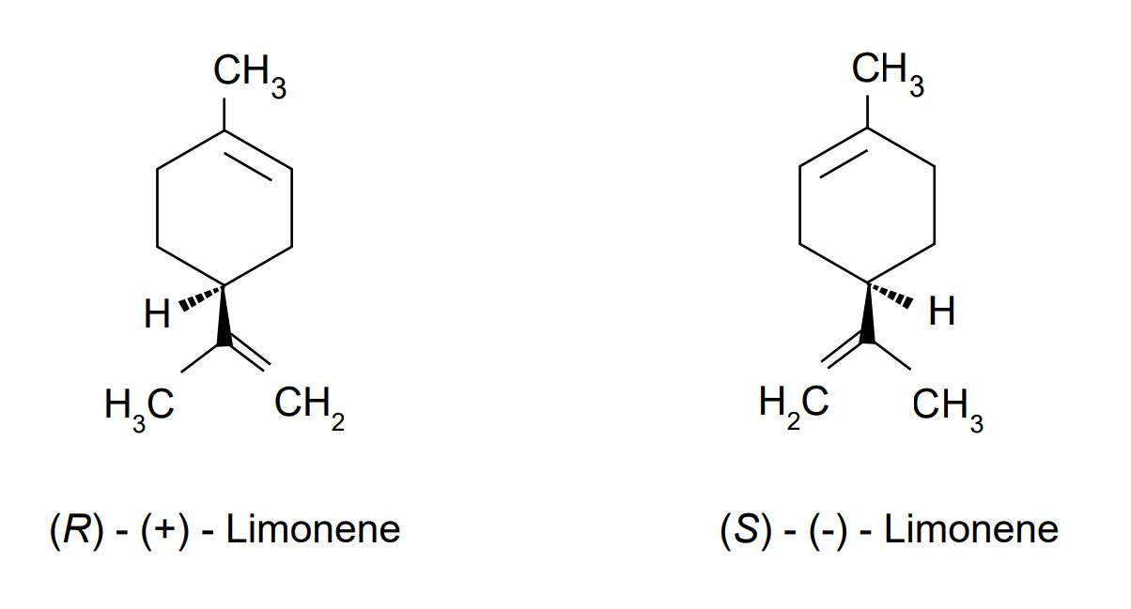

Apparatus
- Plastic bottles x2
- Cotton wool

Chemicals
- (R)-(+)-Limonene
- (S)-(–)-Limonene

Extension
Students could obtain small quantities of (R)-(+)- limonene in natural fruits by carrying out steam distillation of the peel of citrus fruits such as oranges and lemons and comparing the odours against the standards.
However, the S-(-) isomer is scarce in citrus fruits: pine needles might be a good source, but the presence of other terpenes might make it hard to separate.

Health, safety and technical notes
- Read our standard health and safety notes here https://rsc.li/3fJh126
- Students must wear eye protection if carrying out steam distillation.
- Not needed for sniffing the stereoisomers.

