Monitoring local pollutant levels
Education in Chemistry
Sustainability in chemistry 2021
Goal 11: make cities and human settlements inclusive, safe, resilient and sustainable
rsc.li/2UhW9EO
This resource shows how learners can access and evaluate real-time data about pollutants in their local area to make the teaching of this topic at age range 14–16 more relevant for them and their future. Extension questions are provided to use the activity for age 16–18 learners.

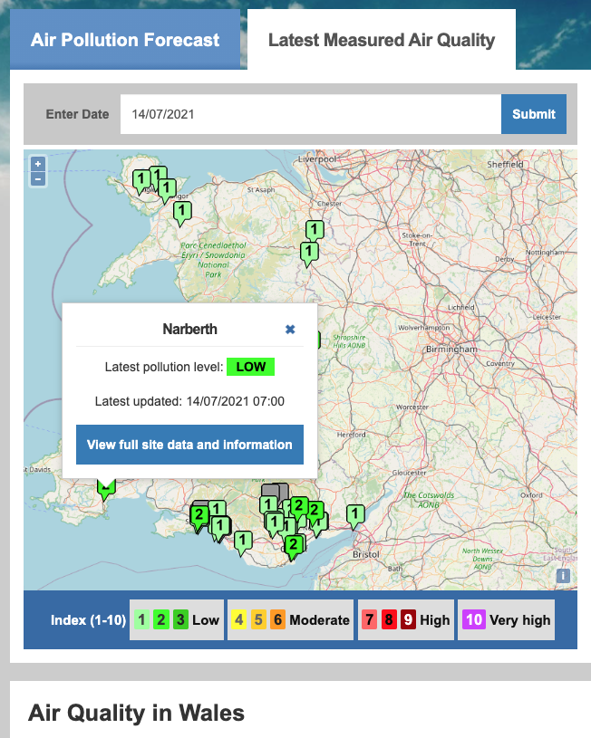
Where to find the data

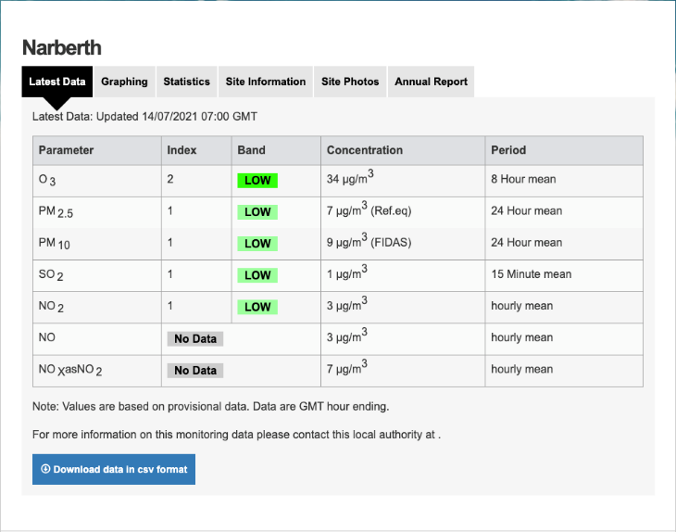
There are a number of websites that you can use (see next page). They all offer an interactive map like the one shown here for Wales. You can click on a particular site of interest to access the data for that site.

The data immediately available by this method will usually be a snapshot of the current levels of different pollutants for the latest reading taken by the monitoring site. If you want to save the data, you can download it in *.csv format that will open in most spreadsheets where you can do further analysis.
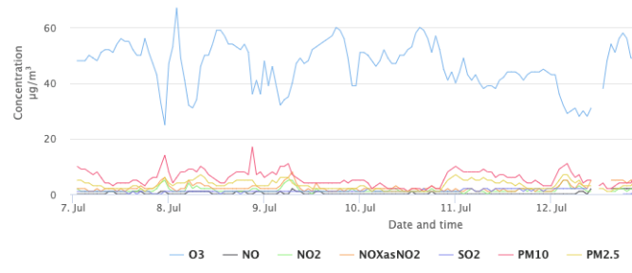
Using this type of data students could explore, for example, the difference in pollutant levels between urban and more rural sites in the region where they live.
The sites also offer some on-screen graphs showing changes in pollutant levels over specified time periods, although the sites vary as to the time periods that they provide.

The table below shows where you can find pollution level data for your students across the UK and Ireland.
Data provider | Website for the interactive map | Area covered
DEFRA (UK Government) | https://uk-air.defra.gov.uk/interactive-map | All of the UK
EPA (Irish Government) | https://airquality.ie/ | Republic of Ireland
Regional governments for the UK | https://www.airqualityengland.co.uk/ | England
 | http://www.scottishairquality.scot/latest/ | Scotland
 | https://airquality.gov.wales/ (Click on the ‘Latest Measured Air Quality’ tab) | Wales
 | https://www.airqualityni.co.uk/ | Northern Ireland

To investigate the effects of initiatives to improve air quality, it is necessary to access data over a longer period of time. For a given monitoring site, you can select a whole year or more for the UK and up to a month for Ireland. However, doing this can produce a very large amount of data, as readings are typically taken a number of times every day. Some of the sites do offer average readings for each day to save having to simplify the data manually in a spreadsheet.
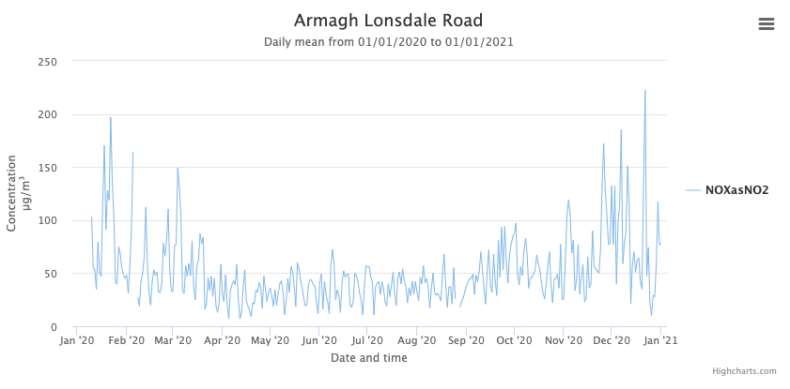
For example, this graph shows the average daily level of nitrogen oxides recorded by a monitoring site in Northern Ireland over the period January 2020 to January 2021. You can clearly see the effect of the lockdown from April to August due to the Covid-19 pandemic in reducing the pollutant level.

Teacher notes on the activity
With air pollution currently responsible for 9% of deaths globally, we must reduce it if we are to meet the requirement of Goal 11 for our cities to be safe in the future. It is important to monitor levels of key pollutants to see how well initiatives such as congestion pricing zones and electric vehicles are affecting air quality.
The following activity will give you a chance to look at current and historical levels of the pollutant nitrogen dioxide in the town or area where you live.
- Go to the online interactive map of monitoring sites for [insert region here] which can be found here [insert URL of air quality site for your region]. You can use this QR code for quick access on your device.
Edit the worksheet to point students to the region and air quality data site local to them (see the table on the previous page). If you want to create a QR code like the one shown here, go to https://goqr.me/ or a similar site and type in the URL you need them to access.
- On the map, find the monitoring station nearest to your home and click on its label to see the most recent levels of nitrogen dioxide and other pollutants. Note the time that this data was recorded.
It might be a good idea to demonstrate to the class how to select a monitoring station and access the detailed data before they try it for themselves.
- Compare the most recently recorded concentration of nitrogen dioxide in μg/m³ at your local site with the daily air quality index scale below.
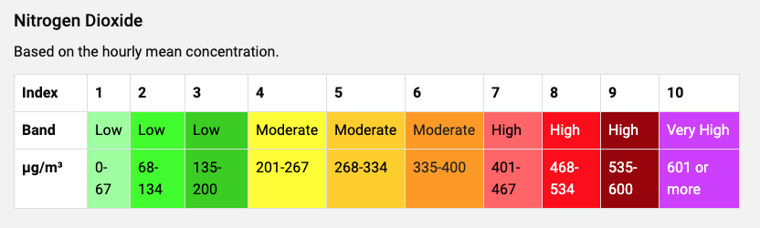
Note that low levels are considered safe for all, while moderate levels may cause health problems for those with heart or lung conditions. High and very high levels may cause health problems for anyone. See: https://uk-air.defra.gov.uk/air-pollution/daqi for more detail on the levels.
Be sensitive when discussing the effects of nitrogen dioxide, as some students might have personal experience of someone with health problems related to heart and lung conditions.
- Use the interactive map again and find the nitrogen dioxide levels for some different situations. Here are some examples of comparisons you can make.
  - Choose a different monitoring site that is more urban or more rural than your local site.
  - Choose a different time of day when there might be more or less road traffic at your local site.
  - Choose the same time of day at your local site on different days in the last week or month.
Suggest explanations for the differences in nitrogen dioxide levels between the chosen situations.
This is an opportunity for students to take ownership of the task and have some choice in what they investigate. Alternatively, you might want to guide groups of students to different comparisons that they can feed back to the whole class.
- The World Health Organisation (WHO) has set a guideline maximum annual mean daily value of 40 μg/m³ of nitrogen dioxide to protect the public from adverse health effects. Levels may exceed this for short periods of time during busy periods, but should not exceed 200 μg/m³ during any one-hour period. See: https://www.who.int/news-room/fact-sheets/detail/ambient-(outdoor)-air-quality-and-health
Comment on how the nitrogen dioxide levels at the situations you have looked at compare with the WHO guidelines.
Most nitrogen dioxide levels will be below 40 μg/m³ across the UK and Ireland except for urban areas during times of busy traffic. Levels have been falling in recent years, but there is debate as to whether this is happening quickly enough.
- Outline three ways in which levels of nitrogen dioxide due to road vehicles are being reduced from the higher levels that existed in previous decades.
Ways in which levels of nitrogen dioxide due to road vehicles are being reduced include:
  - Introduction of catalytic convertors.
  - Cleaner diesel engines, which meet stricter standards since 2016.
  - More hybrid and electric vehicles on the road.
  - Introduction of congestion pricing zones leading to a reduction in urban traffic.
  - Improvements in public transport in some urban areas, taking cars off the road.

Extension questions (16–18)
- Convert the value of the current nitrogen dioxide level at your local monitoring site from μg/m³ into mol/dm³.
Note that 1 μg = 1 x 10⁻⁶ g and 1 m³ = 1 x 10³ dm³.
Atomic masses: N = 14, O = 16.
The answer to the calculation depends on the level of nitrogen dioxide used. Here is a sample answer based on a nitrogen dioxide level of 20 μg/m³.
Concentration in g/dm³ = 20 x 1 x 10⁻⁶ g / 1 x 10³ dm³ = 2.0 x 10⁻⁸ g/dm³
Molar mass of nitrogen dioxide, NO₂ = 14 + 16 + 16 = 46 g/mol
Concentration in mol/dm³ = 2.0 x 10⁻⁸ g/dm³ / 46 g/mol = 4.35 x 10⁻¹⁰ mol/dm³
- Your answer to question 7 will give a very small number of mol/dm³. However there are still a large number of nitrogen dioxide molecules breathed in by the average person every breath.
If the volume of a typical breath is 0.5 dm³, use your answer to question 7 and Avogadro’s number (6.02 x 10²³) to find out just how many nitrogen dioxide molecules there are in every breath you take near to your local monitoring site.
Amount of nitrogen dioxide in 0.5 dm³ = 0.5 x 4.35 x 10⁻¹⁰ mol/dm³ = 2.17 x 10⁻¹⁰ mol
Actual number of nitrogen dioxide molecules = 2.17 x 10⁻¹⁰ mol x 6.02 x 10²³ /mol = 1.3 x 10¹⁴ molecules
That’s a lot of molecules in every breath – even at ‘safe’ levels of nitrogen dioxide.

“Our World In Data’ https://ourworldindata.org/air-pollution#air-pollution-is-one-of-the-world-s-leading-risk-factors-for-death

