Titration apparatus

This resource accompanies the infographic poster and fact sheet Titration apparatus in Education in Chemistry, which can be viewed at: rsc.li/4ddP1gp

Learning objectives
- Recognise the apparatus used in titration experiments.
- Justify the use of particular pieces of apparatus.
- Evaluate the accuracy of apparatus used in titration experiments.

Learning objectives 1 and 2 are assessed using the task and learning objective 3 in the follow-up questions.

Introduction

Titration uses very specific equipment that learners will need to be able to recognise from diagrams. Learners will also need to be able to write accurately about the equipment and justify why certain apparatus is used. Use this worksheet alongside the titration apparatus poster to familiarise learners with the apparatus before introducing them to titration procedures or to help them revise the name and purpose of the specialised equipment.

Scaffolding

Two versions of the student worksheet are available:
- Unscaffolded (★★) – learners complete the task with only the illustrations from the poster to help them, then answer the follow-up questions.
- Scaffolded (★) – the task offers a partially completed table and the follow-up questions include hints, plus calculations are broken down into stages.

You can use the infographic poster to support learners to complete the table. Display the poster on an interactive whiteboard or on the classroom wall for learners to refer to.

You can use the cards on pages 5 and 6 of this document to offer additional language support to meet learning objectives 1 and 2. Alternatively, use them as flash cards as part of a revision activity for all learners.

Answers for task
Name | Illustration | Diagram | Purpose
Dropping bottle and pipette |  | 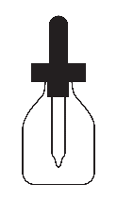 | For adding drops of indicator to the solution in the conical flask (eg for acid-base titrations). Some titrations don’t need this as they are self-indicating.
Volumetric flask |  | 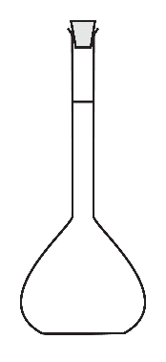 | Specially calibrated to make up an exact solution of a particular volume. Flasks are available in a range of sizes, the most common are 100 cm³ and 250 cm³. The stopper allows the solution to be mixed to make sure it is homogeneous before titration. The volumetric flask only has one graduation mark.
Volumetric pipette |  | 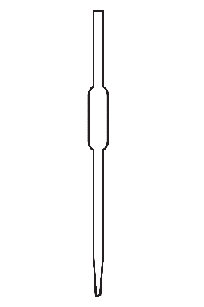 | Delivers an accurate volume of solution into the conical flask for titration. The pipette only has one graduation mark.
Wash bottle |  | 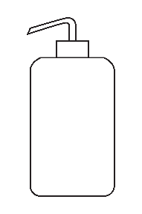 | Used to wash down the sides of the conical flask during the titration. This allows any drops of reagent which have splashed up the sides of the conical flask to be returned to the solution in the flask so they can react.
Clamp and clamp stand | 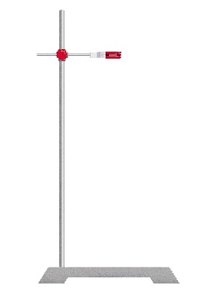 | 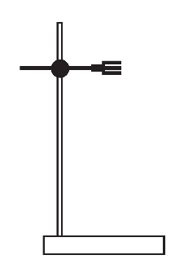 | Supports the burette so that the level of the solution is horizontal and can be read accurately.
Name | Illustration | Diagram | Description and purpose
White tile |  |  | Helps determine (see) the colour change at the end-point of the reaction. The dark bases of clamp stands make this difficult otherwise.
Conical flask |  | 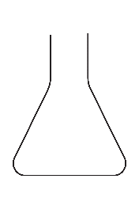 | Used to hold the solution for the titration. Its conical shape allows it to be swirled without spilling the contents.
Burette |  | 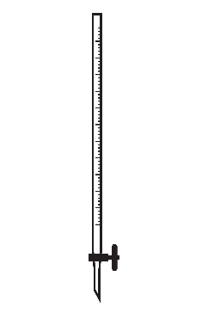 | Used to deliver and accurately measure a volume of solution into a conical flask. The graduations on the burette allow the delivery of volumes typically between 10.00 cm³ and 50.00 cm³ to an accuracy of ±0.05 cm³.
Tap or stopcock |  | 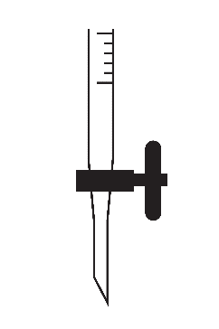 | Used to control the amount of solution added from the burette. The speed that the solution is delivered through the tap can be varied, including dropwise to give a more accurate result. This must be kept in the closed horizontal position before filling.
Pipette filler |  |  | Draws the solution into the pipette through capillary action.

Answers to follow-up questions
- Suggested answers and explanations:
- Parallax errors are caused by reading the burette from above or below the fill line. Take the reading at eye-level to avoid parallax error.
- The surface of the solution in the burette is curved, which can give two different lines, this is called a meniscus. The graduations on the burette are calibrated to be correct if you read the volume from the bottom of the meniscus.
- Human error may occur if reading the scale as if it started from the bottom. Remember that the scale on a burette starts from zero at the top.
- Seeing the bottom of the meniscus through a clear solution with a busy background or through a coloured or opaque solution can be difficult. To make the reading easier you can hold a white piece of paper behind the burette.
- Any other sensible answer.
- Scientists might not fill the burette up to zero because they need to be able to read it at eye level to get the most accurate reading (to avoid parallax errors). It is not necessary for the solution to be at exactly 0 cm³ (it must not be above the 0 cm³ line) as long as there is an initial burette reading and a final burette reading. It may not affect the results of a titration because the final result is a difference between a start value and an end value, but it is best practice to mostly fill the burette to allow several titrations and to ensure that the drop-wise additions required to accurately reach the end-point are not a significant % volume of the total titre volume. Lowering the clamp stand and burette (without the conical flask) onto a stool for the purpose of mostly filling the burette at eye level is a more acceptable practice.

- Universal indicator would not provide a single, sharp colour change when the end-point (neutralisation point) is reached.

- For the pipette there is only one reading, the reading at the fill line.

$$\% uncertainty=\frac{0.06}{25} ×100=0.24\%$$

For the burette two readings are taken, the start value and the end value, so the ± value is doubled.

$$\% uncertainty=\frac{0.10}{25} ×100=0.4\%$$

So, the overall % uncertainty would be the sum of both = 0.24 + 0.40 = 0.64%

Support cards
Dropping bottle and pipette | Volumetric flask | Volumetric pipette
Wash bottle | Clamp and clamp stand | White tile
Conical flask | Burette | Tap or stopcock
Pipette filler | For adding drops of indicator to the solution in the conical flask. Some titrations don’t need this as they are self-indicating. | Specially calibrated flask to make up an exact solution of a particular volume. The stopper allows you to mix the solution to make sure they it is homogeneous before titration.
Delivers an accurate volume of solution into the conical flask for titration. Only has one graduation mark. | Used to wash down the sides of the conical flask during the titration. This allows any drops of reagent splashed up the sides of the conical flask to be returned to the solution in the flask so they can react. | Supports the burette so that the level of the solution is horizontal and can be read accurately.
Helps to determine (see) the colour change at the end-point of the reaction. The dark bases of clamp stands make this difficult otherwise. | Used to hold the solution for the titration. Its conical shape allows it to be swirled without spilling the contents. | Used to deliver and accurately measure a volume of solution into a conical flask.
To control the amount added from the burette. This must be kept in the closed horizontal position before filling. | Draws the solution into the pipette through capillary action.

