Titration apparatus

Learning objectives
- Recognise the apparatus used in titration experiments.
- Justify the use of particular pieces of apparatus.
- Evaluate the accuracy of apparatus used in titration experiments.

Introduction

Titration is an analytical technique used to determine the concentration of an unknown solution by reacting it with a standard solution. A standard solution is one which has an accurately known concentration. Titration uses very specific equipment which you will need to be able to recognise from diagrams. You will also need to be able to write accurately about the equipment and justify why certain apparatus is used.

Follow-up questions

Complete the task on page 2 first, then answer the follow-up questions.
- When you record burette readings, it is important to read from the bottom of the meniscus. This is because the graduations on the burette are calibrated to give the correct volume from the bottom of the meniscus. Give two other factors that could affect the accuracy of a burette reading and how to avoid them.
- Some shorter chemists only fill their burettes to the 10.00 cm³ level. Explain why they may do this and discuss whether it would affect the results of the experiment.
- Universal indicator is not recommended when carrying out an acid-base titration reaction. Explain why.

Hint: An indicator such as phenolphthalein is preferred due to its single colour change.
- Answer the following questions using the formula:

$$\% uncertainty=\frac{absolute uncertainty}{measured value} ×100$$

- A 25 cm³ pipette has an accuracy of ±0.06 cm³. Calculate the % uncertainty for measuring out a volume of 25 cm³ with a pipette. Discuss the results of your calculations.
- Burettes have an accuracy of ±0.05 cm³. Calculate the % uncertainty for titrating a volume of 25 cm³ with a burette. Remember to take into account the start and end values that you measure.
- Now, calculate the overall % uncertainty associated with this titration experiment.

Task

Fill out the table below to summarise the apparatus used in titration, including name, simple diagram and purpose.

Name | Illustration | Diagram | Purpose

Volumetric flask
 |  |  | Delivers an accurate volume of solution into the conical flask for titration. The pipette only has one graduation mark.

Wash bottle
 | 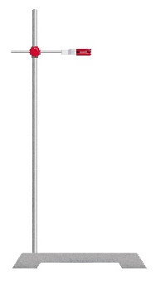 |  | This supports the burette so that the level of the solution is horizontal and can be read accurately.
Name | Illustration | Diagram | Purpose

White tile
 |  |  | This flask is used to hold the solution for the titration. Its conical shape allows it to be swirled without spilling the contents.

Burette
 |  | 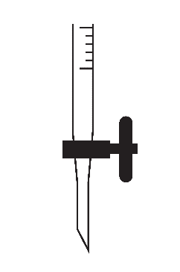
 |  |  | Draws the solution into the pipette through capillary action.

