Surprise origin for Benin bronzes

Original article by Tom Metcalfe. Adapted by Nina Notman.

Geochemical analysis reveals surprise insights into early Atlantic trade routes

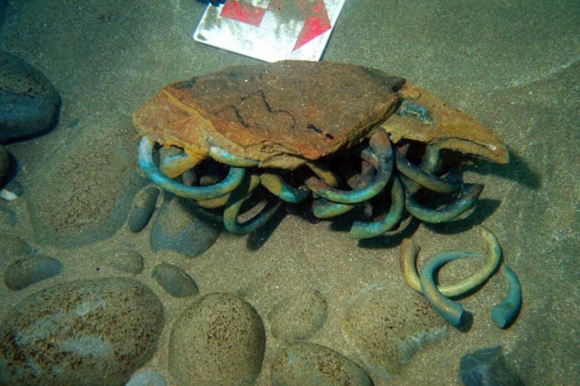
Geochemists have confirmed that most of the Benin bronzes – sculptured heads, plaques and figurines made by the Edo people in West Africa between the 16th and 19th centuries – are made from brass that originated thousands of miles away in the German Rhineland.

The surprising discovery casts new light on the artworks, many of which were looted by British forces during the military expedition of 1897 that brought the Edo’s Kingdom of Benin to an end. The Kingdom of Benin is separate from the modern republic of Benin, and its territories were eventually absorbed into Nigeria.

Source: © Werner Forman/Universal Images Group/Getty Images

Some of the 313 manillas excavated from shipwrecks in the Atlantic and used in the geochemical analysis

An estimated 5000 Benin bronzes are held in art collections around the world, including at the British Museum in London and The Met in New York. Nigeria has asked for repatriation, but fewer than 100 have been returned so far.

Metal detectives

Tobias Skowronek, a geochemist at the Technische Hochschule Georg Agricola in Bochum, Germany, who led the new study, says it was long suspected that metal used for the artworks was melted-down manillas that the Portuguese brought to West Africa. But where those manillas were originally purchased and where the metal was mined wasn’t known, he says.

Manillas are horseshoe-shaped copper alloy bracelets used as money in West Africa by European slavers and traders from the 16th century onwards. The copper was usually alloyed with zinc to make brass. During that era, the metal was often referred to as bronze, a name more typically used to describe copper- tin alloys.

To determine the origins of the metal in the Benin bronzes, Tobias and his colleagues analysed 67 manillas known to have been used in early Portuguese trade. The manillas were recovered from five shipwrecks in the Atlantic and three land sites in Europe and Africa. The scientists determined the lead isotope signatures of the manillas, and determined the amounts of other trace impurities in the brass such as antimony, arsenic, nickel and bismuth.

Tobias’ team found strong similarities between the manillas studied and the metal used in more than 700 Benin bronzes with previously published chemical compositions. The team also found that the chemical composition of the copper in the manillas matched copper ores mined in northern Europe, which suggests that modern-day Germany, specifically the German Rheinland, was the main source of the metal.

This is adapted from the article Benin bronzes are made of German brass in Chemistry World. Read the full article: rsc.li/3MVDM0E

