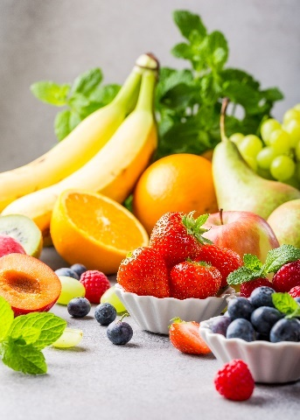
- Many fresh fruit and vegetables produce ethene.
This gas may then ripen other fruit which is unripe.

The table below shows how much ethene (in cm³) is produced from 1 kg of fruit each hour.
Source: Envato Elements
Name of fruit or vegetable | Volume of ethene produced by 1 kg of fruit in 1 hour (in cm³)
Apricot | 30
Avocado | 150
Rhubarb | 0.25
Banana | 3.2
Pineapple | 1.2 × 10^{–3}
Passion fruit | 235
Pear | 85
- Write the volume of ethene produced by 1 kg of pineapple per hour as a normal number (that is, one not in standard form).

- Place the fruit in order of the volume of ethene they produce each hour, smallest first.

- Calculate the volume of ethene produced by the following masses of fruit.
Remember to give units in your answers.
- 2 kg of bananas in 1 hour
- 200 g of apricots in 1 hour
- 4 kg of pears in 2 hours

- Ethene has the molecular formula C₂H₄.
Draw the structure of an ethene molecule showing the chemical bonds.

- Ethene is described as an unsaturated hydrocarbon, define each term in the table below.
Unsaturated
Hydrocarbon
- State the name of a chemical substance that could be used to show that ethene is unsaturated.

- Give the result of the test when using the substance in part f).

- This question is about the two molecules in the table below.

- Complete the table.
 | 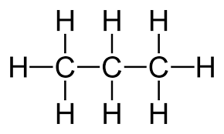  Molecule 1 | 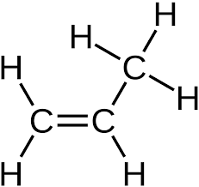  Molecule 2
Homologous series

General formula of homologous series

Name of substance

Molecular formula

Burns with smoky flame (Y/N)
- Give the name of a substance that would change molecule 2 into molecule 1.

- Which of the molecules is the more reactive?
Give a reason.

Parts d) and e) are about the molecule shown.
- What is the name of this molecule?

- Which molecule in the table (molecule 1 or molecule 2) is this molecule most similar to?
Give a reason for your answer.

