Metallic bonding: teacher guidance

This resource forms part of the Review my learning series from the Royal Society of Chemistry. Additional support for addressing misconceptions identified using these worksheets can be found at rsc.li/3mm0IeW.

This worksheet assesses content from the 14–16 specifications. The content is a subset of the Bonding worksheets and can be used to provide extra support for learners on metallic bonding. It can identify learners’ knowledge gaps and misconceptions following the completion of that part of the curriculum.

The Metallic bonding worksheet covers the following topics:
- interpreting diagrams representing metallic bonds
- the presence of positive metal ions and negative delocalised electrons in metallic bonds
- electrostatic forces in metallic bonds
- explaining why metals conduct electricity.

If learners successfully answer questions on these topics, they can attempt the extension question where they can complete diagrams representing the formation of metallic bonds.

There is only one level of this worksheet. Level 1() is a scaffolded worksheet in which learners select words from a word list to complete sentences.

The worksheets can be used in a variety of ways:
- as an assessment of learners’ knowledge at the beginning or end of a period of teaching
- as an assessment of knowledge during a period of teaching and after learners have completed the relevant section of the specification
- as a revision tool prior to the relevant examination
- as a refresher exercise for teachers or non-subject specialists.

There is also scope to use this worksheet to support learners who struggle with this type of bonding particularly. These learners could then be encouraged to attempt the partially scaffolded Bonding worksheets to reinforce their understanding.

The ‘What do I understand?’ page can be used both to identify areas needing whole class attention and as an indicator for learners to help guide their revision.

The Teacher guidance provides model answers for each level and guidance on learners’ misconceptions. Learners can use the model answers to self- or peer assess.

Answers

Metallic bonding: knowledge check
- metallic bonding
Guidance: Most learners will recognise the diagram representing metallic bonding. Some will have misconceptions in interpreting it. They need to understand electronic configurations, atoms and ions, charges on ions and delocalised electrons.
- Metallic bonding – the electrons leave the outer shells of metal atoms, forming positive metal ions and a ‘sea’ of delocalised electrons that are free to move. This bonding is a result of the strong electrostatic forces of attraction between the positive metal ions and the negative delocalised electrons.
Guidance: Learners commonly refer to metal atoms and delocalised electrons in metallic bonds, instead of metal ions and delocalised electrons.

Metallic bonding: test myself
- Metallic bonds are found in metals only.
Guidance: The clue is in the name and most learners will know the answer.
- Metallic bonds are strong.
Guidance: Since the strength of a bond is relative, this may be difficult for learners to answer if they have not studied intermolecular forces.
- The electrons are free to move.
Guidance: Most learners will be familiar with the word local and its meaning. They can be encouraged to suggest how the term delocalised might apply to metallic bonding.
- Metals are good conductors of electricity because they contain delocalised electrons that are free to move and carry the charge.
Guidance: The guidance for question 2.3 applies here. Learners need to recall that an electron is a negatively charged particle and an electric current flows when electrons move round a circuit.

Metallic bonding: feeling confident?

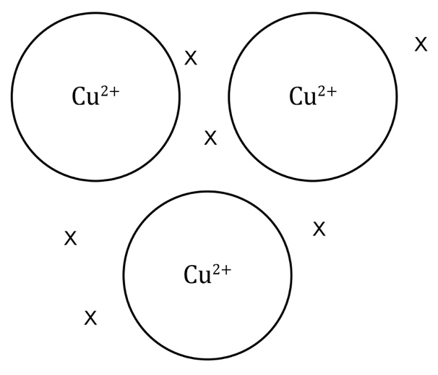
Guidance: Learners need to add the delocalised electrons. Since copper ions have a 2+ charge, there should be two delocalised electrons for every metal ion – six in the diagram for copper. Ideally, the metal ions should be touching each other, but since this leaves little room to add the delocalised electrons, spaces have been left.

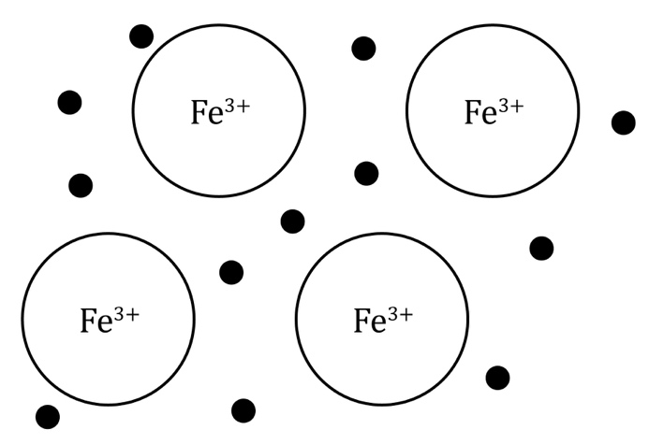
Guidance: Electrons in a metal become delocalised because metal atoms are packed closely together. The metal ions should be drawn in regular rows to show the lattice structure of the metal. Learners need to add the delocalised electrons. Iron ions have a 3+ charge so there should be three delocalised electrons for every metal ion. Ideally, the metal ions should be touching each other, but since this leaves little room to add the delocalised electrons, spaces have been left. A common misconception is that metallic bonding involves the transfer of electrons from one atom to another. Learners need to understand that the electrostatic forces of attraction are between the positive metal ion and the sea of electrons, not between specific ions and electrons.

Metallic bonding: what do I understand?
Mini-topic | Assessed via:
I can interpret diagrams representing metallic bonds. | Q1.1
I know that there are positive metal ions and negative delocalised electrons in metallic bonds. | Q1.2, Q2.3
I know about electrostatic forces in metallic bonds. | Q1.2
I can explain why metals conduct electricity. | Q2.4
Feeling confident? topics | Assessed via:
I can complete diagrams to represent the formation of metallic bonds. | Q3.1, Q3.2

