A sticky situation
A context-based learning (CBL) resource

Student handouts

Kevin Parker
KKI Associates Ltd
Produced for the Royal Society of Chemistry

Table of contents
A sticky situation – context-based learning exercise 4
Scenario 4
Module structure 4
Workshop 1 – Team briefing session 6
Memo from the chairman 6
Letter from the lawyers 7
Background on Global Resource Energy Exploitation and Development corporation (GREED corp) 9
Australia Daily Times 10
Konigsberg in the mountains 11
Student research project worksheets 12
Supplementary Information 12
Worksheet 1: Engines and lubrication 14
Challenges for an engine oil 14
How does the engine’s operation affect the oil? 15
Worksheet 2: The properties and composition of lubricating oil 16
Lube oil composition and manufacture 16
Oil changes with temperature 16
Oil changes in service 16
Worksheet 3: Classifying engine oils 17
Oil viscosity and performance 17
Worksheet 4: Formulating the oil – polymers and viscosity index improvers (VIIs) 18
Australian oil news – January 2014 18
Worksheet 5: Formulating the oil – polymers and viscosity index improvers in use 20
Worksheet 6: Discussions with the car manufacturer 21
Worksheet 7: The problem of extending service life 23
Anti-wear additives 23
Zinc dithiophosphates – what are they? 23
What happens in high sulfur fuels? 23
Worksheet 8: Extending oil life (part 2) 24
Oxidative degradation of lubricating oil 24
Chemistry of antioxidants 24
Base oil additive interactions 24
Workshop 2 – Internal reporting and information sharing 25
Team task 1 25
Team task 2 25
Team task 3 25
Team task 4 25
Analysing the problem 25
Samples available to Northland Petroleum team 26
Analytical techniques available to Northland Petroleum team 26
Workshop 3 – Information sharing and report structuring 27
Team task 1 27
Team task 2 27
Team task 3 27
Notes and acknowledgements 28
Acknowledgements 28

A sticky situation – context-based learning exercise
Welcome to our context-based learning and problem-solving module based around the chemistry of lubricants (‘engine oils’). Context-based learning ‘aims to teach chemical concepts by starting with observations from real world contexts’ (from http://rsc.li/20VGu6n).
In this example, you will be carrying out a chemical investigation typical of a ‘real world’ problem.

Scenario
An Australian billionaire who owns various oil exploration, refining, and marketing companies, also has developed a new Ski Resort. After the launch press conference, his exotic sports car breaks down in front of the world’s press. The engine of the vehicle has been completely seized as the oil has gelatinised. The billionaire sues Northland Petroleum (NP), who produce the oil used in his car, and threatens to sever all his other commercial links with NP. The Chairman of NP asks his head of technology to set up a task force to quickly investigate and respond. Your team is that task force…

Module structure
Your team are asked to investigate and report on 8 different areas relevant to the problem, from general information about engines and lubricants to detailed analysis of polymer solubility. These areas are set out as 8 separate Worksheets, which can be approached in any order, by a single team member or a group. Each worksheet will (hopefully) be informative and challenging in its own right. However they each feed at least one factor into the overall question of ‘what happened to the billionaire’s car?’ So after having jointly or individually completed each of the worksheets you will pool your information and use it to assess what happened to the car, report on it, and recommend better ways of formulating the oil in future.
Your team will meet in 3 formal facilitated workshops (and as many informal times as you wish) where you will co-ordinate the work and report back to each other.
Workshop 1 will be a task briefing session where facilitators will clarify the task and you can start some preliminary work on the topic.
Workshop 2 will be where you report progress to each other, structure your next series of tasks and request additional information (e.g. from Northland Petroleum’s chemical analysis laboratories).
Workshop 3 will be where you finally pull all the information together, and produce a contents page of your final team report. A facilitator should approve this contents page before the end of the workshop
The final team report exercise should identify the multiple, inter-locking failure factors hinted at or revealed in the 8 Worksheets. Other information that may become available to you, via a number of routes, as the module progresses and you should take this new information into account in your report.
By the end of the module you will have learned:
- Information about an important chemistry-based industry
- The application of several new analytical techniques
- How to analyse, summarise, and communicate complex information
- How to work with others on a team task and meet a joint deadline
April 2015. Kevin Parker, KKI Associates Ltd

Workshop 1 – Team briefing session
At the start of this workshop, facilitators should briefly describe the problem and what you are required to do.
You will be given the following information, which everyone should read and comprehend:
- Memo from the Chairman
- Email from the Head of R&D
- Letter from the Lawyers
- Background on Global Resource Energy Exploitation and Development Corporation (GREED Corp)
- Article ‘Open Mike’ defends refinery policy (Australia Daily Times)
- Article Konigsberg in the mountains (Fastest Gear Magazine)
When you have done this, speak to a facilitator who will give out the 8 worksheets. You may organise your work on these worksheets as you see fit. It may be simplest if everyone works on all the worksheets. That way everyone will have full information about the problem. If you decide to split up the worksheet exercise then you will need to spend a considerable time briefing each other at the next workshop. Whichever way you choose to allocate tasks, all the worksheet reports should be completed before the next Workshop session, ready to be handed in at that session.
When you have all agreed on a work plan, please agree this with a facilitator before leaving the workshop.

Memo from the chairman

To: head@R&D.Northland_Petroleum.com
From: chairman@Northland_Petroleum.com

Jan,
Please see the attached lawyers’ letter from Australia. Our main lubricants reseller in Australia has had a major engine failure in his sports car right in front of the press and assorted TV cameras! Apparently it’s all over the internet as well (what on earth is a ‘trope’?). So he’s threatening to terminate our agreement over breach of contract.
This is pretty disastrous for us as lubricants is a very profitable business for us in Australia (they drive a lot!). We’ve never had any problems with the guy before, although he’s a pretty colourful character (Google ‘Open’ Mike and you’ll get the picture) with a lot of interests in the area.
Can you investigate and come up with a report on what happened and some recommendations about what to do about it before the end of the month please?

To: lubes_tech_team@R&D.Northland_Petroleum.com
From: head@R&D.Northland_Petroleum.com

STOP WHAT YOU ARE DOING AND READ THIS
OK everyone, sorry to shout but see the chairman’s email and the letter from the lawyers. We got a major problem here and a short time to do anything about it.
I suggest we need the following information before we can write the report to the chairman (and something to Mr Michael):
Some background on Mr Michael and GREED Corporation (I’ll do that)
A clear exposition of how engine oils are supposed to perform
The issues in lubricating modern high performance engines (and the Chairman might need a tactful revision of ‘Suck, Squeeze, Bang and Blow’ as he’s not a technical man)
A check that GREED are blending the oils correctly (didn’t we see something about their storage of Viscosity Index Improver – can someone dig that out?)
A quick chat with the car manufacturers (though they’ll doubtless be keen to blame our oil)
Any factors we can come up with about the failure (are there specific issues in Australia we haven’t taken into account when we formulated the oil?)
Get to it.

Letter from the lawyers
Dear Sir/Madam
We have the honour to represent the legal interests of Mr Hope N. Michael and the interests of his holding company Global Resource Energy Exploitation and Development Corporation (GREED Corp). Among his other interests, Mr Michael has purchased licenses from you to blend and market a range of high quality engine lubricants under the NP ‘Super Q’ brand name. These oils are represented as meeting the specifications of major engine manufacturers’ quality requirements.
However, on September 14 of this year Mr Michael’s car had a catastrophic engine failure as he attempted to drive away from a press launch at his new Ski Resort in the Snowy Mountains in New South Wales.
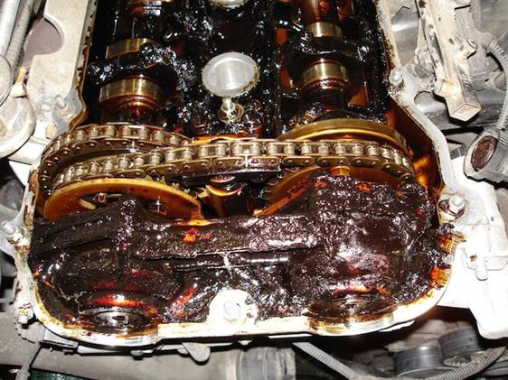
Figure 1: Engine with almost completely solidified oil
Subsequent inspection of the engine showed that the engine oil had almost completely solidified into a dark gelatinous mass (see picture), which clearly failed to protect the moving parts in any way. Mr Michael’s Car (a unique Konigsberg RV1) has suffered extensive damage to the gearbox as well as a complete engine write-off. The cost of replacing these parts has been estimated at over $50,000.
In addition, this episode, in front of a large group of media representatives, has caused Mr Michael, a well-known figure in Australia, a great deal of negative publicity and derisive comments in papers, TV and social media. For those familiar with such things, ‘Mike Failure’ has apparently become an Internet ‘trope’.
Mr Michael feels that his judgement in entering a business deal with Northland Petroleum has been called into question. He cannot afford for his reputation to be compromised by selling products that do not meet their stated specifications.
Accordingly, unless we hear from you by the end of the month with proposals for compensation, we wish to alert you that we will be activating the ‘breach of contact’ clause to terminate GREED’s agreement with Northland Petroleum.
We understand that you may wish to investigate this matter further before replying in detail. We have therefore taken steps to send you samples of the oil used in Mr Michael’s car – both that recovered from the engine and new samples from Mr Michael’s factory (we believe the technical tem is ‘blending plant’) in Western Australia.
Yours faithfully,
Jo Ha-ang
Senior partner

Background on Global Resource Energy Exploitation and Development corporation (GREED corp)

To: lubes_tech_team@R&D.Northland_Petroleum.com
From: head@R&D.Northland_Petroleum.com

OK team, I’ve done a quick search on Mr Michael. Since taking over Global Resource Energy Exploitation and Development Corporation 20 years ago he has built it into one of the most important energy companies in Australia. GREED has interests in oil exploration, some gas fields, and an oil refinery producing a range of fuels from atmospheric distillation and cat Cracking. He’s recently invested in a new development of an exclusive ski Resort in Australia’s Snowy Mountains.
He seems to be pretty forthright about environmentalists (see attached articles) and unapologetic about using rather old refining technology to make quite high sulfur fuels. Don’t see how that would help us at all, but bear it in mind anyway.
There’s also an article about his car. He’s actually had a private road made up to his ski resort so he can race up and down with his friends! Boys and their toys…
More seriously, I asked our NP representative in Australia to do some ‘quiet digging’ about the problem. He seems to have found the news item about a spill or leak at their Lube Oil blend plant – it’s in one of the sheets below but I don’t really see how it helps us.
However, since I last heard from him he’s gone on long-term sick leave – he was hit by a fast-moving sports car while hiking last weekend and has been left unconscious. His assistant has looked through his office and all they found was a weather forecast of some sort and a page of scribbled internet links. Again, I don’t know how helpful that is, as I can’t tell whether it’s technical or purely private information. If you think it might be useful I’ll get it to you before our next meeting.

Australia Daily Times

‘Open Mike’ defends refinery policy
Fuel quality claims ‘spurious’
In a hard hitting response to concerns expressed by environmentalists, Hope N. Michael, owner and CEO of GREED refining corporation, refuted criticism of the fuel produced at his, and other Australian refineries.
‘This spurious concern for fuel economy and engine performance is just another sneaky trick, aimed at Australia’s petroleum industry by the ‘eco-hippies’’ he said, at a press conference yesterday.
‘I use our fuels in my Konigsberg, which is probably the fastest car in Australia’ he said, ‘no problems at all.’

‘Benz slams local high sulfur fuels’
Fuel consumption higher on some Mercedes petrol engines in Oz due to sulphur levels
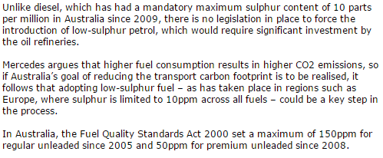
Source: http://bit.ly/20GnGqG

Konigsberg in the mountains
Special feature: Petra head
‘She’s a bit of a goer isn’t she?’ Hope Michael, commonly known by his nickname ‘Open Mike’ beams as we get out of his Konigsberg RV1 at Saxon Valley in the Snowy Mountains. We’re now at 6000 ft and the air is noticeably clearer and cooler than at the bottom of the twisty 19 hairpin road up to Michael’s new ski development.
I wonder about taking coaches up here but Michael is laughing at me. ‘No, we’ve blasted a nice wide highway through the forest on the other side of the hill for them. We’re going to keep this road as it is and only let cars on it. We’re trying to get a minimum speed limit on it to encourage sports cars to come this way. After all you have black run pistes so why not a black run access route?’ I can’t quite decide whether he’s joking, but having been a passenger on the drive up, I think he’s probably serious.

The supercar screamed as we hurtled up the private road that Michael has been sharing with a few motoring friends. He claims not to have raced but does admit to ‘comparing times now and then, just to see.’

‘They have some nice new motors but nothing to touch this one with a hybrid twin turbo, KERS, and all the F1 stuff.’ Is it completely standard I wonder? My lasts drive in a Konigsberg didn’t seem quite as raucous and elemental as this one.
Michael looks a little evasive for a second before admitting, ‘we’ve touched nothing really, just taken a few electrical things out of circuit, heaters (well, we’re in Australia) and all that sat-nav stuff. Doesn’t really change the performance just helps the KERS recharge quicker.
‘Anyway, fancy taking the wheel on the way down?’

Fastest Gear magazine Australia

Student research project worksheets
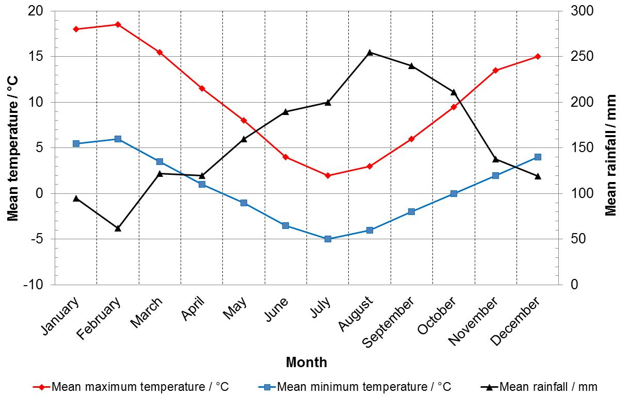
Figure 2: Annual Australian temperatures and rainfall

Supplementary Information
The pieces of paper on this and the next page were found in the desk of the Australia representative of Northland Petroleum (currently hospitalised).
Influence of aldehydes in make-up oils on antioxidation properties
http://bit.ly/1V3O3Ek
³¹P NMR and Mass Spectrometric studies of the reaction of zinc dialkyldithiophosphates with cumene hydroperoxide. (Part 1). Kinetics and mechanisms of the initial homolytic reaction
http://bit.ly/1QVFLgD
Polymer crystalinity
http://bit.ly/20VBpLd
ZDDP engine oil – The zinc factor
http://bit.ly/1TSoAQ0
Role of certain OCP viscosity modifiers in gel formation and filter blocking tendencies of engine oils
http://bit.ly/1TSoLKY
Formulating flexibility
http://bit.ly/1SIqUKc
New base oils pose a challenge
http://bit.ly/1SIr2cD
Oil specifications
http://bit.ly/1RpPsGd
The history and mechanisms of ZDDP
http://bit.ly/1Wem59b
How polymers work
http://bit.ly/1os1ALB
Solubility parameters: Theory and application
http://bit.ly/1KFzSVF
³¹P NMR study of the mechanism and kinetics of the hydrolysis of zinc(II)O,O-diethyl dithiophosphate and some related compounds
http://rsc.li/1o37zqf
Tech 101: Zinc in oil and its effects on older engines
http://bit.ly/1T7zyQS
¹³C NMR spectra of model hydroaromatic hydrocarbons and solvents
http://1.usa.gov/1V3SH5o
Motor oil FAQs
http://bit.ly/1nYtQoG
Polymer solutions
http://bit.ly/1TSrXq9
Synthesis and characterisation of olefin copolymers as viscosity modifiers for engine oil (copy and paste to browser)
http://bit.ly/1PCXuHd
Quenching oils and heat treatment fluids information
http://bit.ly/20Lw4JO
Diesel engine lubricants
http://bit.ly/1o3a3oA
The lubricant's nemesis – Oxidation
http://bit.ly/1Q926ue
Insights into organogelation and its kinetics from Hansen solubility parameters. Toward a priori predictions of molecular gelation
http://bit.ly/1PCYn2q
Estimation of solubility parameters for some olefin polymers and copolymers by inverse gas chromatography
http://bit.ly/1QrxUVB

Worksheet 1: Engines and lubrication
Here is a schematic cross-section of a typical modern internal combustion engine.
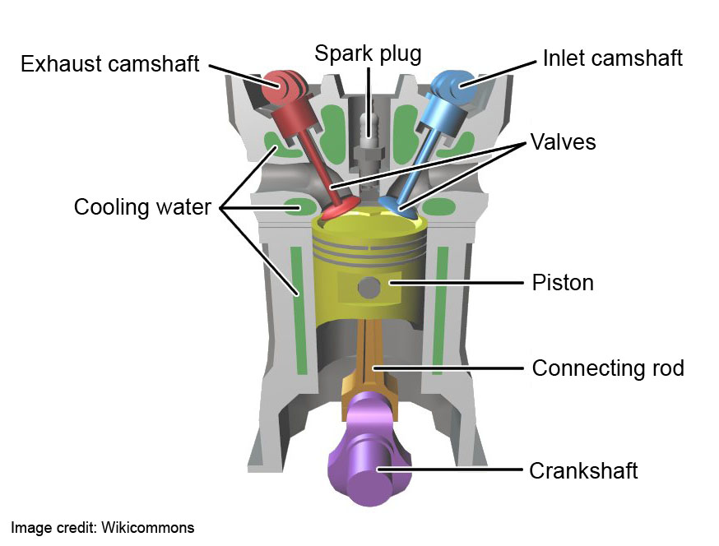
Figure 3: Schematic cross-section of a combustion engine
In a four-stroke (or four cycle) engine, fuel and air is drawn into the combustion chamber past the inlet valve, which is opened by pressure from the lobes on a camshaft. The rising piston then compresses the fuel air mixture, which is then ignited (in a gasoline engine) or self-ignites (in a diesel engine) driving the piston downwards. The piston is sealed in the cylinder by semi-flexible metal rings (‘piston rings’), which should be free to rotate around the piston. Driving the piston down exerts force on the connecting rod and the crankshaft, converting downward motion into a rotational one. Finally the piston rises again, another lobed cam opens the exhaust valve and the burnt fuel (now largely carbon dioxide and water) is pushed out into the exhaust system.
For more information see this ‘How Stuff Works’ page (http://bit.ly/1gMiIpU)
What are the correct names for the four cycles of a car engine? (Hint: they are sometimes referred to by the rather crude expression ‘suck, squeeze, bang and blow!)

Challenges for an engine oil
- What is the main function of the oil in an internal combustion engine?
- Which bearings will be under high pressure and have a lot of force put through them?
- What is meant by hydrodynamic lubrication and boundary lubrication?
- Where in the engine will we see hydrodynamic as against boundary lubrication?
- What is an oil sump?
- What happens when we start an engine and how does that affect the engine?

How does the engine’s operation affect the oil?
- What are the conditions of the oil in the sump of an engine?
- What happens to oil around the cylinder head, camshafts and valves?
- Around the piston rings, a thin film of oil is subject to temperatures of 250 – 300 °C and is in contact with combustion products from the air/fuel mixture. What kind of chemistry would we expect to see in this area?

Worksheet 2: The properties and composition of lubricating oil
You are one of the members of Northland Petroleum’s Lubricants Technology Team. Read the following worksheet, and then compose a short report, making sure to answer the questions posed, and adding/analysing anything you think is relevant to the failure of Michael’s car. Record your sources of information (website links etc).

Lube oil composition and manufacture
Lubricating Oil is blended from a mixture of ‘base oil’ and various chemical additives. Base Oil is usually mineral oil fractions from a vacuum distillation unit, typically containing a mixture of aliphatic and aromatic hydrocarbons with molecular weights around 250 – 350 g mol⁻¹.
- Why do we use mineral oil as a basis for lubricants?
- What is the single most important physical property of a lubricant?
- What happens if an oil of the wrong physical specification (or one that has gone ‘out of spec’) is used?
- What do we add to an oil to protect the engine in those circumstances?

Oil changes with temperature
Lubricating oils in the sump of an engine are at ambient temperature, while in operation the sump temperature may be 80 – 120 °C. Operating parts of the engine (e.g. valves and camshafts) may be hotter than this, while the oil around the piston rings may be at 250 – 300 °C.
- What physical changes will happen to oil as it heats from ambient to 120 °C or more?
- What can we do to mitigate those changes if they are deleterious?
- What trade-offs are there in choosing a thicker oil compared to a thinner oil or vice versa?

Oil changes in service
- What chemical and physical changes would we expect in engine oil during its life, bearing in mind that engines are running hotter than previously, and the interval between oil changes is getting longer?
- What can we do to mitigate those changes if they are deleterious?

Worksheet 3: Classifying engine oils
You are one of the members of Northland Petroleum’s Lubricants Technology Team. Read the following worksheet, and then compose a short report, making sure to answer the questions posed, and adding/analysing anything you think is relevant to the failure of Michael’s car. Record your sources of information (website links etc).

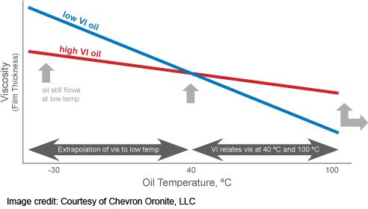
Figure 4: The effect of temperature on the viscosity of oils. Image courtesy of Chevron Oronite.

Oil viscosity and performance
If you look on a can/drum of lubricating motor oil you will see numbers such as 10W/40 or 20W/50. These numbers are fundamental to the properties and performance of oil in an engine, but what do they mean?
- What is Viscosity and Viscosity Index?
- What is the API classification?
- What is the ACEA specification?
- What API or ACEA specification levels would we expect to see used in a very high performance engine?
- Are there special requirements for Turbocharged engines?
- What can happen to oils in use – why do we need to change the oil?
- How are base oils classified, and what do the terms group I, group II, etc mean?
- What have been the advantages and disadvantages of using fully synthetic chemicals, rather than refined mineral oil, as lubricant base oil?

Worksheet 4: Formulating the oil – polymers and viscosity index improvers (VIIs)
You are one of the members of Northland Petroleum’s Lubricants Technology Team. Read the following worksheet, and then compose a short report, making sure to answer the questions posed, and adding/analysing anything you think is relevant to the failure of Michael’s car. Record your sources of information (website links etc).

Australian oil news – January 2014
Sticky Situation at LOBP
Staff at the Quintana Lubricants Blending Plant were confronted with a sticky situation last week. Their stores of polymeric Viscosity Index Improver, a vital component of engine oil, had melted in the unseasonal heat. ‘It’s normally a solid’ said manager William ‘Grubby’ Hands, ‘but we found it had liquefied and made a right old mess!’
‘We’re on to the boys back in the lab and asked them to reformulate the stuff so it doesn’t do that again’
A product chemist at Australian Additives limited said a solution to the problem was well in hand. ‘We just need to adjust the VII composition, probably we’ll make the polymer a bit more crystalline’.
Industry specialist Aaron ‘Al’ Rashid said VII slump was a known problem in the industry, and typical solutions were to increase crystallinity either by adding aromatic moieties in the olefin co-polymer or by producing very regular ‘high ethylene’ OCP. ‘VII slump should be a thing of the past with that approach’ he said confidently.
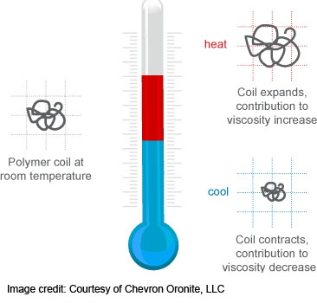
Figure 5: The effect of temperature on polymer coils. Image courtesy of Chevron Oronite
- What is the composition of typical Viscosity Index Improvers?
- What determines their physical properties – what could have caused the polymer ‘slump’ in this instance?
- What potential solutions are there to prevent polymer ‘slumping’?
- How would you tell which solution Australian Additives had adopted?
- Are there any downsides with these potential solutions to the slumping problem?
- What is Differential Scanning Calorimetry and how is relevant to polymer structure?

Worksheet 5: Formulating the oil – polymers and viscosity index improvers in use
You are one of the members of Northland Petroleum’s Lubricants Technology Team. Read the following worksheet, and then compose a short report, making sure to answer the questions posed, and adding/analysing anything you think is relevant to the failure of Michael’s car. Record your sources of information (website links etc).
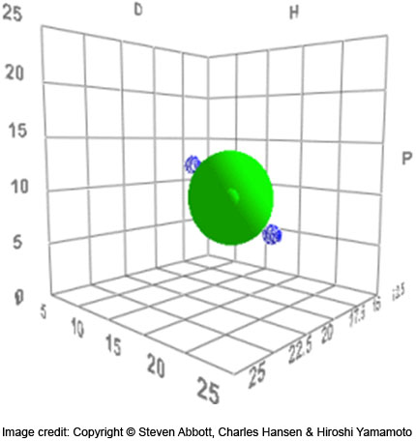
Figure 6: Hansen solubility parameters plot
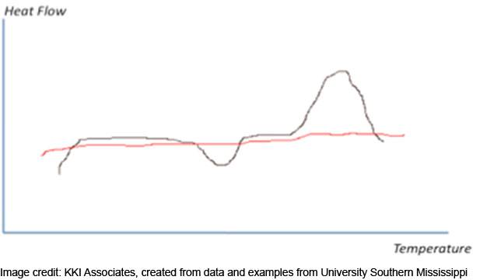
Figure 7: DSC trace
- What are crystalline and amorphous polymers?
- How can they be detected and characterised?
- How do they differ in solubility?
- What are the issues in getting polymers into solution?
- What is the solubility parameter?
- Will the solubility of the polymer in the oil be the same as the solubility of the oil in the polymer, and does it matter?
- What can happen to polymer solutions if they cycle in temperature?
- What are gels and how are they formed?

Worksheet 6: Discussions with the car manufacturer
You are one of the members of Northland Petroleum’s Lubricants Technology Team. Read the following worksheet, and then compose a short report, making sure to answer the questions posed, and adding/analysing anything you think is relevant to the failure of Michael’s car. Record your sources of information (website links etc).
To: lubes_tech_team@R&D.Northland_Petroleum.com
From: CTO@Engine.R&D.Kon.Gmbh.de

Dear Jo,

Thanks for your email and telephone call. We too were disturbed by the problems suffered by Mr Michael’s car, and as we said over the phone it does seem like an oil quality problem. However, we have tried to answer your questions about the critical areas of lubrication.
Long service intervals
As the engine is so specialised, there are few people with the expertise to properly service the car (it requires access to serious computer diagnostic equipment for one thing). Each service can involve a long journey to the nearest specialist. Therefore, we try to prolong the interval between services as much as we can, ideally to more than 20,000 kilometres. We have to say that the limiting factor is often the lubricant when considering how to extend service intervals.
Compact engine/dry sump
Our engine, which has an incredibly high power to weight ratio and specific power output, uses both internal combustion (turbo-charged) and electric power units working together.

Because the engine units get so hot we do not store the oil in the sump of the engine itself but in a separate tank. The oil is kept in a separate header tank and pumped into the engine as required. In order to facilitate starting from cold, there is a specialist oil heater running off a 30 Amp circuit (the same power requirement as the main interior heating unit). One of the things that is always essential to check at any service is that this pump and oil heater are working properly. The circuit is very clearly labelled ‘ heater circuit’ to prevent anyone accidentally disconnecting it.

I hope this helps your investigation. I understand you will be analysing samples of the used oil from Mr Michael’s car. We will be sending out an engineer to assess the engine damage, so it you would like any further information from the vehicle please let us know.

Best regards,

- Why do we still use internal combustion engines, over a century after they’ve been invented?
- What is it about gasoline that makes it such a valuable fuel?
- How efficient is a modern internal combustion engine at turning chemical energy into motive energy?
- What are some of the advantages and disadvantages of so-called ‘dry sump’ engines?
- How has ‘Open Mike’ been using his car?
- What problems might be caused by such usage?
- What tests or checks should Northland Petroleum ask to be carried out on Mr Michael’s car?

Worksheet 7: The problem of extending service life
You are one of the members of Northland Petroleum’s Lubricants Technology Team. Read the following worksheet, and then compose a short report, making sure to answer the questions posed, and adding/analysing anything you think is relevant to the failure of Michael’s car. Record your sources of information (website links etc).

Anti-wear additives
Anti-wear additives are intended to provide protection to parts of the engine in boundary lubrication conditions – where the oil film has completely collapsed or where the geometry precludes any film staying in place. A classic example would be the lobes of a cam-shaft as it depresses the inlet/exhaust valves. The anti-wear additive has to form a chemical film on the metal surface

Zinc dithiophosphates – what are they?
One of the most common types of anti-wear additives are the zinc dithiophosphates or ZDTPs (sometimes abbreviated to ZDDPs). Here is a structure of a typical ZDTP.

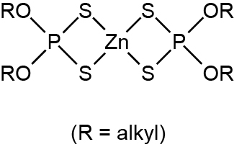
Figure 8: Structure of ZDTP
- Why have these additive been so widely used in engine oils?
- Are modern oils using more or less ZDTP, and why?
- Are there any substitutes for ZDTP anti-wear agents?

What happens in high sulfur fuels?
Diesel and gasoline fuels often contain sulfur, derived from crude oil
- Why is that undesirable in modern engines?
- What will sulfur in fuel produce in combustion?
- How will ZDTP react in the presence of these combustion products?
- How could we observe this/these reaction(s)?

Worksheet 8: Extending oil life (part 2)
You are one of the members of Northland Petroleum’s Lubricants Technology Team. Read the following worksheet, and then compose a short report, making sure to answer the questions posed, and adding/analysing anything you think is relevant to the failure of Michael’s car. Record your sources of information (website links etc).
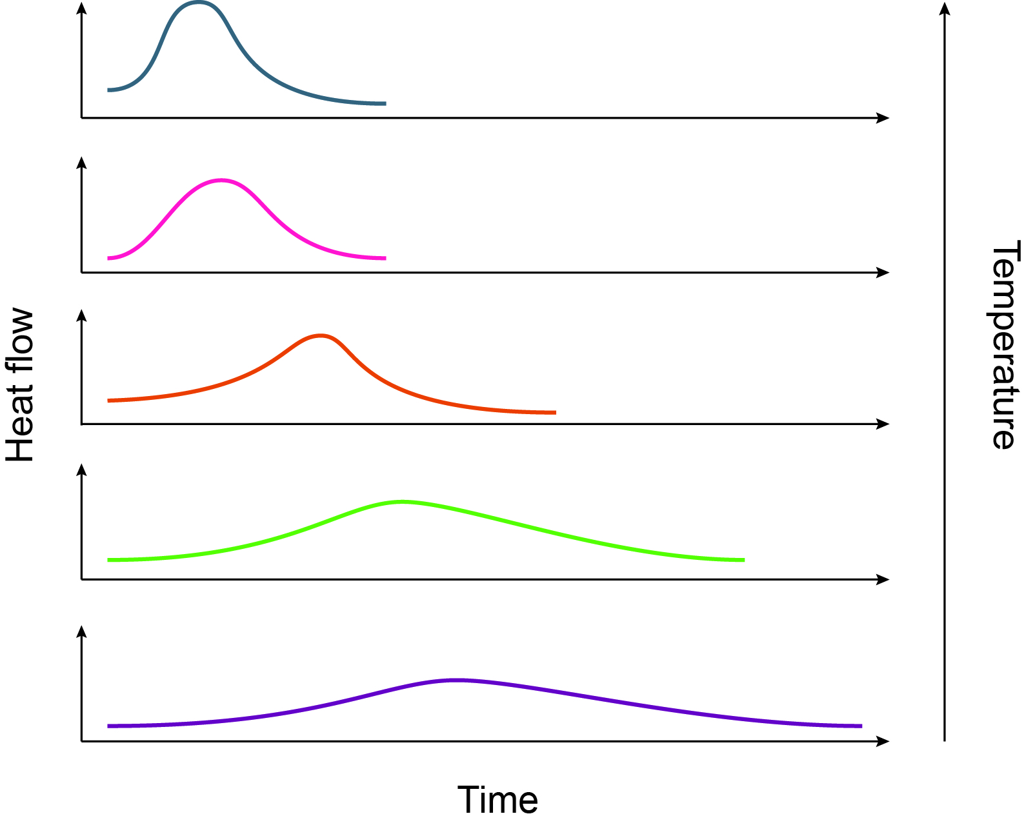
Figure 9: Isothermal microcalorimetry graph

Oxidative degradation of lubricating oil
- What chemistry might we expect to happen to hydrocarbon lubricating oils in an internal combustion engine?
- Around the piston rings, a thin film of oil is subject to temperatures of 250 – 300 °C and is in contact with combustion products from the air/fuel mixture.
- What kind of chemistry would we expect to see in this area?
- What chemical and physical changes would we expect to see in the oil as it oxidises?

Chemistry of antioxidants
- What antioxidants are used in lubricating oils and how do they work?

Base oil additive interactions
- Would we expect antioxidants to be more effective in highly aliphatic hydrocarbon base oils or in base oils containing appreciable amounts of aromatic compounds?
- How could we test the oxidative stability of lubricating oils in laboratory tests?

Workshop 2 – Internal reporting and information sharing
You have studied the background information, and the team have between you completed all the worksheets.

Team task 1
In this workshop, each member of the team should brief each other on the issues addressed in the worksheets. Make sure that everyone understands all the salient issues – any of you may be asked to describe anything to the facilitators!

Team task 2
When you have done this, brainstorm some potential hypotheses about what happened to Mr Michael’s car

Team task 3
When you start to develop some ideas think about how you might confirm them. There are some samples and some analytical tests available to your team (see next page). Decide which tests you’d like carried out on which samples and ‘place your orders’ before the end of the Workshop

Team task 4
Finally make sure that you are all happy with the reports on the individual worksheets, that they are in consistent format, and give them to a facilitator if you have not already done so.

Analysing the problem
- What tests might you like to perform on any of the oil samples available to Northland Petroleum?
- What information would you like to get from Konigsberg’s engineering team?

Below you see a list of lab techniques and test available to you. Some of the techniques are used to prepare samples for testing; others are potentially useful diagnostic tests. Give the facilitator a list of up to 10 tests (per sample) on samples you think are important. You will receive the results within 5 working days, except for those methods marked with an asterisk, which will be delivered at your final workshop.

Samples available to Northland Petroleum team
- Reference engine oil sample blended in Northland
- New engine oil sample blended in Australia, as used in Mr Michael’s Car
- Used oil extracted from Mr Michael’s car following breakdown
- Gel extracted from Mr Michael’s car following breakdown
- Reference sample Viscosity Index Improver as used in Northland
- Reference sample base oil as used in Northland

Analytical techniques available to Northland Petroleum team
- Column chromatography (small preparative scale)*
- ASTM D1533 (Method A), D1744 and D4377 ASTM water in oil test
- Bruker FTIR
- ASTM D5293 – 14 cold cranking simulator – low temperature viscosity
- Oxford Instruments X-ray fluorescence detector
- Varian ³¹P and ¹³C NMR apparatus*
- Size Exclusion Chromatography (small preparative scale)*
- Various standard pH meters
- Differential Scanning Calorimetry apparatus

Workshop 3 – Information sharing and report structuring
You have now carried out further research, and the results of the tests you required should have arrived. You should be able to build a hypothesis about the problems causing the failure of Michael’s car

Team task 1
Read and absorb the results from the analytical tests you have ordered. Do they fit in with your developing hypotheses? How do they change or supplement your view of what’s happening?

Team task 2
A good thing might be to build a schematic diagram of the various factors influencing the problem. Then you can order the various points into a logical structure. Here is what one group of students did in a trial workshop (when the materials were under development)
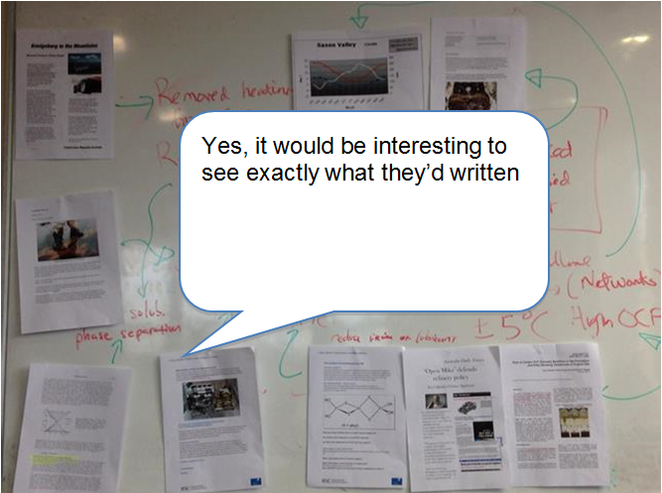
Figure 10: An example of a schematic diagram

Team task 3
Your output from this session is a ‘contents page’ of the final report. You should show this contents page to the facilitator before the end of the session. Your facilitator may have some suggestions for other points to discuss in the report.

Notes and acknowledgements
This material has been developed by Dr Kevin Parker of KKI Associates, with help and advice from Dr Dylan Williams of the Department of Chemistry at the University of Leicester.

Acknowledgements
Kevin Parker would like to thank:
- Dr Ian Bell of Afton Chemicals, who had the original idea for the resource, and Dr Gareth Dowd of BP Castrol who helped to bring KP somewhat more up to date with the state of the art in lubricants
- Professor Colin Pulham and Dr Colin Campbell of the University of Edinburgh, for letting him test some early iterations of the material on some of their post-graduate students
- The Department of Chemistry at the University of Southern Mississippi for their permission to quote liberally from their web resource on polymer solubility
- Post-graduate students Alex Cousen and Adam Michalchuk from the Universities of Bath and Edinburgh for providing the photographs of their schematic ‘link everything together board’ – see previous page
- Dr Luc Patiny Director of Chemical Information at Ecole Polytechnique Fédérale de Lausanne (EPFL) for his work in developing the ¹³C NMR chemical shift predictor, http://www.nmrdb.org used by KP to simulate the ¹³C NMR spectra in this resource
- Robert Connel, Head of External communications at Chevron Oronite, for permission to use graphic images from their web-site
- Edinburgh University students Ewan Bain, Catherine Connolly, Charlie Harrison, Fiona Jamieson, Jessica Moon, Victoria Stevenson (‘Team D1’) and Ellie Brisbane, Rebecca Coulter, Geraldine Hay, Jillian McCormick, Annica Saaret (‘Team C3’) for testing the full version of the material and giving useful and enthusiastic feedback.

