The sublimation of air freshener

Learning objectives
- Describe sublimation and deposition.
- Understand the difference between sublimation and deposition.
- Use the particle model to explain sublimation and deposition.

Introduction

Air fresheners are used to make a room smell pleasant and come in different forms including solids, liquids and aerosol sprays. In this demonstration, you will observe the changes of state that occur when a solid air freshener is heated and then cooled.

The demonstration

At the start of the demonstration, your teacher will have set up the equipment in a fume cupboard as shown in the diagram below. Answer questions 1–5 while you are waiting for an observable change.
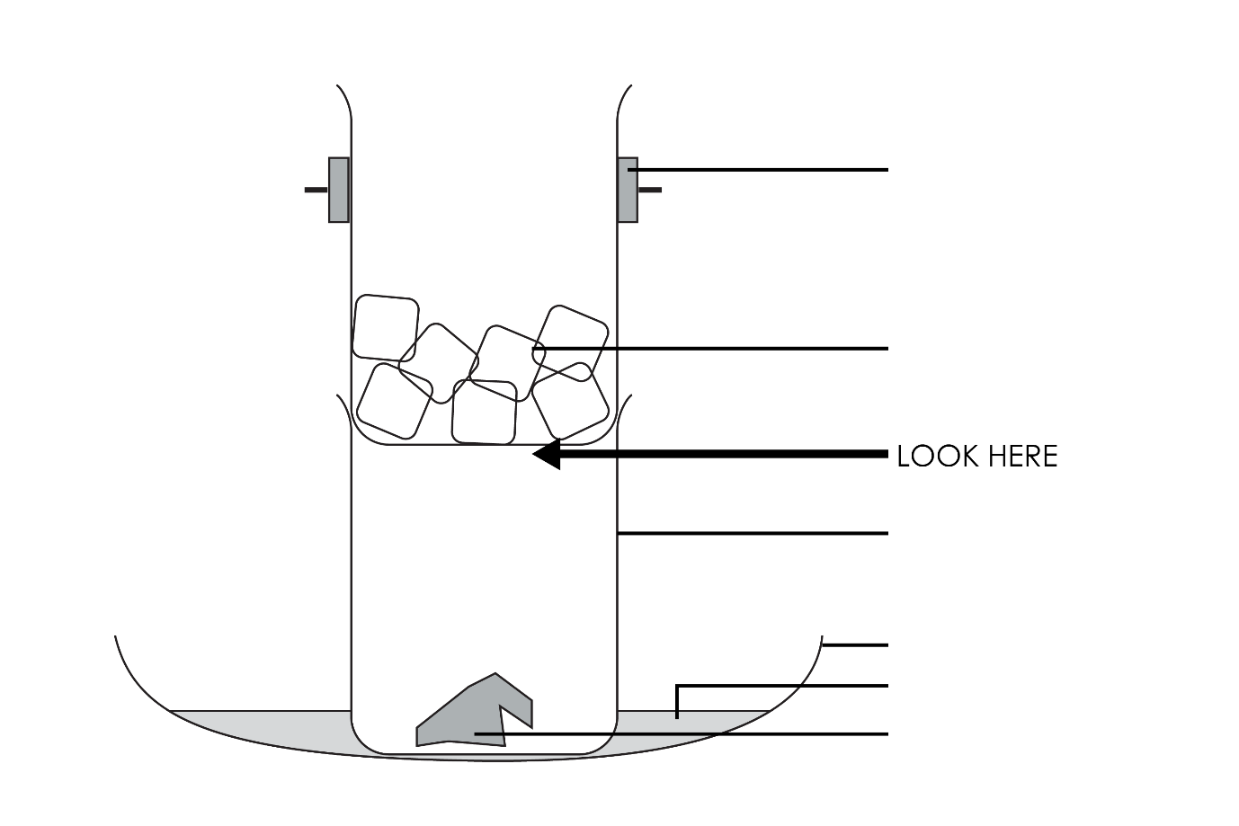

Questions
- Use the words below to label the diagram.

ice hot water air freshener clamp
small dish beaker

Complete the sentences.

- The demonstration is carried out in the fume cupboard because some air fresheners produce ________________ substances when they are ________________ quickly, which are not good to breathe in.

- ________________ was used to slowly heat the air freshener.

- Ice was added to the top beaker to make a _______________ surface for the gaseous air freshener particles to hit.

- Predict what you will observe during the demonstration.

__________________________________________________________________________________

__________________________________________________________________________________

__________________________________________________________________________________

Observations

Record your observations from the demonstration here.

1. _______________________________________________________________________________

__________________________________________________________________________________

__________________________________________________________________________________

2. _______________________________________________________________________________

__________________________________________________________________________________

__________________________________________________________________________________

Conclusion

Choose the correct word to complete the sentences.

cooled lost gas solid liquid heated energy
evaporation sublimation condensation deposition

When the air freshener was ________________ it changed from a solid to a ________________ because the particles took in lots of ________________. We call this process ________________.

When the gas particles hit the ________________ surface they turned back to a ________________ because they had ________________ a lot of energy. We call this process ________________.

Changes of state questions
- Choose the correct word to explain the following changes of state:

evaporation melting sublimation

condensation deposition freezing

- Solid $→$ liquid (eg ice to water) is known as ___________________________.
- Liquid $→$ solid (eg water to ice) is known as ___________________________.
- Liquid $→$ gas (eg water to steam) is known as ___________________________.
- Gas $→$ liquid (eg steam to water) is known as ___________________________.
- Solid $→$ gas (eg dry ice to carbon dioxide gas) is known as _____________________.
- Gas $→$ solid (eg carbon dioxide gas to dry ice) is known as _____________________.

- During the air freshener demonstration, two changes of state took place.

Draw a circle around the words that best describe those changes of state.

evaporation melting sublimation

condensation deposition freezing

