- This question is about molecules in the table.
Complete the table.
 |  | 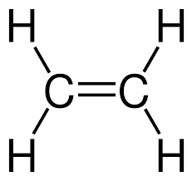
Tick to show if diagram is a polymer | Answer: |  | Answer:
Name of substance | Answer: Poly(propene) | Answer: Ethene | Answer: Poly(ethene) | Answer: Propene
Unsaturated or saturated | Answer: Saturated | Answer: Unsaturated | Answer: Saturated | Answer: Unsaturated
Observation on adding orange bromine water | Answer: Stays orange | Answer: Orange to colourless | Answer: Stays orange | Answer: Orange to colourless

- This question is about the molecule below.

- Name the molecule.
Answer: Propene.

- Draw a section of the polymer in which two repeating units are shown bonded together.
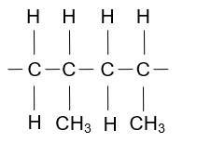
- What is the name of the polymer in part b)
Answer: Poly(propene).
- Explain what happens to the carbon double bond in the molecule in part a) when it makes a polymer.
Answer: It forms a carbon single bond.
Each carbon atom then forms two more carbon single bonds to other monomer units.
- What type of polymerisation occurs to make the polymer in part b)?
Answer: Addition polymerisation.

- The equations below show monomers forming polymers.
Complete each equation by drawing the structure of the monomer or polymer in the box.

b)

c)

d)

- Polymers are very useful, but there are problems associated with their use.
Briefly describe why each of the following is a problem.
- The resources needed to make them.
Answer: Most polymers use substances in crude oil, and this is a finite resource.
- Disposal in landfill sites.
Answer: Most are non-biodegradable and take thousands of years to degrade.
- Disposal by combustion.
Answer: Toxic gases produced, for example, hydrogen chloride from PVC.
High temperature incineration may also form harmful products.

