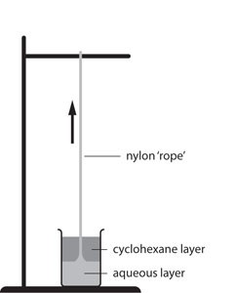
- The nylon rope trick is an experiment that you may have seen.
Watch a video at https://youtu.be/lNWc6xUf6U4

In this famous demonstration, two different monomers are added together.

One monomer is dissolved in water (the aqueous phase), and then the other monomer is added (the organic phase).

The two layers are immiscible.

Where the two layers meet, a chemical reaction takes place between the two monomers, making a polymer called nylon.

The nylon may then be carefully removed as a ‘rope’.
Source: Royal Society of Chemistry

- Define the following terms.

- Monomer

- Immiscible

- Polymer

The organic layer is made of one of the monomers dissolved in a substance called cyclohexane.

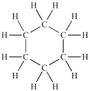
The structure of cyclohexane is shown below.

Questions b) to e) are about cyclohexane.
- To which class of hydrocarbon would cyclohexane belong – alkanes or alkenes?
Give a reason.

- State the general formula of the class of hydrocarbon in part b).

- What is the molecular formula for cyclohexane?

- State whether cyclohexane fits the general formula in part c).
Give a reason.

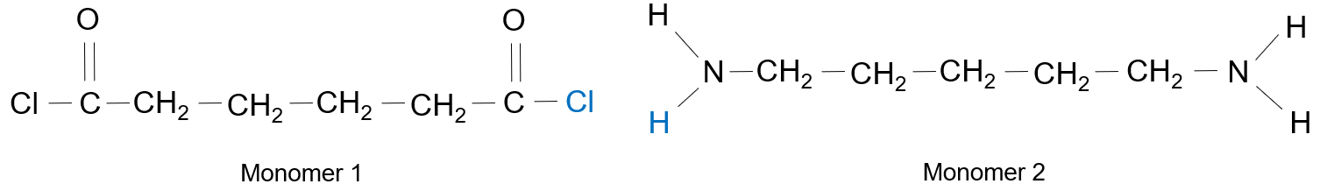
The structures of the two monomers in the nylon rope trick are as follows:

- State what is the same about each of the monomers and what is different about them.
Similarities:

Differences:

- The monomers react together as follows:
The chlorine atom from monomer 1 (shown in blue) combines with the hydrogen atom from monomer 2 (also shown in blue).

The hydrogen and chlorine atoms bond together to form a new substance, X.
The remaining parts of the monomers bond together using a carbon atom from monomer 1 and a nitrogen atom from monomer 2.
- State the name of substance X.

- Explain why the monomers bond together once substance X has been made.
Think about the number of bonds the carbon and nitrogen atoms make.

- Complete the diagram below to show the new bond between the two monomers.
Substance X has already been removed.
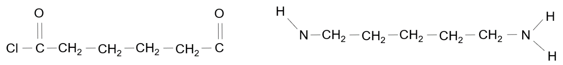

- Give the name of the type of polymer formed in this reaction.

- A polyester is another example of the same type of polymer as nylon.
The monomers that can make a polyester are shown below.
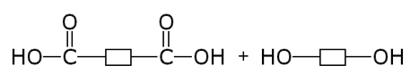

Monomer 3 Monomer 4

- State the name of the functional group present in each monomer.

Monomer | Functional group
Monomer 3
Monomer 4

In order to form a polymer, the OH group from monomer 3 joined with a hydrogen from monomer 4, to form water.
- Show this formation of water by placing a ring around these two groups in the diagram above.

- Draw the structure of the molecule formed when monomer 3 and monomer 4 bond together.

- Assuming that the reaction now continues at both ends of the molecule in part c), draw the repeat unit of the polyester formed.

