The sublimation of air freshener

Learning objectives
- Describe sublimation and deposition.
- Understand the difference between sublimation and deposition.
- Use the particle model to explain sublimation and deposition.

Introduction

Air fresheners are used to make a room smell pleasant and come in different forms including solids, liquids and aerosol sprays. In this demonstration, you will observe the changes of state that occur when a solid air freshener is heated and then cooled.

The demonstration

At the start of the demonstration your teacher will have set up the equipment in a fume cupboard as shown in the diagram below. Answer questions 1–5 while you are waiting for an observable change.
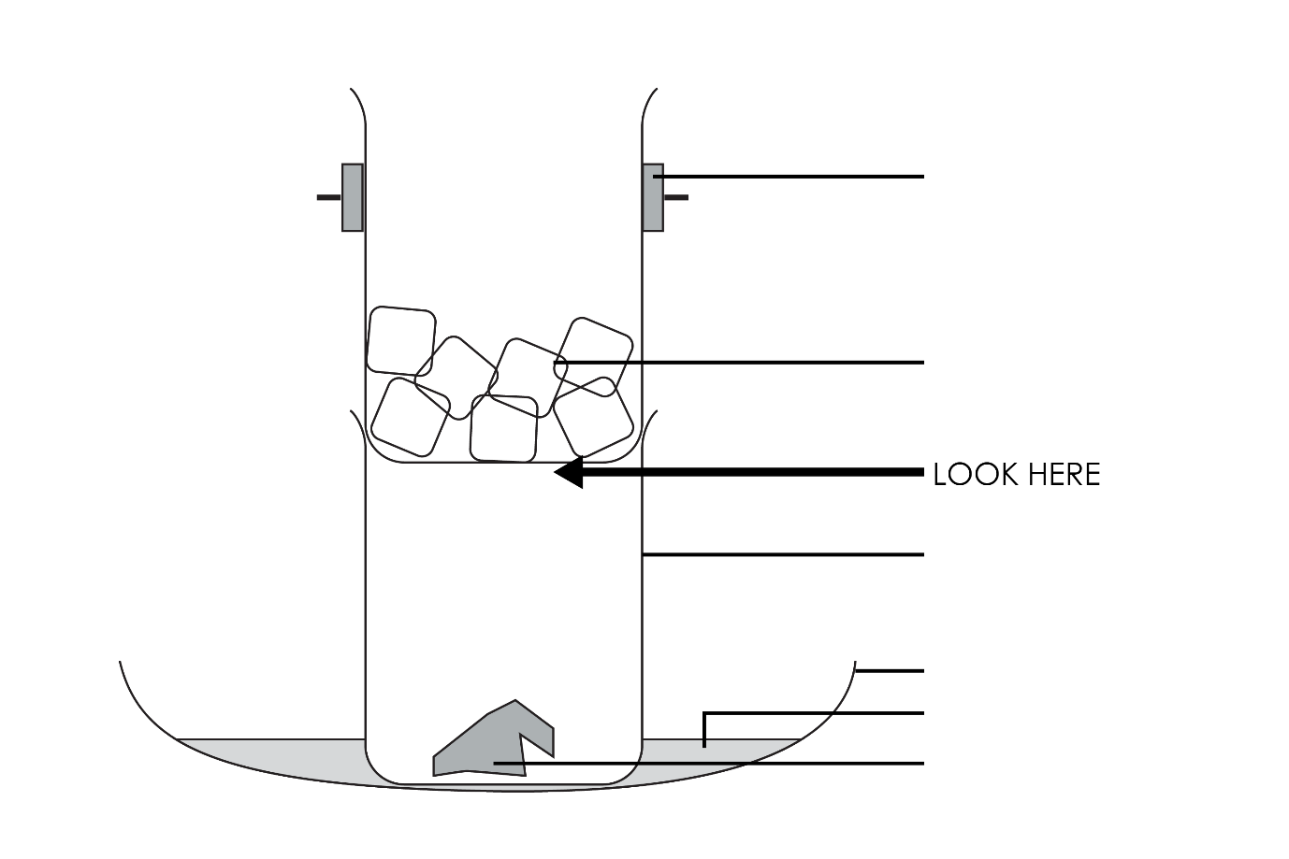

Questions
- Label the diagram.
- Suggest a reason why the demonstration is carried out in a fume cupboard.

__________________________________________________________________________________

__________________________________________________________________________________
- Describe how the air freshener is heated.

__________________________________________________________________________________

__________________________________________________________________________________
- Suggest a reason why ice was added to the top beaker.

__________________________________________________________________________________

__________________________________________________________________________________
- Predict what you will observe during the demonstration.

__________________________________________________________________________________

__________________________________________________________________________________

__________________________________________________________________________________

Observations

Record your observations from the demonstration.

__________________________________________________________________________________

__________________________________________________________________________________

__________________________________________________________________________________

__________________________________________________________________________________

__________________________________________________________________________________

Conclusion

Using your own words, explain your observations.

__________________________________________________________________________________

__________________________________________________________________________________

__________________________________________________________________________________

__________________________________________________________________________________

__________________________________________________________________________________

__________________________________________________________________________________

Changes of state questions
- Write the words that explain the following changes of state:
- Solid $→$ liquid (eg ice to water) is known as ___________________________.
- Liquid $→$ solid (eg water to ice) is known as ___________________________.
- Liquid $→$ gas (eg water to steam) is known as ___________________________.
- Gas $→$ liquid (eg steam to water) is known as ___________________________.
- Solid $→$ gas (eg carbon dioxide solid or dry ice to carbon dioxide gas) is known as ___________________________.
- Gas $→$ solid (eg carbon dioxide gas to dry ice) is known as ____________________.

- During the air freshener demonstration, two changes of state took place. Using your answers from Q6, name the two state changes that you observed.
- _________________________________________________________
- _________________________________________________________

Challenge question

Dry ice, or solid carbon dioxide, sublimes at –78.5°C
- Describe what you would observe when a piece of dry ice is left on a table at room temperature, 22°C.

__________________________________________________________________________________

__________________________________________________________________________________

__________________________________________________________________________________
On a sunny day, the snow lying on the ground appeared to ‘shrink’, but there was no sign of running water.
- Use your knowledge of particle theory to explain why.

__________________________________________________________________________________

__________________________________________________________________________________

__________________________________________________________________________________

__________________________________________________________________________________

__________________________________________________________________________________

__________________________________________________________________________________

