Aromatic chemistry

Naming aromatic compounds

- Name the following aromatic derivatives using IUPAC nomenclature

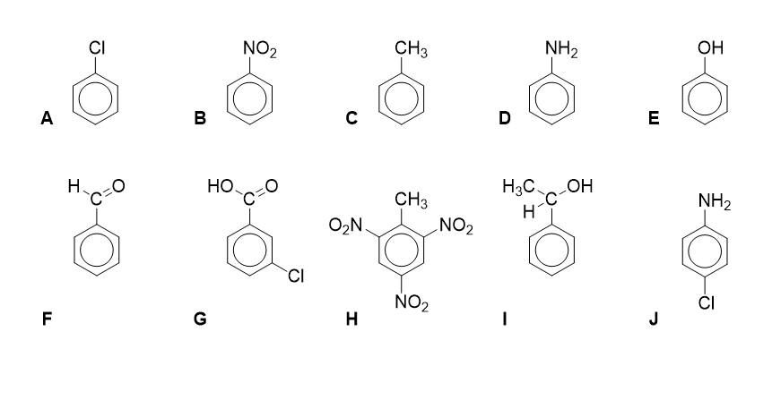

Industrially important molecules

- Name the benzene derivative and outline why it is industrially important.

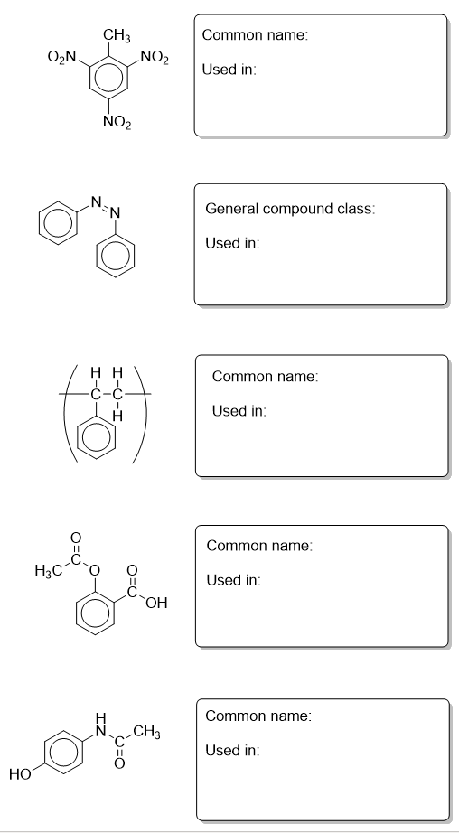

Structure of benzene

The benzene ring is present in many important compounds and therefore determining its structure was very important. The German chemist Kekulé (1865) had suggested that benzene existed as a hexagonal carbon ring with alternate single and double bonds. Professor Ingold of London University prepared some crystals of hexamethylbenzene and sent them to the crystallographers at the University of Leeds for analysis. There Kathleen Lonsdale showed by mathematical analysis of her X-ray diffraction pattern that Kekulé’s proposed structure was incorrect. Kathleen later became a Professor at University College London and only the second woman fellow of the Royal Society.

- Draw the structure Kekulé proposed
(1 mark)
- Why could the crystallographers not work on benzene rather than the hexamethyl derivative?
(1 mark)
- If Kekulé’s structure were true, what would the X-ray of benzene show? (you can use pictures to illustrate your answer where appropriate)
(2 marks)
- What features of benzene were shown up by the X-ray analysis that helped to disprove the Kekulé structure?
(2 marks)
- If benzene had the structure proposed by Kekulé, what kind of reaction mechanisms would it show?
(1 mark)

The enthalpy of hydrogenation of cyclohexene is -120 kJ.mol⁻¹. Using this information what would you expect the enthalpy of hydrogenation of benzene to be if the Kekulé structure holds true? The actual enthalpy of hydrogenation of benzene is -208 kJ.mol⁻¹. What does this infer about the actual structure of benzene?
(3 marks)

Electrophilic substitution

The mechanism of electrophilic substitution is the same for any generic electrophile with benzene or a derivative of benzene. The part that changes is the generation of the electrophile.

- Outline the electrophilic substitution of methyl benzene with a generic electrophile E⁺ to form the derivative shown. (4 marks)
- Write equations to show the generation of the electrophile in

- Nitration
(3 marks)
- Friedel-crafts acylation with propanoyl chloride
(3 marks)

Synthetic routes with benzene

Fill in the boxes with the structures, reagents and uses
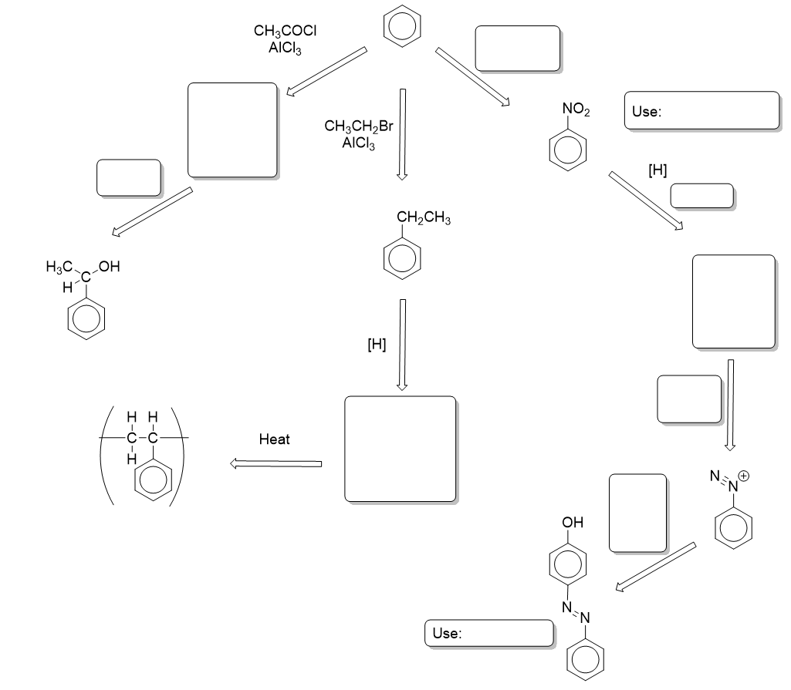

Aromatic chemistry - Answers

Naming aromatic compounds

A = Chlorobenzene
B = Nitrobenzene
C = Methylbenzene
D = Phenylamine or aminobenzene
E = Phenol or hydroxybenzene
F = Phenylethanone
G = 3-chlorobenzoic acid
H = 2,4,6-trinitromethylbenzene
I = Phenylenthanol
J = 4-chlorophenylamine

Industrially important molecules
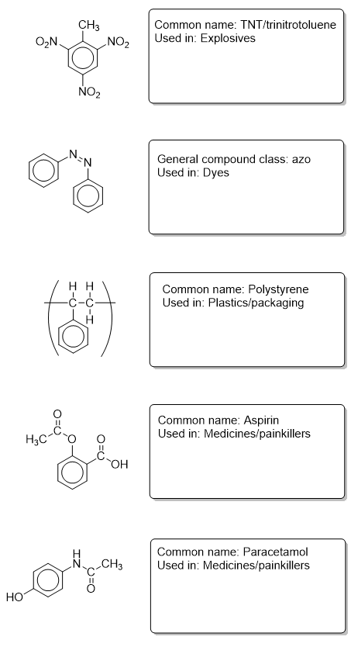

Structure of benzene
1.
2. Benzene is a liquid (1)
3. A 3D molecule (1) with alternating shorter bonds with longer ones (1)
4. Planar molecule (1) all bonds the same (intermediate) bond length (1)
5. Electrophilic addition mechanisms (1)
6. Kekulé is expected to be 3 x -120 = -360kJ.mol⁻¹ (1) Benzene gives out less energy upon hydrogenation (1) so it is more stable than the Kekulé structure suggests.

Electrophilic substitution
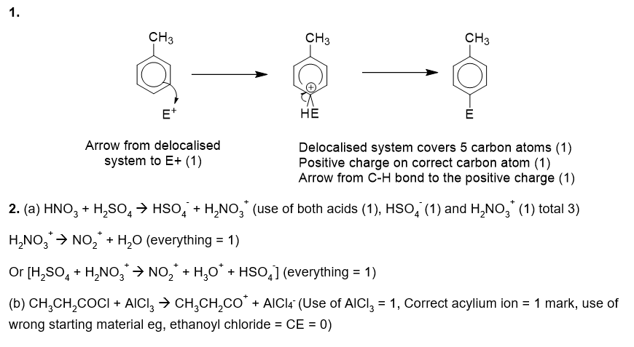

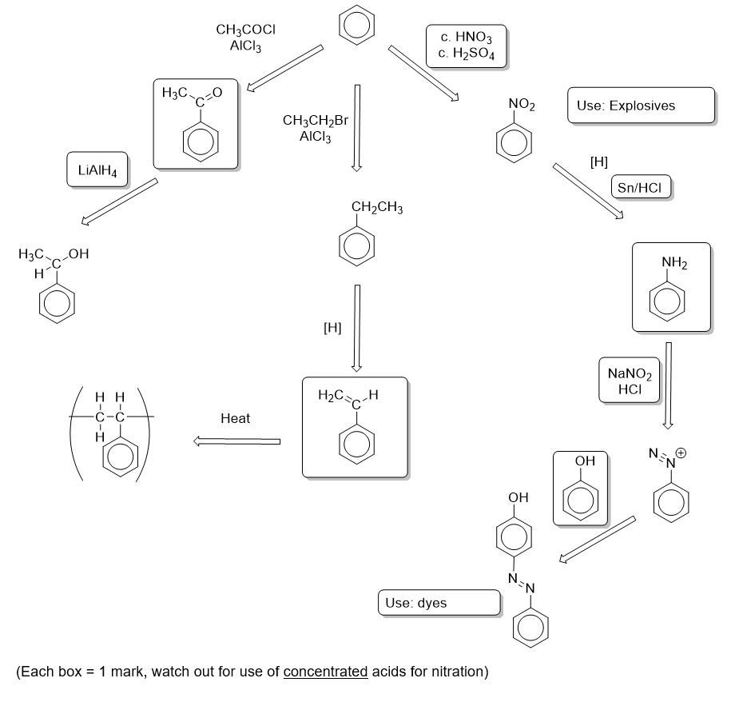
Synthetic routes with benzene

