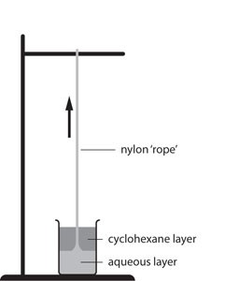
- The nylon rope trick is an experiment that you may have seen.
Watch a video at https://youtu.be/lNWc6xUf6U4

In this famous demonstration, two different monomers are added together.

One monomer is dissolved in water (the aqueous phase), and then the other monomer is added (the organic phase).

The two layers are immiscible.

Where the two layers meet, a chemical reaction takes place between the two monomers, making a polymer called nylon.

The nylon may then be carefully removed as a ‘rope’.
- Define the following terms.
Source: Royal Society of Chemistry

- Monomer
Answer: Small molecules that link together to form a polymer.
- Immiscible
Answer: Liquids that do not dissolve in each other, and do not mix.
- Polymer
Answer: A very long chain molecule made of many small molecules (monomers) bonded together.

The organic layer is made of one of the monomers dissolved in a substance called cyclohexane.

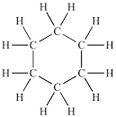
The structure of cyclohexane is shown below.

Questions b) to e) are about cyclohexane.
- To which class of hydrocarbon would cyclohexane belong – alkanes or alkenes?
Give a reason.
Answer: Alkanes – it is made of carbon single bonds only.
- State the general formula of the class of hydrocarbon in part b).
Answer: C_{n}H_{(2n+2)}
- What is the molecular formula for cyclohexane?
Answer: C₆H₁₂
- State whether cyclohexane fits the general formula in part c).
Give a reason.
Answer: No, as if there are 6 carbons, there should be 14 hydrogen atoms.
Cyclic alkanes must lose two hydrogen atoms if they are to form a ring.
So these have the same general formula as alkenes.

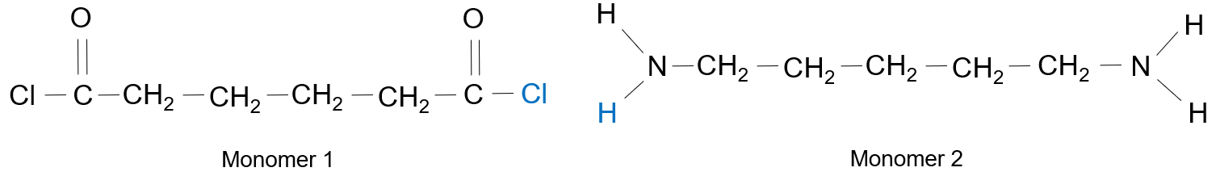
The structures of the two monomers in the nylon rope trick are as follows:

- State what is the same about each of the monomers and what is different about them.
Similarities:
Answer: They are both molecules containing carbon and hydrogen atoms.
Both contain six carbon atoms.
Differences:
Answer: Monomer 1 contains oxygen and chlorine, whereas monomer 2 contains nitrogen.
- The monomers react together as follows:
The chlorine atom from monomer 1 (shown in blue) combines with the hydrogen atom from monomer 2 (also shown in blue).

The hydrogen and chlorine atoms bond together to form a new substance, X.
The remaining parts of the monomers bond together using a carbon atom from monomer 1 and a nitrogen atom from monomer 2.
- State the name of substance X.
Answer: Hydrogen chloride.

- Explain why the monomers bond together once substance X has been made.
Think about the number of bonds the carbon and nitrogen atoms make.
Answer: The carbon atom was forming four bonds, and nitrogen was forming three bonds.
When HCl is formed, the carbon now forms only three bonds and nitrogen forms two.
The carbon atom bonds to the nitrogen atom to form a new C-N bond, and the numbers of bonds are restored to their original values.

- Complete the diagram below to show the new bond between the two monomers.
Substance X has already been removed.
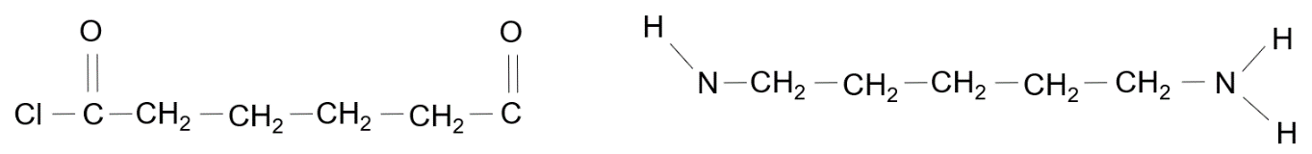

- Give the name of the type of polymer formed in this reaction.
Answer: A condensation polymer.

- A polyester is another example of the same type of polymer as nylon.
The monomers that can make a polyester are shown below.
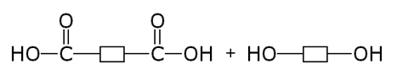

Monomer 3 Monomer 4

- State the name of the functional group present in each monomer.

Monomer | Functional group
Monomer 3 | Answer: Carboxylic acid.
Monomer 4 | Answer: Alcohol.

In order to form a polymer, the OH group from monomer 3 joined with a hydrogen from monomer 4, to form water.
- Show this formation of water by placing a ring around these two groups in the diagram above.
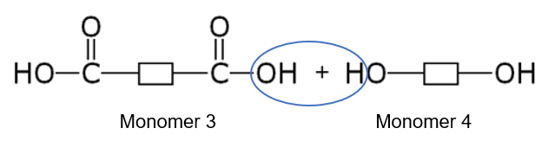
- Draw the structure of the molecule formed when monomer 3 and monomer 4 bond together.
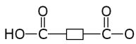
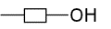

- Assuming that the reaction now continues at both ends of the molecule in part c), draw the repeat unit of the polyester formed.
