Titration apparatus

Learning objectives
- Recognise the apparatus used in titration experiments.
- Justify the use of particular pieces of apparatus.
- Evaluate the accuracy of apparatus used in titration experiments.

Introduction

Titration is an analytical technique used to determine the concentration of an unknown solution by reacting it with a standard solution. A standard solution is one which has an accurately known concentration. Titration uses very specific equipment which you will need to be able to recognise from diagrams. You will also need to be able to write accurately about the equipment and justify why certain apparatus is used.

Task

Fill out the table on pages 2 and 3 to summarise the apparatus used in titration, including name, diagram and purpose.

Follow-up questions
- List three factors that could affect the accuracy of a burette reading and how to avoid them.
- Some shorter chemists only fill their burettes to the 10.00 cm³ level. Explain why they may do this and discuss whether it would affect the results of the experiment.
- Universal indicator is not recommended when carrying out an acid-base titration reaction. Explain why.
- Burettes have an accuracy of ±0.05 cm³. A 25 cm³ pipette has an accuracy of ±0.06 cm³. Calculate the % uncertainty for measuring out a volume of 25 cm³ with a burette and a pipette. Discuss the results of your calculations.

Task

Name | Illustration | Diagram | Purpose
 | 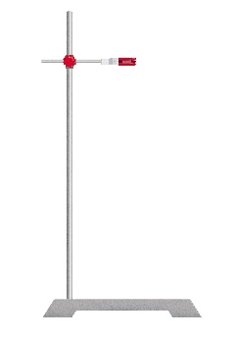
Name | Illustration | Diagram | Purpose

