Addition polymers

Polymers are versatile substances that can be made into a wide range of useful materials, from non-stick frying pans to bulletproof vests, with many of their potential uses yet to be discovered. They can also be found in nature in the form of proteins and DNA. Polymers can be synthesised by addition or condensation reactions and their properties can be explained in terms of intermolecular forces and functional groups.

Did you know …?

Shape memory polymers are smart materials and their shape memory can enable clothing to actively regulate your temperature or wound dressings to release drugs with changes in pH.

Synthesising polymers
Addition polymers are macromolecules, long chain covalent molecular structures consisting of repeating units. In a copolymer there is more than one repeating unit, whereas homopolymers, eg poly(chloroethene) (PVC), consist of only one.

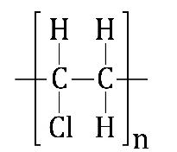 | 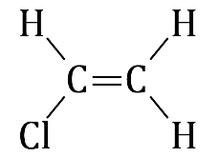 | 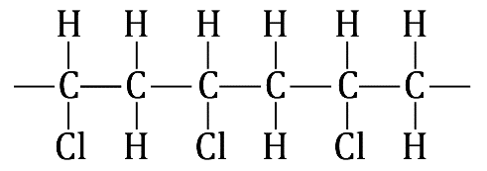
Repeating unit of chloroethene | Monomer of chloroethene | Poly(chloroethene) or (PVC)

Addition polymers are synthesised from unsaturated monomers without the formation of any side products. They tend to degrade less easily than condensation polymers because of the stronger C–C bonds in their backbone chain.

Physical properties

The physical properties of polymers are dictated by intermolecular forces. Hydrocarbon polymer chains are held together by London dispersion forces. Stronger polymer substances are held together by hydrogen bonding or covalent cross-links.

Did you know …?

Polymers are used as thickening agents in food sauces, paints, cosmetics and inks – anything you want thickened, so it’s no surprise they are also lubricants.

Synthetic and natural polymers

Synthetic polymers, known as plastics, can take decades to degrade and can release toxic fumes if burnt. Biodegradable plastic is broken down by microorganisms into compounds found in nature, while compostable plastic will only degrade under specific physical conditions.

Naturally occurring polymers include cotton, starch, DNA and proteins. Early synthetic polymers were chemically modified natural polymers, made by nitrating cellulose (nitrocellulose) and cross-linking natural rubber (vulcanised rubber).

Did you know …?

Polylactic acid is one of the most widely used bioplastics. It is made from plant starch and is used to make disposable cutlery and the plastic for 3D printing.

