Using thin-layer chromatography to investigate the reaction – teacher notes

Introduction
Revision of chromatography ideas introduced pre-16 could be useful – eg separation of coloured inks using filter paper. Emphasise the ability of chromatograms to identify substances from very small samples.

Thin-layer chromatography is a powerful tool for determining if two compounds are identical. If the compound to be identified leaves exactly the same pattern on a chromatography plate as a known compound it is reasonable to conclude that they are the same. However, if extra spots are observed as well as the characteristic pattern of the known compound, then impurities are likely to be present in the sample. The definitive test to show that two pure samples are the same is to run a mixed spot using a variety of solvents and show that you do not get a separation.

In this experiment both crude and recrystallised samples of aspirin are compared with a known sample of aspirin.

Apparatus
- Thin-layer chromatography plate and a pencil (not a biro or felt tip pen)
- Test tubes in a stand x 4 (& method of labelling the test-tubes)
- Capillary tubes for use as micropipettes x 3
- Chromatography chamber. Either a screw top jar tall enough to take the tlc plate, a small beaker with a petri dish for a lid, or a commercial tank
- Access to a fume cupboard and short wavelength UV lamp.
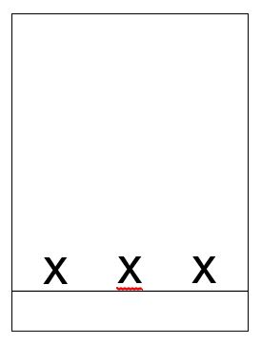

Chemicals
- Ethanol
- Dichloromethane
- Access to a few iodine crystals (three or four per experiment is enough)
- Samples for testing
- Ethyl ethanoate as chromatography solvent.

Health, safety and technical notes
- Read our standard health and safety guidance here https://rsc.li/3NwSBrB
- Wear eye protection
- Ethanol is flammable, see CLEAPSS Hazcard HC040a
- Dichloromethane is harmful by inhalation. Avoid breathing vapour and avoid contact with skin and eyes, see CLEAPSS Hazcard HC028
- Iodine can be an eye irritant, see CLEAPSS Hazcard HC054
- Ethyl ethanoate is volatile, highly flammable and the vapour may irritate the eyes and respiratory system. Avoid breathing the vapour and avoid contact with the eyes. Keep away from flames. See CLEAPSS Hazcard HC043a

Results
A good separation is obtained which can be seen by using UV light to observe the plate. Impurities should be clearly visible in the crude sample.

Answers
- Separation of substances is based on the many equilibrations the solutes experience between the moving (ethyl ethanoate) and stationary (silica) phase. Less polar substances move more quickly than more polar ones. In general the stationary phase is strongly polar and strongly binds polar substances. The moving liquid phase is usually less polar than the adsorbent and most easily dissolves substances that are less, or even non-polar. The results are made visible by UV absorption or by chemical reaction with iodine.
- The recrystallised aspirin and the commercial sample should only show one spot with the same R_{f} value. Other spots should be seen in the crude sample.

Further investigation
Try using different solvents to see whether better separation of impurities in the crude product is possible.

