Composition of the Earth

Learning objectives
- Identify and label the layers of the Earth.
- State the properties of each layer of the Earth.
- Deduce the most abundant elements and their proportion in each layer from incomplete information.

Introduction

Formed around 4.5 billion years ago, Earth is the only planet in our solar system known to support life.

As early as the 5th century BC the ancient Greeks documented the idea of its spherical structure. Since then, our understanding has developed and the current model is a layered structure. Each layer has unique chemical and physical properties.

Instructions
- Complete the information cards.
- Use the infographic poster and fact sheet to find out the most abundant elements in each layer of the Earth.
- Add notes to describe each layer at the bottom of each information card.
- Once you have completed the cards, cut them out and add them to your diagram of the Earth.

Extension

Complete the pie charts showing the most abundant elements in each layer of the Earth. Label each section with the correct proportion and create a key to show the elements present in each layer.

Information cards

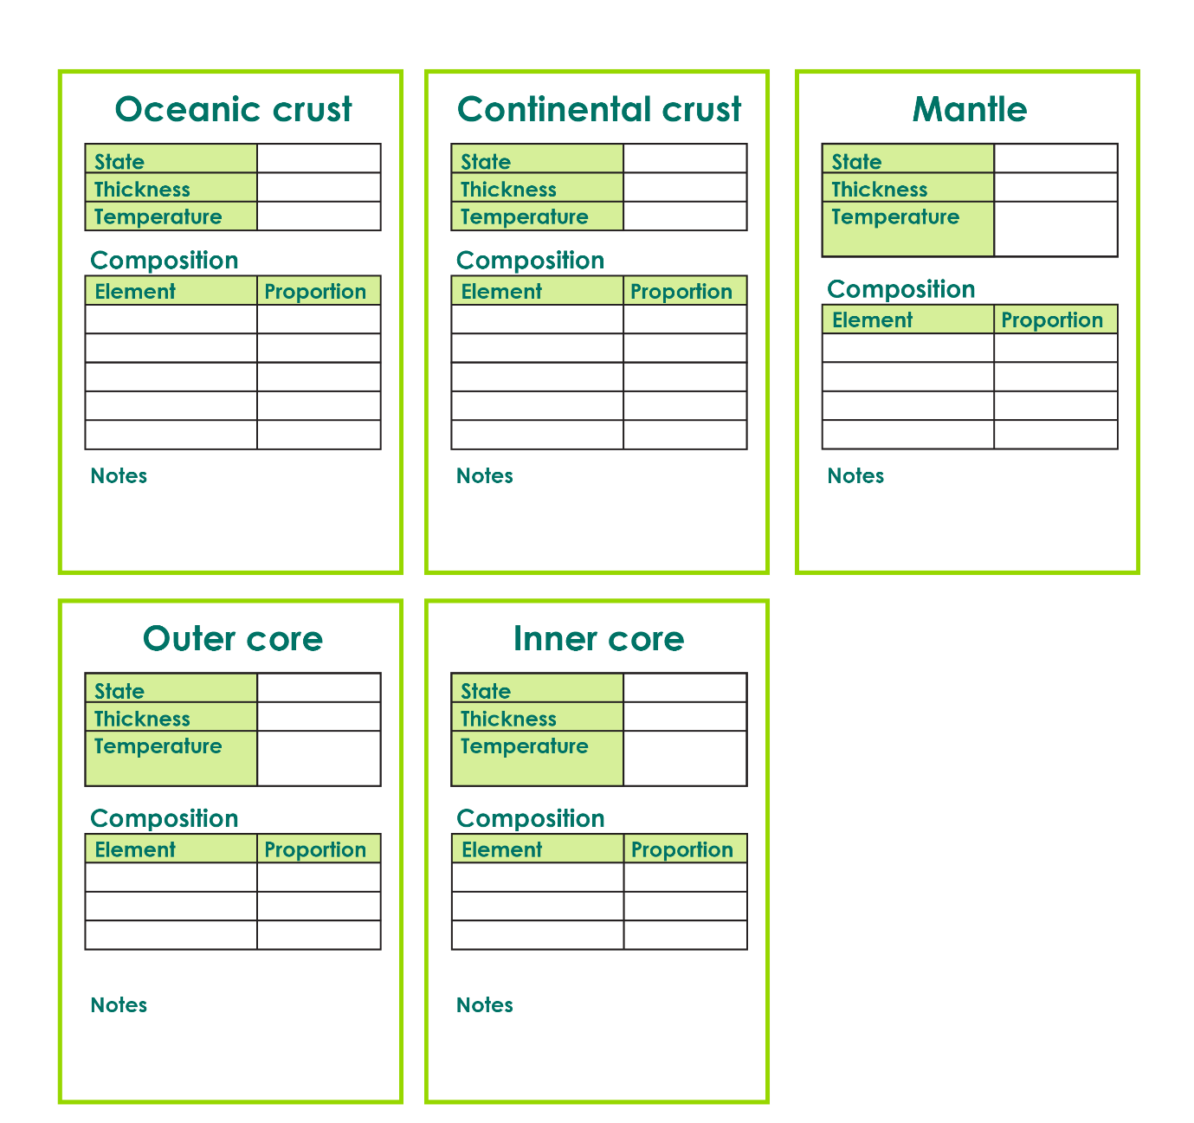

The most abundant elements in the Earth

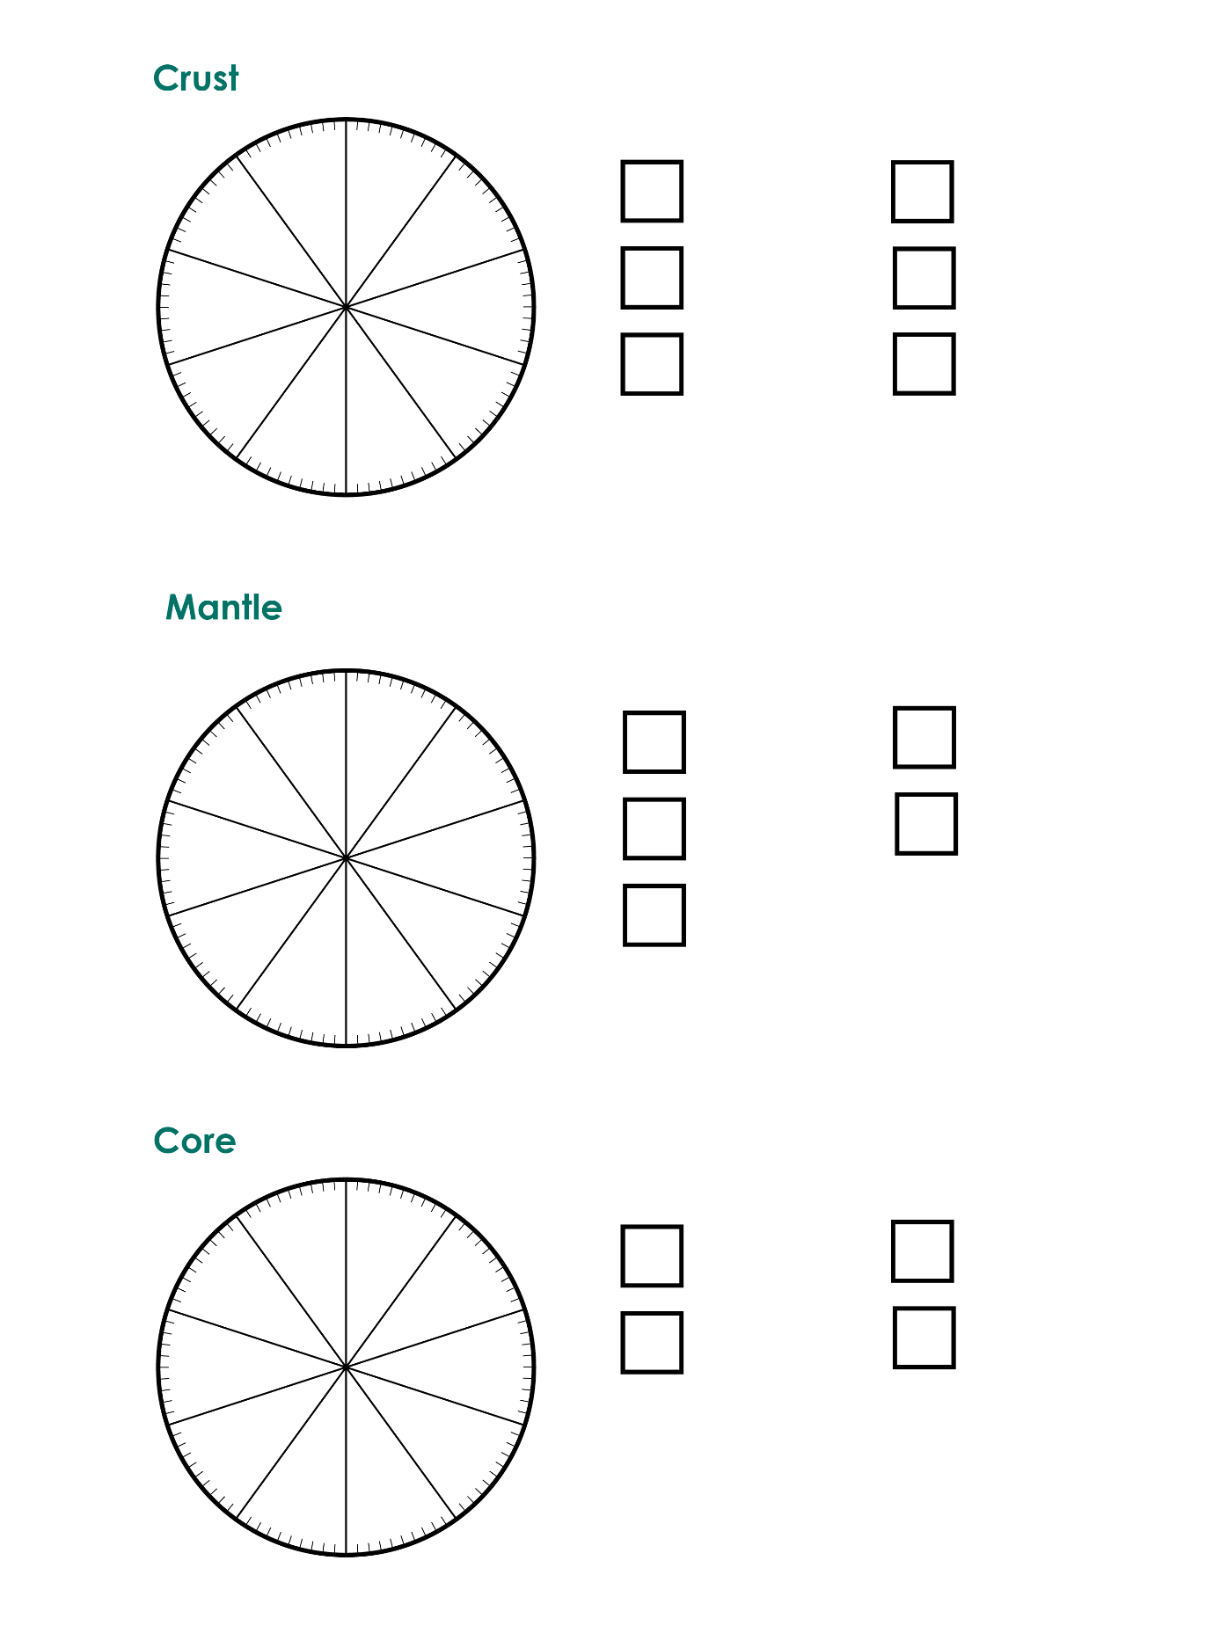

Composition of the Earth
