Particle model: teacher guidance

This resource forms part of the Review my learning series from the Royal Society of Chemistry. Additional support for addressing misconceptions identified using these worksheets can be found at rsc.li/3mm0IeW.

These worksheets assess content from the 11–14 and 14–16 specifications. They can be used to identify learners’ knowledge gaps and misconceptions following the completion of that part of the curriculum.

The Particle model worksheets cover the following topics:
- states of matter
- arrangement of particles in solids, liquids and gases
- names of state changes
- relative energy of particles in solids, liquids and gases
- changes in the kinetic energy when substances change state
- melting point and boiling point
- using melting point and boiling point data to deduce the state of a substance at a given temperature.

If learners successfully answer questions on these topics, they can attempt the extension question. This requires learners to use melting and boiling point data to complete a table identifying the state of a substance at different temperatures.

Level 1 () is a scaffolded worksheet in which learners select words from a word list to complete sentences. Level 2 () is a partially scaffolded worksheet in which learners complete sentences. Level 3 () is an unscaffolded worksheet in which most of the tasks involve answering questions with a minimum of prompts.

The worksheets can be used in a variety of ways:
- as an assessment of learners’ knowledge at the beginning or end of a period of teaching – the level of the worksheet used can be matched to the ability of the learners
- as an assessment of knowledge during a period of teaching and after learners have completed the relevant section of the specification
- as a revision tool prior to the relevant examination
- as a refresher exercise for teachers or non-subject specialists.

There is also scope to increase the level of the worksheets used as learners progress through the curriculum.

The ‘What do I understand?’ page is common to all levels of worksheet and can be used both to identify areas needing whole class attention and as an indicator for learners to help guide their revision.

The Teacher guidance provides model answers for each level and guidance on learners’ misconceptions. Learners can use the model answers to self- or peer assess.

Answers

Particle model: knowledge check
- scaffolded/partially scaffolded/unscaffolded
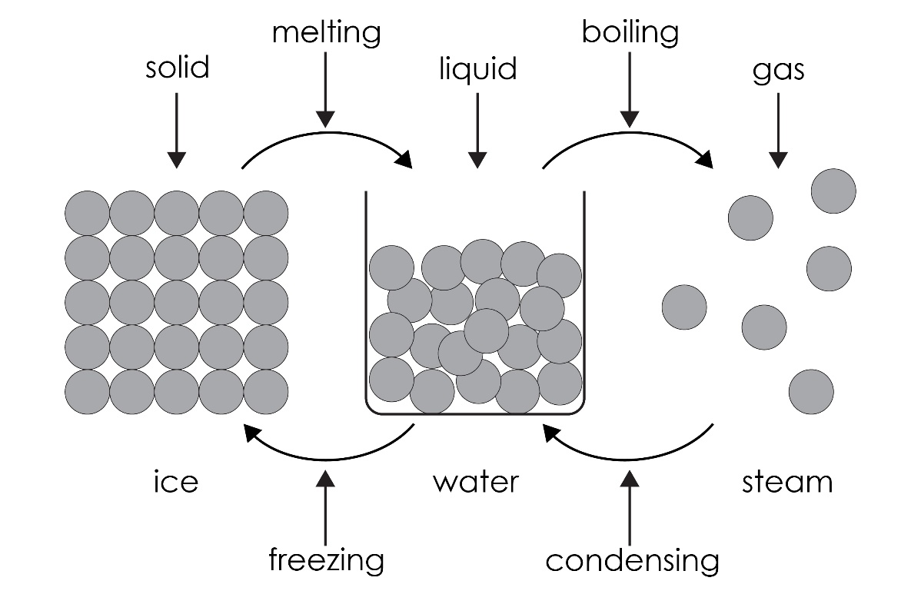
Guidance: Learners have many misconceptions about the states of matter. Because learners are familiar with ice, water and steam, there is a tendency to think that the three states of matter only apply to water.
A common misconception is assuming particles have the same property as the substance they make up; that they can expand, contract, melt, boil, etc. Learners need to realise that the particles stay the same. It is the amount of energy the particles have that determines the state of a substance.
Many overestimate the amount of space between the particles in a liquid. The particles in a liquid are mostly touching, but randomly arranged and move over each other. Many learners have difficulty with the concept of empty space between particles in a gas, assuming it is occupied by something else with gas particles in it.
Another common misconception is confusing melting and dissolving. Boiling and evaporation are also often confused. Boiling happens at a set temperature for a pure substance; evaporation can happen at any temperature if particles possess enough energy to escape the surface of the liquid. Being able to boil a gas or freeze a solid are other common misconceptions.

- scaffolded/partially scaffolded

In solids, the particles are very close together in a regular pattern. The particles vibrate around a fixed position. Solids have a fixed shape. Solids cannot be easily compressed because their particles are close together with no space to move into.

unscaffolded
  - The particles in a solid are close together and touching.
  - The particles vibrate in a fixed position.
  - The particles are close together with little space to move into.
Guidance: See question 1.1.
- scaffolded/partially scaffolded

In liquids, the particles are very close together and are randomly arranged, but still touching. The particles move around each other and have more energy than in a solid but less than in a gas.

Liquids do not have a fixed shape. Liquids can flow and take the shape of their container, because their particles can move around each other. Liquids cannot be easily compressed because their particles are close together with little space to move into.

unscaffolded
  - The particles in a liquid are close together and randomly arranged with most touching.
  - Particles move randomly and can flow around each other.
  - i. Particles in a liquid have more energy than in a solid.
    - Particles in a liquid have less energy than in a gas.
Guidance: See question 1.1.

- scaffolded/partially scaffolded

In gases, the particles are far apart and randomly arranged. The particles move quickly in all directions. The particles in a gas have much more energy than the particles in a liquid or solid. Gases do not have a fixed shape and can flow and completely fill their container. Gases can be compressed because their particles are far apart with space to move into.

unscaffolded
  - The particles in a gas are far apart and randomly arranged.
  - They move quickly in all directions.
  - Gases are easy to compress because there are large spaces between the particles.
Guidance: See question 1.1.

Particle model: test myself
- scaffolded/partially scaffolded/unscaffolded
  - Solid → liquid (eg ice to water) is known as melting.
  - Liquid → solid (eg water to ice) is known as freezing.
  - Liquid → gas (eg water to steam) is known as boiling.
  - Gas → liquid (eg steam to water) is known as condensing.
Guidance: Confusing melting and dissolving is a common misconception. Boiling and evaporation are also often confused. Boiling happens at a set temperature for a pure substance; evaporation can happen at any temperature if particles possess enough energy to escape the surface of the liquid. Being able to boil a gas or freeze a solid are other common misconceptions.
- scaffolded

gas

partially scaffolded/unscaffolded

Particles have most kinetic energy in the gas/gaseous state.
Guidance: Energy is a difficult concept for learners to understand. Here, it describes the movement of particles. This can be related to the common use of the word as in ‘having more energy to do something’.
- scaffolded/partially scaffolded/unscaffolded

The kinetic energy increases.
Guidance: The use of models such as polystyrene spheres can help learners to visualise the changes in kinetic energy of particles as a substance changes state. Roleplay, where the learners represent particles, can also help (although the gaseous state gets a bit excitable).

- scaffolded/partially scaffolded/unscaffolded

The particles in a solid are in a regular arrangement. All the particles are touching and vibrate around a fixed position.
Guidance: See question 1.1.
- scaffolded/partially scaffolded/unscaffolded

The particles in a gas move quickly in all directions.
Guidance: See question 1.1.
- scaffolded/partially scaffolded/unscaffolded

When temperature is increased, the particles in a gas move more quickly because they have more kinetic energy.
Guidance: A common misconception is that the kinetic energy of particles only changes when a substance changes state. Learners need to appreciate that, as a substance is heated, the kinetic energy of its particles gradually increases to a point where they have enough energy to change state.
- scaffolded/partially scaffolded/unscaffolded

The melting point is the temperature at which a solid becomes a liquid.
Guidance: Since learners are probably most familiar with the different states of water and its melting and boiling points, some will think all substances melt at 0°C and boil at 100°C. Question 3.1 gives boiling and melting points for some elements.
- scaffolded/partially scaffolded/unscaffolded

The boiling point is the temperature at which a liquid becomes a gas.
Guidance: See question 2.7.

- scaffolded/partially scaffolded
  - Below 50°C, the substance is a solid.
  - Above 170°C, the substance is a gas.
  - So, at 100°C, the substance is a liquid.

unscaffolded

At 100°C, the substance is a liquid.
Guidance: Drawing a temperature scale will help learners to understand the states at different temperatures. Also see guidance for question 2.7. (Note: the substance in the question is hypothetical to illustrate the point.)
- scaffolded/partially scaffolded
  - Below –220°C, the substance is a solid.
  - Above –112°C, the substance is a gas.
  - So, at 25°C, the substance is a gas.

unscaffolded

At 25°C, the substance is a gas.
Guidance: The use of negative numbers will confuse many learners, with some assuming that –220 is greater than –112. The use of a temperature scale including negative numbers will help many learners. (Note: the substance in the question is hypothetical to illustrate the point.)

Particle model: feeling confident?
- scaffolded/partially scaffolded/unscaffolded
Substance | Melting point (°C) | Boiling point (°C) | State at  –100°C  unscaffolded | State at  0°C  scaffolded/  partially scaffolded/  unscaffolded | State at 100°C  scaffolded/  partially scaffolded/  unscaffolded
A | 44 | 280 | solid | solid | liquid
B | 30 | 2403 | solid | solid | liquid
C | –39 | 357 | solid | liquid | liquid
D | –101 | –35 | liquid | gas | gas
E | –209 | –183 | gas | gas | gas
F | –71 | –62 | solid | gas | gas
G | –7 | 59 | solid | liquid | gas
H | 302 | 669 | solid | solid | solid
I | 27 | 677 | solid | solid | liquid

Guidance: The guidance for questions 2.9 and 2.10 also applies here. The data provided for substance A to I are melting and boiling points for some elements. The substances in questions 2.9 and 2.10 are hypothetical to illustrate the point.

Particle model: what do I understand?
Mini-topic | Assessed via:
I know the states of matter. | Q1.1, Q1.2, Q1.3, Q1.4,  Q2.1
I can describe the arrangement of particles in:  - solids  - liquids  - gases. | Q1.1, Q1.2, Q1.3, Q1.4,  Q2.4
I know the names of state changes. | Q1.1  Q2.1
I understand the relative energy of particles in:  - solids  - liquids  - gases. | Q1.1, Q1.3, Q1.4  Q2.2, Q2.3, Q2.5
I understand the changes in kinetic energy when substances change state. | Q2.3, Q2.6
I understand that different substances have different melting and boiling points and know what these represent. | Q2.7, Q2.8, Q2.9
I can use melting and boiling point data to deduce the state of a substance at a given temperature. | Q2.9, Q2.10
Feeling confident? topics | Assessed via:
I can use melting and boiling point data to identify the state of a substance at different temperatures. | Q3.1

