Basic mathematical competencies question sheet

Rearranging equations

- The amount of substance in moles (n) in a solution can be calculated when the concentration given in mol/dm³ (c) and volume (v) in cm³ are known by using the equation:
$$\text{n = }\frac{\text{cv}}{\text{1000}}$$
- Rearrange this equation making c the subject of the equation. (1 mark)
- Rearrange this equation making v the subject of the equation. (1 mark)

- The density of a substance can be calculated from its mass (m) and volume (v) using the equation:
$$\text{d = }\frac{\text{m}}{\text{v}}$$
- Rearrange this equation so that the mass of a substance can be calculated given its density and volume.
(1 mark)
Chemists most commonly work with masses expressed in grams and volumes in cm³. However, the SI unit for density is kg/m³.

- Write an expression for the calculation of density in the SI unit of kg/m³ when the mass (m) of the substance is given in g and the volume (v) of the substance is given in cm³.
(2 marks)
- The de Broglie relationship relates the wavelength of a moving particle (λ) with its momentum (p) through Planck’s constant (h):
$$\text{λ} \text{= }\frac{\text{ h}}{\text{p}}$$
- Rearrange this equation to make momentum (p) the subject of the formula.
(1 mark)
Momentum can be calculated from mass and velocity using the following equation.
$$\text{p =mv}$$
- Using this equation and the de Broglie relationship, deduce the equation for the velocity of the particle.
(2 marks)
- The kinetic energy (KE) of a particle in a time of flight mass spectrometer can be calculated using the following equation.
$$\text{KE =}\frac{\text{1}}{\text{2}}\text{m}{\text{v}}^{\text{2}}$$
Rearrange this equation to make v the subject of the equation.
(2 marks)

BODMAS (order of operations)
The order of operations for a calculation is very important. If operations are carried out in the wrong order then this could lead to the wrong answer. Most modern calculators will anticipate BODMAS issues when operations are entered but human beings can override the calculator’s instincts.

- Do the following calculations in your head.

- 3 + 5 × 5 =
- 6 × 6 + 4 =
- 20 – 6 × 2 =
- 48 – 12 ÷ 4 =
- 4 + 4 ÷ 2 =
- 100 – (20 × 3) =
(6 marks)
- The molecular formula of glucose is C₆H₁₂O₆. Three students entered the following into their calculators to calculate the relative formula mass of glucose. Repeat their calculations as shown.
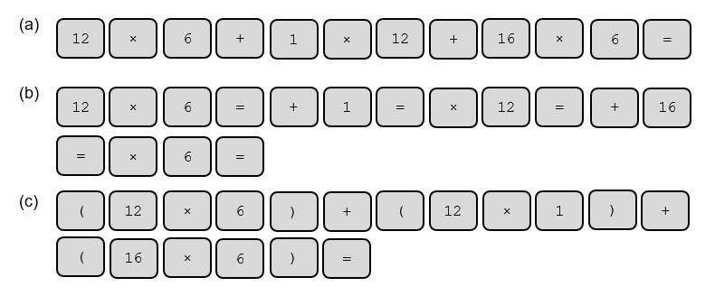
(d) Write a sentence summing up why the answers differ.
(4 marks)

Quantity calculus (unit determination)

- Determine the units of density given that
$$density=\frac{mass(g)}{volume ({cm}^{3})}$$
(1 mark)
- Determine the units of concentration given that
$$concentration= \frac{number of moles (mol)}{volume ({dm}^{3})}$$
(1 mark)
- Pharmacists often calculate the concentration of substances for dosages. In this case the volumes are smaller, measured in cm³, and the amount is given as a mass in grams. Determine the units of concentration when
$$concentration= \frac{mass (g)}{volume ({cm}^{3})}$$
(1 mark)
- Rate of reaction is defined as the ‘change in concentration per unit time’. Determine the units for rate when concentration is measured in mol dm^{–3} and time in seconds.
(1 mark)

- Pressure is commonly quoted in pascals (Pa) and can be calculated using the formula below. The SI unit of force is newtons (N) and area is m².
$$pressure= \frac{force }{area }$$
Use this formula to determine the SI unit of pressure that is equivalent to the Pascal.

(1 mark)
- Determine the units for each of the following constants (K) by substituting the units for each part of the formula into the expression and cancelling when appropriate. For this exercise you will need the following units [ ] = mol dm^{–3}, rate = mol dm^{–3} s^{–1}, p = kPa.

- $K_{c}= \frac{{\left[A\right][B]}^{2}}{[C]}$
- $K= \frac{rate}{\left[A\right][B]}$
- $K_{p}\frac{({pA)}^{0.5}}{\left(pB\right)}$
- $K_{w}=\left[H^{+}\right]\left[{OH}^{-}\right]$
- $K_{a}=\frac{\left[H^{+}\right] {[X}^{-}]}{\left[HX\right]}$

Expressing large and small numbers

Standard form and scientific form

Large and small numbers are often expressed using powers of ten to show their magnitude. This saves us from writing lots of zeros, expresses the numbers more concisely and helps us to compare them.
In standard form a number is expressed as;

a × 10^{n}

where a is a number between 1 and 10 and n is an integer.

Eg, 160 000 would be expressed as 1.6 × 10⁵

Sometimes scientists want to express numbers using the same power of ten. This is especially useful when putting results onto a graph axis. This isn’t true standard form as the number could be smaller than 1 or larger than 10. This is more correctly called scientific form.
Eg, 0.9 × 10^{–2}, 2.6 × 10^{–2}, 25.1 × 10^{–2} and 101.6 × 10^{–2} are all in the same scientific form.

- Express the following numbers using standard form.
- 1 060 000
- 0.001 06
- 222.2
(3 marks)
- The following numbers were obtained in rate experiments and the students would like to express them all on the same graph axes. Adjust the numbers to a suitable scientific form.
(3 marks)
- Calculate the following without using a calculator. Express all values in standard form.
- $\frac{{10}^{9}}{{10}^{5}}$
- $\frac{{10}^{7}}{{10}^{-7}}$
- $\frac{{1.2 × 10}^{6}}{2.4 {× 10}^{17}}$
- ${(2.0 × 10}^{7}) × {(1.2 × 10}^{-5 })$
(4 marks)

Significant figures, decimal places and rounding

For each of the numbers in questions 1–6, state the number of significant figures and the number of decimal places.

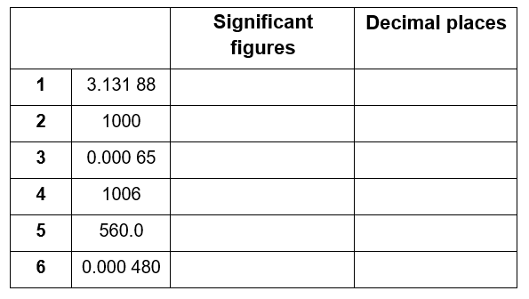

(6 marks)

- Round the following numbers to (i) 3 significant figures and (ii) 2 decimal places.
- 0.075 84
- 231.456

(4 marks)

Unit conversions 1 – Length, mass and time

Mo’s teacher has drawn a diagram on the board to help him with converting quantities from one unit into another.

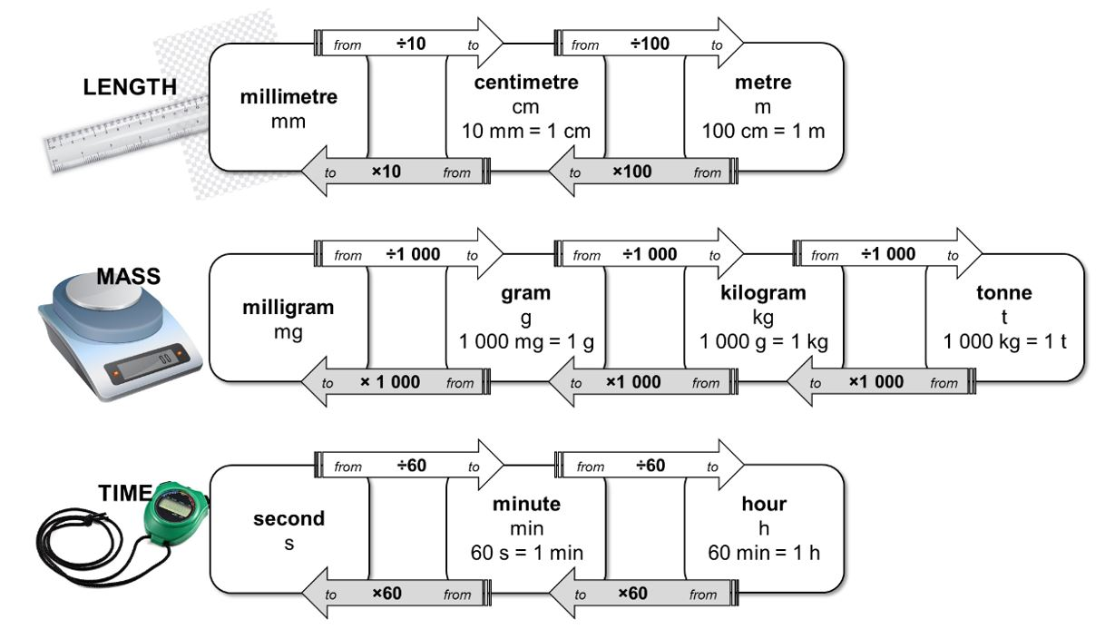
For example, to convert a length in millimetres into units of centimetres, divide by 10,
eg 10 mm = 1 cm.

Use the diagram to help with the following unit conversions.
(10 marks)
- A block of iron has a length of 1.2 cm. Calculate its length in millimetres.
- The width of the classroom is 7200 cm. Calculate its length in metres.
- A reaction reaches completion after 4½ minutes. Convert this time into seconds.
- The stop clock reads 2 min 34 s. Convert this time into seconds.
- A method states that a reaction needs to be heated under reflux for 145 min. Calculate this time in hours and minutes.
- A factory produces 15 500 kg of ammonia a day. Calculate the mass of ammonia in tonnes.
- A paper reports that 0.0265 kg of copper oxide was added to an excess of sulfuric acid. Convert this mass of copper oxide into grams.
- A packet of aspirin tablets states that each tablet contains 75 mg of aspirin. Calculate the minimum number of tablets that contain a total of 1 g of aspirin.
- A student measures a reaction rate to be 0.5 g/s. Convert the rate into units of g/min.
- A factory reports that it produces fertiliser at a rate of 10.44 kg/h. Calculate the rate in units of g/s

Unit conversions 2 – Volume

The SI unit for volume is metre cubed, m³. However as volumes in chemistry are often smaller than 1 m³, fractions of this unit are used as an alternative.

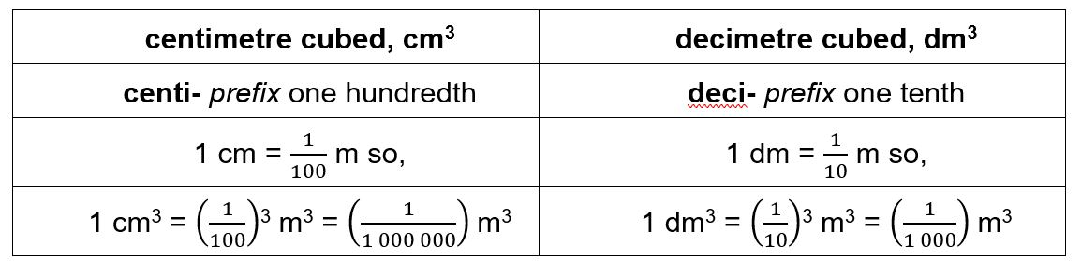

- Complete the table by choosing the approximate volume from the options in bold for each of the everyday items (images not drawn to scale).
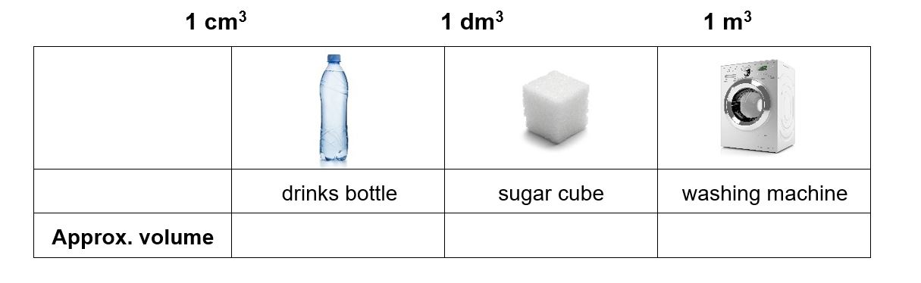
(1 mark)
- Complete the following sentences;
(1 mark)
To convert a volume in cm³ into a volume in dm³, divide by
To convert a volume in cm³ into a volume in m³, divide by

- A balloon of helium has a volume of 1600 cm³. What is its volume in units of dm³?
- The technician has prepared 550 cm³ of HCl(aq). What is its volume in units of m³?
- An experimental method requires 1.35 dm³ of NaOH(aq). What volume is this in cm³?
- A swimming pool has a volume of 375 m³. What volume is this in cm³?
- A 12 g cylinder of CO₂ contains 6.54 dm³ of gas. What volume of gas is this in units of m³?
- marks)

- Which cylinder of propane gas is the best value for money?
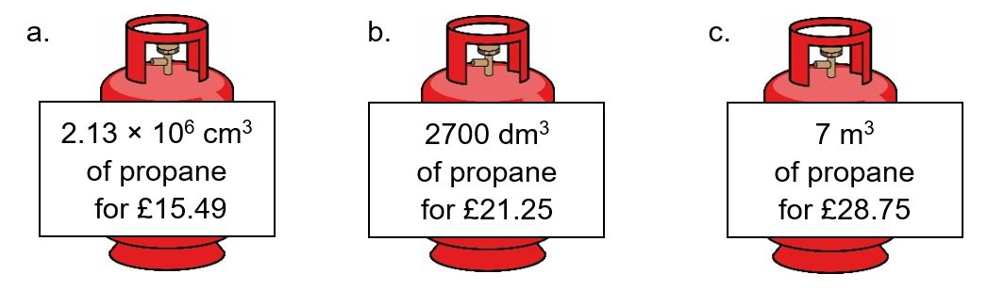
(3 marks)

Moles and mass
One mole of a substance is equal to 6.02 × 10²³ atoms, ions or particles of that substance. This number is called the Avogadro constant.
The value of the Avogadro constant was chosen so that the relative formula mass of a substance weighed out in grams is known to contain exactly 6.02 × 10²³ particles. We call this mass its molar mass.
We can use the equation below when calculating an amount in moles:

amount of substance (mol) | = | mass (g)
molar mass
(g mol^{–1})

How is a mole similar to a dozen?
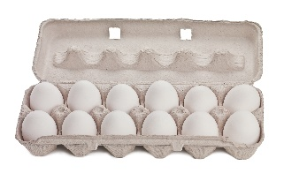
Stating the amount of substance in moles is just the same as describing a quantity of eggs in dozens. You could say you had 24 or 2 dozen eggs.

Use the equation above to help you answer the following questions.

- Calculate the amount of substance, in moles, in:
(3 marks)
a. 32 g of methane, CH₄ (molar mass, 16.0 g mol^{–1})
b. 175 g of calcium carbonate, CaCO₃
c. 200 mg of aspirin, C₉H₈O₄

- Calculate the mass in grams of:
(3 marks)
a. 20 moles of glucose molecules (molar mass, 180 g mol^{–1})
b. 5.00 × 10^{–3} moles of copper ions, Cu²⁺
c. 42.0 moles of hydrated copper sulfate, CuSO₄•5H₂O

a. 3.09 g of a transition metal carbonate was known to contain 0.0250 mol.
i. Determine the molar mass of the transition metal carbonate.
(1 mark)
ii. Choose the most likely identity for the transition metal carbonate from the list below:
CoCO₃ | CuCO₃ | ZnCO₃ | - mark)
- 4.26 g of a sample of chromium carbonate was known to contain 0.015 mol.
Which of the following is the correct formula for the chromium carbonate? (2 marks)
CrCO₃ | Cr₂(CO₃)₃ | Cr(CO₃)₃

BONUS QUESTION
If you had 1 mole of pennies which you could share with every person on earth how much could you give each person? Approximate world population = 7 500 000 000.

Moles and concentration
To calculate the concentration of a solution we use the equation:

concentration (mol dm^{–3}) | = | amount of substance (mol)
 |  | volume (dm³)
Use the equation to help you complete each of the statements in the questions below.

- 1.5 mol of NaCl dissolved in 0.25 dm³ of water produces a solution with a concentration of mol dm^{–3}.
- 250 cm³ of a solution of HCl(aq) with a concentration of 0.0150 mol dm^{–3} contains moles.
- A solution with a concentration of 0.85 mol dm^{–3} that contains 0.125 mol has a volume of dm³.
(1 mark each)

In this question you will need to convert between an amount in moles and a mass as well as using the equation above.

Space for working is given beneath each question.
a. 5.0 g of NaHCO₃ dissolved in 100 cm³ of water produces a solution with a concentration of mol dm^{–3}.
(2 marks)

b.25.0 cm³ of a solution of NaOH(aq) with a concentration of 3.8 mol dm^{–3} contains g of NaOH.
(2 marks)

c. The volume of a solution of cobalt(II) chloride, CoCl₂, with a concentration of 1.3 mol dm^{–3}
that contains 2.5 g of CoCl₂ is cm³.
(3 marks)

