Liquefying paint – answer sheet
Education in Chemistry
September 2020
rsc.li/3h1PjJa
Retrieval practice and quick-fire questions to revise your chemistry knowledge
3. Now test yourself by answering as many of these 10 quick questions as you can.
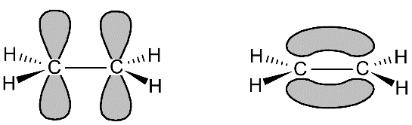
a.

two p orbitals overlap to form a π orbital

b. Acid: C=O 1680-1750 cm⁻¹; O-H (acid) 2500-3000 cm⁻¹ (broad); C-O 1000-1300 cm⁻¹
Ester: C=O 1680-1750 cm⁻¹; C-O 1000-1300 cm⁻¹

c. Fluoromethane is the most polar due to the strong dipole in the C-F bond.
In methane the small dipoles of the individual C-H bonds cancel out, so methane is non-polar.
In dichlorodifluoromethane there is a dipole symmetrically between the two C-Cl bonds and a bigger dipole in the opposite direction directly between the two C-F bonds. Overall, this results in a small molecular dipole directly between the C-F bonds. However, it is smaller than the dipole in fluoromethane because the two C-F dipoles are vector quantities and cancel each other out in one direction.

d. Initiation: Cl₂ 2Cl•
Propagation: CH₂Br₂ + Cl• •CHBr₂ + HCl
•CHBr₂ + Cl₂ CHBr₂Cl + Cl•
Termination: •CHBr₂ + Cl• CHBr₂Cl

e. Reduction: 3e⁻ + 4H⁺ + ${VO}_{2}^{+}$ V²⁺ + 2H₂O
Oxidation: Zn Zn²⁺ + 2e⁻
Redox: 8H⁺ + ${2VO}_{2}^{+}$ + 3Zn 2V²⁺ + 4H₂O + 3Zn²⁺

f. 3-phenyl pentanedioic acid

g. benzyl propanoate

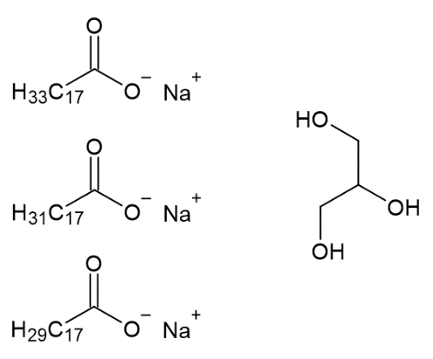
h. Products:

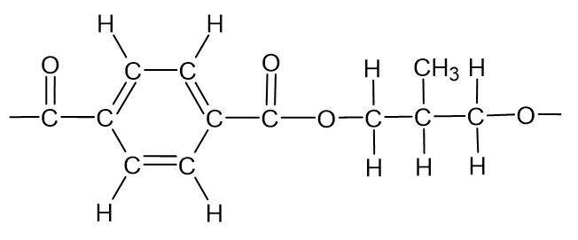

j. A central transition metal ion surrounding by ligands. Ligands are ions or molecules with a lone pair of electrons that form a coordinate bond with the transition metal ion or metal.

