The chemistry of iron

This resource accompanies the article Carbon monoxide – the silent killer in Education in Chemistry which can be viewed at rsc.li/3Q1cRjd

Learning objectives
- Review bonding concepts and use them to describe the bonding in haemoglobin (task 1).
- Apply the equilibrium law and Le Chatelier’s principle to the equilibrium reactions occurring between haemoglobin, oxygen and carbon monoxide (task 2).
- Draw conclusions from half-cell equations and their $E^{0}$values about the relative stabilities of binding ligands in complex ions (task 3).
- Analyse the half-cell equations and their $E^{0}$values to examine the effect of pH on redox potential and the final oxidation state of the reductant (task 4).

How to use

There are four tasks in the resource, which can be used in several ways to fit in with the scheme of learning and assessment plan for the programme. For example:
- as part of the teaching programme for transition metals (tasks 1 and 2) and redox chemistry (tasks 3 and 4)
- as a whole class activity, eg a time framed, team-based learning challenge
- as part of a revision programme reviewing topics of bonding, chemical equilibrium, transition metal and redox chemistry
- as a summative homework assessment at the end of teaching transition metals
- as part of a synoptic summative assessment of physical and inorganic chemistry

Hints are provided for some questions to make them more accessible to a wider range of learners.

The second part of task 4 is intended to be a challenge. Learners will construct full ionic equations from half-cell equations and their respective $E^{0}$values for rusting in alkaline conditions.

Answers

Task 1
- Bonding diagram for water showing two lone pairs and two bond pairs of electrons. Lone pairs identified as a feature of a ligand.

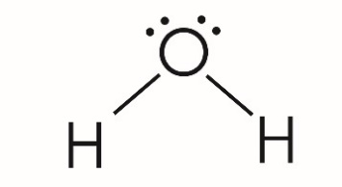

- Coordinate/dative covalent bonds are formed between the nitrogen atoms and the central Fe²⁺ ion.
- The lone pair of electrons on the attached atom allows it to form this type of bond.

- The haemoglobin complex is octahedral. Using the valence shell electron pair repulsion (VSEPR)/electron pair repulsion theory, the six bond pairs around the central Fe²⁺ orientate to maximum bond angle to minimise repulsion.

- Diagram to include a coordinate bond from the oxygen lone pair to the central Fe²⁺ and a double bond in the oxygen molecule as below. 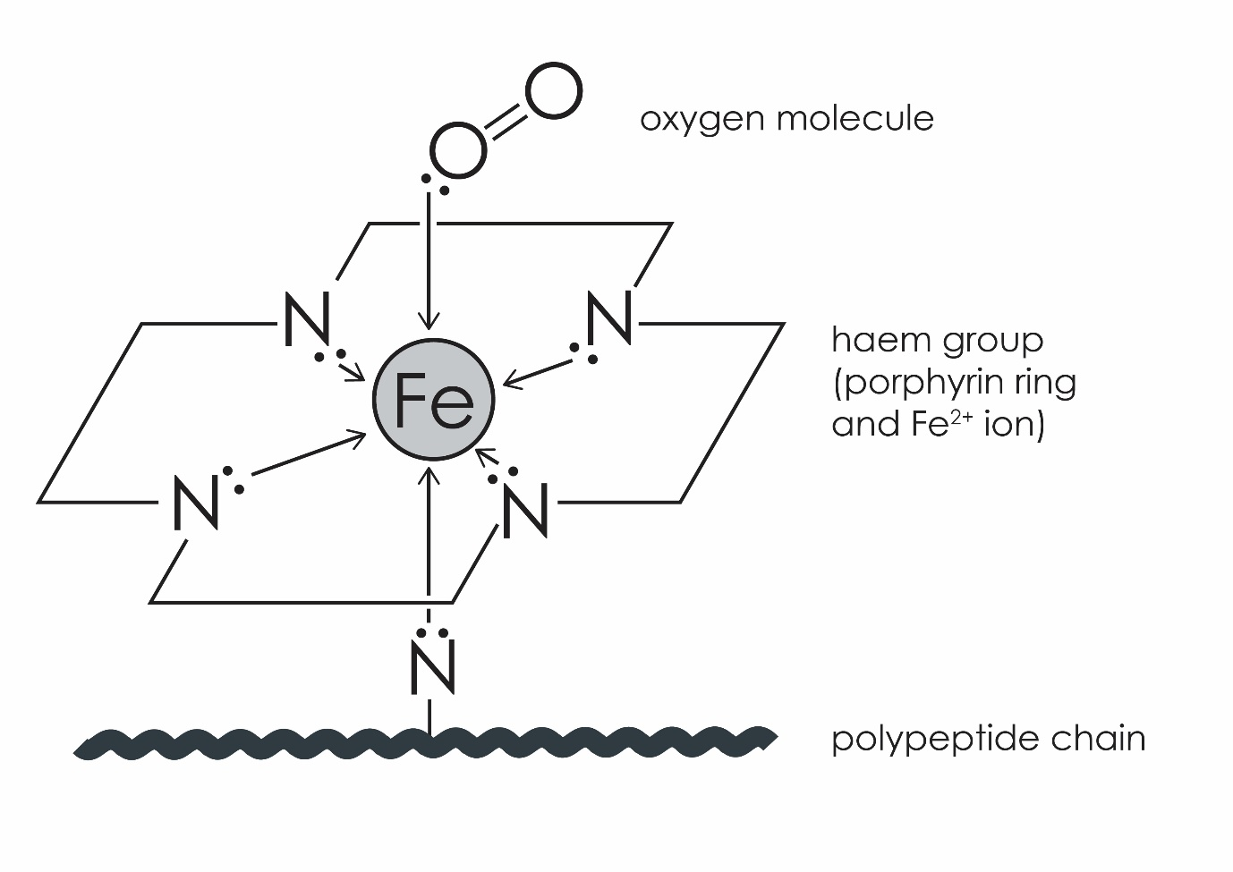
- Diagram to include a coordinate bond from the carbon lone pair on the carbon monoxide molecule to the central Fe²⁺ atom and a triple bond between C and O. 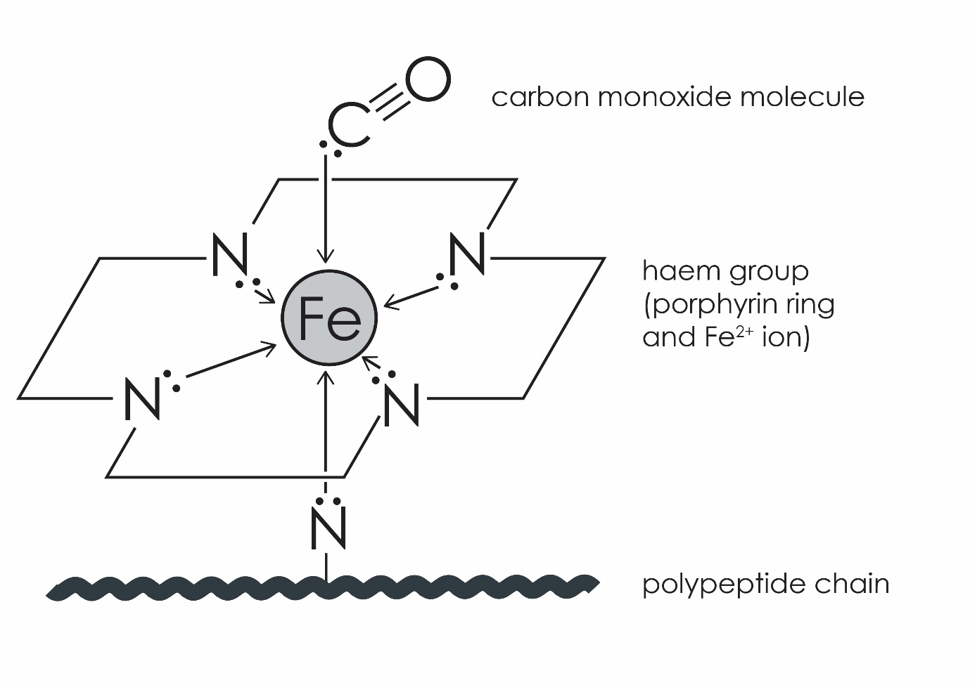
- Each diagram to show a triple bond between the atoms and a lone pair of electrons on each atom. The cyanide ion should also have a negative charge.

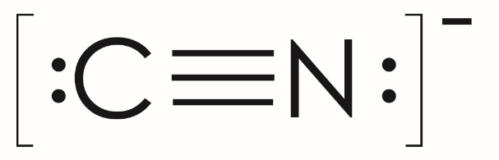

Task 2
- Incomplete combustion of hydrocarbons in a limited supply of oxygen prevents carbon being fully combusted to carbon dioxide. Carbon monoxide is produced instead.

- Ligand exchange/substitution.

- When the concentration of oxygen, [O₂], is high in the lungs, the position of equilibrium in equilibrium reaction 1 moves from the left to the right and O₂ displaces/substitutes the H₂O bonded to the haemoglobin complex ion.
- The reverse reaction is favoured when [O₂] is lower in the tissues and so O₂ is released.

- $K_{stab}=\frac{[Hb(C{O)}_{4}]}{[{Hb(O_{2})}_{4}]{[CO]}^{4}}$

- $Units= {mol}^{-4} {dm}^{12}$

- Equilibrium reaction 2 has a higher$K_{stab}.$
- CO is a stronger ligand than O₂ and equilibrium lies further to the right-hand side (RHS). The higher stability of Hb(CO)₄ causes CO poisoning and prevents O₂ being transported in the blood.

Task 3

- NH₃
- Equilibrium reaction 3
- ${[Ni({NH}_{3})_{6}]}^{2+}$

- ${[Fe(H_{2}{O)}_{6}]}^{3+} + e^{-} ⇌ {[Fe(H_{2}{O)}_{6}]}^{2+}{ E}^{0}=+0.77 V$

H₂O is a less electron-donating ligand than NH₃ – it has a less positive $E^{0}$value than NH₃ and therefore is the less likely to be reduced. It is more likely to be reduced than an anionic ligand though.

$${[Fe({CN)}_{6}]}^{3-} + e^{-} ⇌ {[Fe({CN)}_{6}]}^{4-}{ E}^{0}=+0.37 V$$

Cyanide is the only anionic ligand – it has the least positive $E^{0}$value and therefore is the least easily reduced.

$${[Fe({NH}_{3})_{6}]}^{3+} + e^{-} ⇌ {[Fe({NH}_{3})_{6}]}^{2+}{ E}^{0}=+0.95 V$$

NH₃ is a more electron-donating ligand than H₂O – it has the most positive $E^{0}$value and therefore is the most likely to be reduced.

Task 4

- Purple to colourless.
- $Mn{O_{4}}^{-}\left(aq\right) + 8H^{+}\left(aq\right) + 5e^{-} ⇌ {Mn}^{2+}\left(aq\right) + 4H_{2}O\left(l\right)$

$$Mn{O_{4}}^{-}\left(aq\right) + 2H_{2}O\left(l\right) + 3e^{-} ⇌ {MnO}_{2}\left(s\right) + 4{OH}^{-}(aq)$$

- The $E^{0}$value is more positive for the $Mn{O_{4}}^{-}\left(aq\right)/H^{+}(aq)$ half-cell, therefore manganate(VII) is a stronger oxidant and equilibrium lies further to the right-hand side. The final oxidation state for the $Mn{O_{4}}^{-}\left(aq\right)/H^{+}\left(aq\right)$half-cell is +2. The final oxidation state for the $Mn{O_{4}}^{-}\left(aq\right)/H_{2}O(l)$ half-cell is limited to +4.

- The $Mn{O_{4}}^{-}\left(aq\right)/H^{+}\left(aq\right)$half-cell has a more positive $E^{0}$value than the ${Cl}_{2}\left(aq\right)/{Cl}^{-}\left(aq\right)$half-cell; therefore ${Cl}^{-}\left(aq\right)$ will be oxidised to ${Cl}_{2}\left(aq\right)$ in the presence of $Mn{O_{4}}^{-}\left(aq\right)/H^{+}\left(aq\right)$.

- Challenge
- ${Fe}^{2+}={1s}^{2}, {2s}^{2}, {2p}^{6}, {3s}^{2}, {3p}^{6}, {4s}^{2}, {3d}^{6}$

$${Fe}^{3+}={1s}^{2}, {2s}^{2}, {2p}^{6}, {3s}^{2}, {3p}^{6}, {4s}^{2}, {3d}^{5}$$

${Fe}^{3+}$ has a half-filled d-level. Therefore, there is no repulsion due to electron pairing.

- $Step 1: 2Fe\left(s\right)+ O_{2}\left(g\right) + {2H}_{2}O\left(l\right) → {4OH}^{-}\left(aq\right) + 2Fe^{2+}(aq)$

$$Step 2:4Fe{(OH)}_{2} + O_{2}\left(g\right) + {2H}_{2}O\left(l\right) → 4Fe{(OH)}_{3}$$

- Step 1: $E_{cell}=+0.84 V.$ This value is positive and therefore the cell is feasible.

Or, the $E^{0}$value for the $O_{2}\left(g\right), 2H_{2}O\left(l\right)/{OH}^{-}\left(aq\right)$half-cell is more positive than for the ${Fe}^{2+}(aq)/Fe(s)$ half-cell.

Step 2: $E_{cell}=+0.96 V.$ This value is positive and therefore the cell is feasible.

Or, the $E^{0}$value for the $O_{2}\left(g\right), 2H_{2}O\left(l\right)/{OH}^{-}\left(aq\right)$half-cell is more positive than for the $Fe({OH)}_{3}(s)/Fe({OH)}_{2}(s){,OH}^{-}(aq)$ half-cell.

