The chemistry of food
Activity 1: identifying food colourings in soft drinks
Equipment (per group)

Cocktail sticks/tooth picks
Artificial food colourings
1% sodium chloride (NaCl) solution
2 × 250 cm³ beakers
Watch glass
Ruler
Sharp pencil
Concentrated extracts from soft drinks
2 × TLC plates

Safety and hazards
Wear safety glasses and a lab coat when instructed to.
To do
- Carefully place the thin-layer chromatography (TLC) plate on the desk in front of you. Always hold the plate by the edges only, to make sure you avoid getting the oils from your fingers onto the plate itself.
- Using a sharp pencil and ruler, draw a very faint line about 2 cm from the bottom of the plate. Make a pencil mark on this line every 15 mm.
- Using a toothpick, place a small dot of the first sample of food colouring on a mark on the pencil line. It is important to make the spots very small. Usually, one touch with a toothpick is enough.

- Label each dot in pencil.
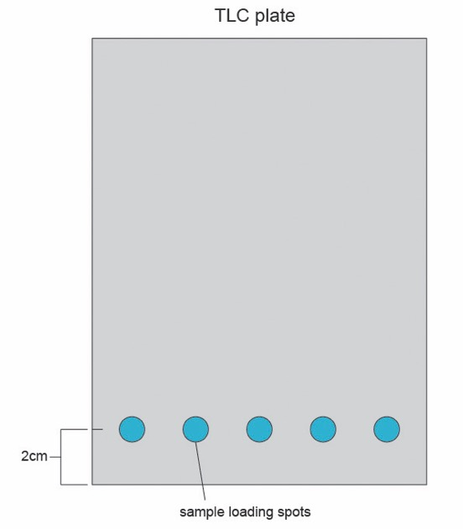

© Royal Society of Chemistry
- Repeat until you have spotted all the food colourings separately across the bottom of the plate.
- Place a thin layer (approximately 0.5 cm) of 1% sodium chloride solution (solvent) in the bottom of the beaker.
- Place the spotted plates in the tank, spotted end down (spots must remain above the solvent level) and place a watch glass over the top of the beaker.
- Repeat this procedure on a fresh TLC plate using the concentrated extracts from soft drinks.
- Allow the solvent to rise to near the top of the plate. This may take up to an hour. Then remove the plate from the solution.
- Use the method in your workbook (the table in question 2) to find the artificial colourings that are used in the soft drinks.

Activity 2: finding the vitamin C content of fruit juice
You will use the reaction between iodine and vitamin C (ascorbic acid) to calculate the amount of vitamin C in a sample of shop-bought, high vitamin C content, orange juice. Do not drink any of the juice.
Equipment (per group)

Burette and stand
250 cm³ conical flasks
White tile
100 cm³ measuring cylinder
10 cm³ syringe for measuring the starch solution
100 cm³ beaker for collecting iodine solution
Distilled water
0.00125 M iodine solution
0.5% starch solution
Funnel
Glass rod
Pasteur pipette
Fruit juice

Safety and hazards
Wear safety glasses in the lab when instructed to.
Avoid skin contact with iodine solution as it will stain the skin.
To do
- Measure a 100 cm³ sample of juice into a conical flask. Add 1 cm³ starch solution. Stir well.
- Collect some iodine solution in a 100 cm³ beaker. Carefully, fill the burette to the 0 cm³ line with iodine solution, using a funnel, taking care to avoid skin contact. You may need to place the burette stand on a stool to see the fill line clearly at eye level.

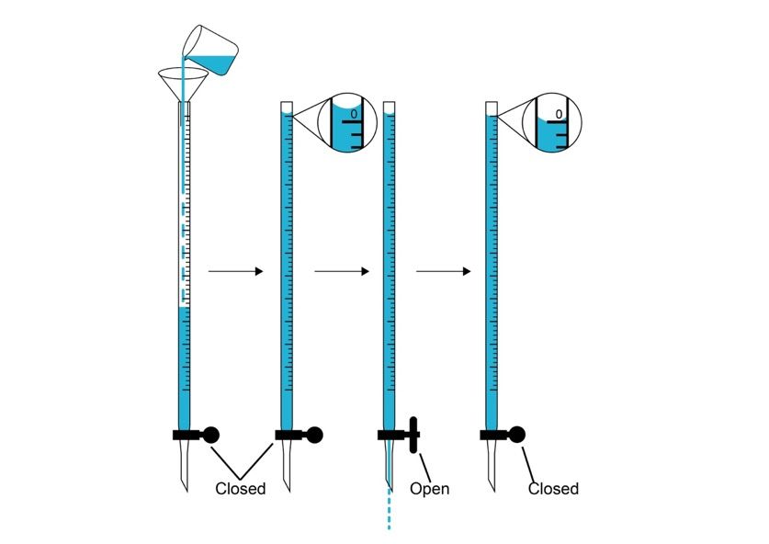
You will need to refill the burette to 0 cm³ every time you use it.

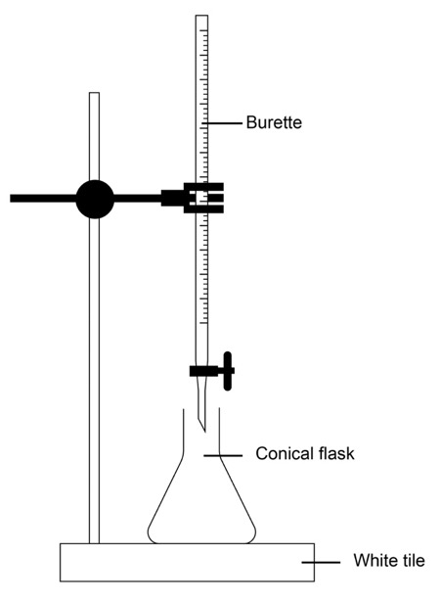
- Place the conical flask on top of the white tile, below the burette, as shown in the diagram.

Both images © Royal Society of Chemistry
- Carefully and slowly add the iodine solution to the conical flask. Swirl the flask well after each addition.
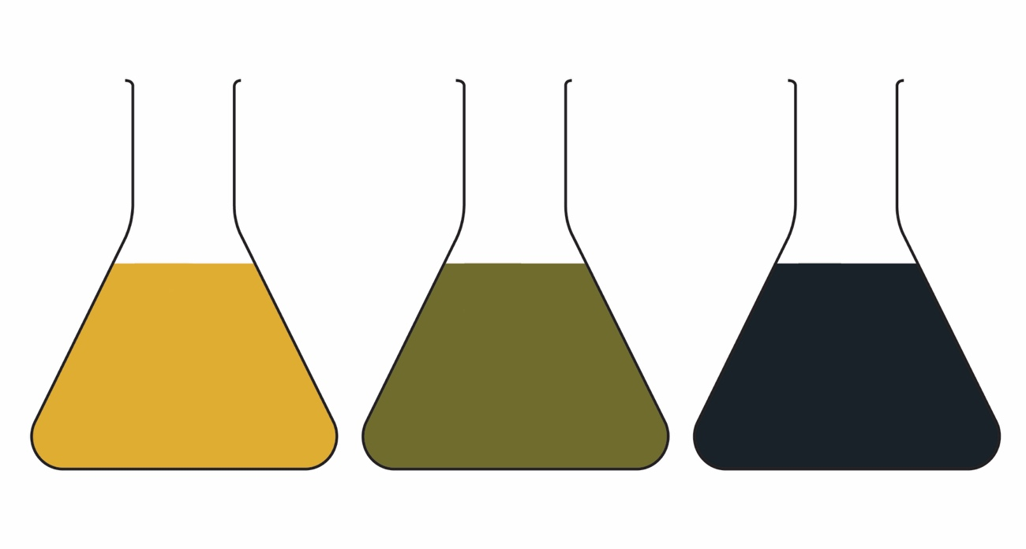
- Continue to add small amounts of iodine to the conical flask until the endpoint. This will be difficult to spot due to the colour of the juice – you should look for a dirty green colour and specks of black solid forming.

Endpoint
Over titrated
Start
© Royal Society of Chemistry
- Carefully read the volume of iodine used from the burette. Record this in the table in your workbook in the trial run column.
- Now you know approximately when the endpoint will be reached, you can be more accurate in the next repeat. As you get close to the expected endpoint, slow the rate at which the iodine is added by turning the burette tap so the iodine is added dropwise.
- Repeat the procedure until you have three titres that agree to within +/– 0.1 cm³. You can reuse the conical flask as long as you rinse it out well with distilled water each time.

Activity 3: finding the iron content of food
Safety and hazards
- Always wear safety glasses when instructed to.
- Take care to not drop the cuvette (tube).
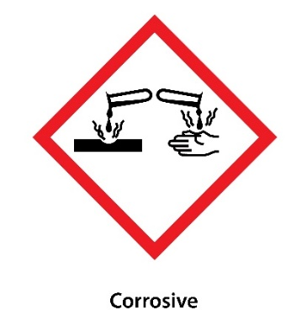
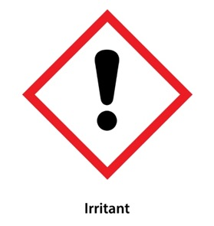
- The solutions of iron(III) chloride (FeCl₃) are harmful and corrosive. Handle these solutions with care to avoid skin contact.

© Shutterstock
Equipment

5 × labelled standard solutions of iron(III) chloride (FeCl₃) labelled 1–5.
Potassium thiocyanate (KSCN) solution
3 × food extract solutions (broccoli, spinach, peas)
Distilled water
5 × cuvettes
5 × teat pipettes
Automatic pipette
Spectrophotometer
Ruler

To do
- Read through the guide to using an automatic pipette at the end of this method.
- Check that your automatic pipette is set to 5 cm³. If it isn’t, ask for help.
- Use the automatic pipette to add 5 cm³ potassium thiocyanate to each of the
100 cm³ of the five standard solutions of iron(III) chloride. You should see a faint pink colour. Wear eye protection and be careful to avoid contact with skin when measuring the FeCl₃ solutions. ≥ 1.5 M FeCl₃ solutions are also harmful if ingested.
Note: if automatic pipettes are not available, use a 5 cm³ plastic pipette instead.
To draw a calibration curve
Note: as different models of spectrophotometers can vary in their operation, please make sure that you are familiar with the model you are using and follow all instructions provided.
- Make sure the spectrophotometer reads 480 nm. If it does not, ask for help from your teacher. A control (blank) cuvette should already be in the correct position.
- Shut the lid.
- Take a blank measurement.
- The reading should be close to 0. Record the exact reading in the results table in your student workbook.
- Use a teat pipette to fill a clean cuvette to the line/arrow with solution 1.
- Lift the lid of the spectrophotometer and place a cuvette into the correct space. (Make sure the opaque side is facing the middle and the clear side is facing the front.)
- Take a reading from the solution and record this in your results table.
- Repeat steps 1–7 using solutions 2–5.
- Plot the results on the graph paper in your workbook and draw a calibration curve with a ruler.
To analyse iron content in a range of foods
- Choose a solution extracted from a foodstuff (KSCN is already added to these).
- Fill a cuvette with the extract up to the line/arrow.
- Place the cuvette in space 1 of the spectrophotometer. Close the lid.
- Press button 1 on the green dial.
- Note the reading in the results table in your workbook
- Use your calibration curve to determine the concentration of iron in the food.
- Repeat with the other food extracts.

Using an automatic pipette
Equipment
- Automatic pipette set to 5000 µl (5 cm³)
- Clean pipette tips
- Solution of complexing agent
- Standard and sample solutions
Method
- Check that the automatic pipette is set to 5 ml (5 cm³). Do not adjust the setting.
- Add a clean pipette tip.
- Press the button to the first stop.
- Insert the tip into the liquid.
- Slowly release the button. The correct volume of liquid is automatically collected.
- Transfer the liquid to the beaker containing the standard solution.
- Gently press the button into the second stop position. The liquid is automatically dispensed.
- Repeat steps 1–7 for all standards and samples. The tips can be reused in the same solution but you must change the tip when measuring out a new solution.
- Press the eject button to release the tip before placing the pipette down onto the bench.
- Keep new and used tips separate and dispose of used tips in general waste.

