Equilibria

The equilibrium constant, K_{c}

1. Match each of the reactions to the correct description;
(2 marks)
Making an ester;
CH₃COOH(aq) + CH₃OH(aq)
⇌
CH₃COOCH₃(aq) + H₂O(aq)
Heating hydrated
CuSO₄.5H₂O
Wood burning

An irreversible reaction
A reversible reaction
A reversible reaction at equilibrium

Explain your choice;

(2 marks)

2. We can define a constant, K_{c} for a reaction at equilibrium. Provided the temperature is constant, the value of K_{c} is constant.
For each of the equilibria below, write an expression for the rate constant, K_{c} and derive the units of the constant.

- Electrophilic addition of HCN to propanone;
CH₃COCH₃(aq) + HCN(aq) ⇌ CH₃C(OH)(CN)CH₃(aq)

K_{c} = Units =
(2 marks)

- Esterification;
CH₃CH₂COOH(aq) + CH₃OH(aq) ⇌ CH₃CH₂COOCH₃(aq) + H₂O(aq)

K_{c} = Units =
(2 marks)

- The Haber Process;
N₂(g) + 3 H₂(g) ⇌ 2 NH₃(g)

K_{c} = Units =
(2 marks)

Calculations with K_{c}

1. During the Contact process, SO₂ is converted into SO₃ in a reversible reaction;

2 SO₂ + O₂ ⇌ 2 SO₃ ΔH −197 kJ mol⁻¹

The equilibrium was established at 1000 K and a small sample of the equilibrium mixture extracted. It was found to contain 1.0 mol dm^{–3} of SO₂, 0.2 mol dm^{–3} of O₂ and 1.4 mol dm^{–3} of SO₃.

- Calculate K_{c} at this temperature.

(3 marks)
- In the Contact process the temperature of choice is 700 K. What effect will this have on the value of K_{c} compared to that calculated above?

(1 mark)
2. Catherine is studying the hydrolysis of ethyl butanoate;

CH₃CH₂CH₂COOCH₂CH₃ + H₂O ⇌ CH₃CH₂CH₂COOH + CH₃CH₂OH

She places exactly 1 mol of ethyl butanoate and 2 mol of water in a conical flask and allows the mixture to reach equilibrium. After this time the equilibrium mixture was analysed and found to contain 0.3 mol of butanoic acid. Calculate K_{c} for the equilibrium at this temperature.

(3 marks)
3. In a different reaction, Catherine wants to make butyl ethanoate. She reacts butanol with ethanoic acid in 50 cm³ of water in a round bottomed flask.
C₄H₉OH + CH₃COOH ⇌ CH₃COOC₄H₉ + H₂O

She wishes to make exactly 0.25 mol of butyl ethanoate. If she starts with 0.5 mol of ethanoic acid, how much butanol should she add? (K_{c} for the equilibrium at 20 °C is 3.0. The density of water is 1 g cm^{–3})

(3 marks)

Le Châtelier and K_{c}

Le Châtelier has lost his glasses. He can’t remember which floor of his lab he left them on!
Consider the equilibrium below;

H₂(g) + CO₂(g) ⇌ H₂O(g) + CO(g) ΔH = +40 kJ mol^{–1}

Help Le Châtelier find his glasses by deciding what effect each of the changes in conditions 1-9 listed below will have on the value of K_{c} for this equilibrium.
Le Châtelier is currently in his office on the second floor

- If the change in conditions increase K_{c}, move Le Châtelier one floor up
- If the change in conditions decrease K_{c}, move Le Châtelier one floor down
- If the change in conditions have no effect on K_{c}, Le Châtelier doesn’t move

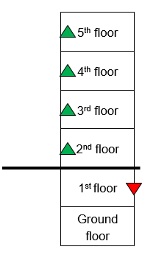
Unless stated otherwise assume that all conditions other than the one mentioned remain constant.

1. Adding a catalyst to the reaction mixture
2. Adding CO₂ to the reaction mixture
3. Increasing the pressure of the system
4. Increasing the reaction temperature
5. Adding CO to the reaction mixture
6. Decreasing the reaction temperature
7. Increasing the volume of the reaction container
8. Increasing the amount of H₂ gas in the reaction mixture
9. Increasing the surface area of the catalyst
(9 marks)
Le Châtelier will find his glasses on the floor.

The equilibrium constant, K_{p}

For gases it is easier to measure the pressure of a gas instead of its concentration. Therefore for equilibria involving only gases we quote the equilibrium constant in terms of pressure and give it the symbol K_{p}.

1. Complete the table below by calculating the equilibrium composition, the mole fractions, the total pressure or the partial pressures for the equilibria shown.
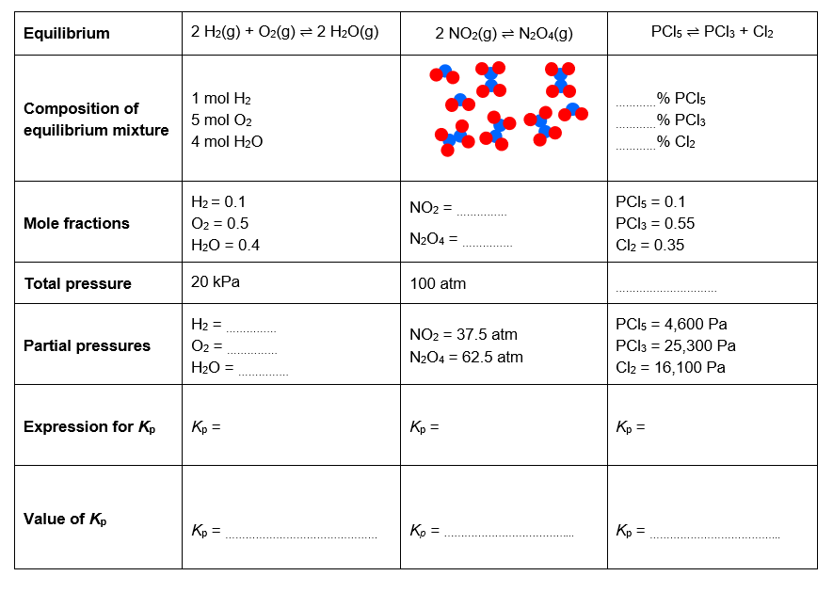
(4 marks)

2. Write an expression for K_{p}, and calculate its value, assuming that each of the systems described above is at equilibrium.
(6 marks)

The solubility product, K_{sp}

1. Define the following terms. Illustrate your definitions with examples from the box.
PbI₂(s) ⇌ Pb²⁺(aq) + 2 I–(aq)
CO(g) + H₂O(g) ⇌ CO₂(g) + H₂(g)
CaCO₃(s) ⇌ CaO(s) + CO₂(g)

Homogeneous equilibrium

Heterogeneous equilibrium

(4 marks)
The solubility product is a special example of a heterogeneous equilibrium.
When writing an expression for the equilibrium constant for a heterogeneous equilibrium, terms for pure solids or pure liquids are left out of the expression.

2. A student tests for the presence of chloride ions in solution by adding a solution of lead nitrate. A white precipitate of lead chloride is formed.

The precipitate exists in equilibrium with its ions;

PbCl₂(s) ⇌ Pb²⁺(aq) + 2 Cl–(aq), K_{sp} = 1.6 × 10^{–5} mol³ dm^{–9} at 298 K

- Write an expression for K_{sp} for this equilibrium.

(1 mark)
- Calculate the solubility of lead chloride at 298 K in mol dm^{–3}.

(2 marks)
- Describe an experiment the student could do to obtain an experimental value for the solubility product, K_{sp} of lead chloride.

(3 marks)

Equilibria – Answers

The equilibrium constant, K_{c}

1.
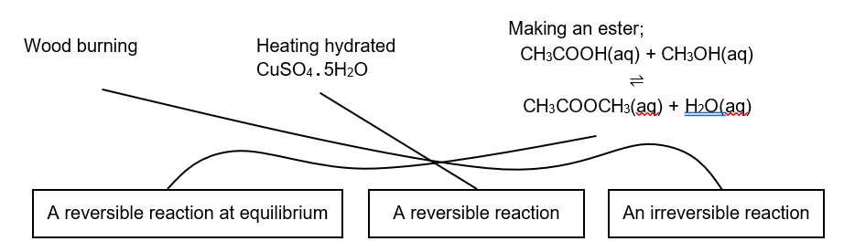
(2 marks for all three correct, 1 mark for 1 correct)

The products from burning wood cannot be turned back into wood so it is irreversible. The copper sulphate once dehydrated can be turned back into the hydrated form by the addition of water. Hence it is a reversible reaction (1 mark for above two points). The esterification reaction is in a closed system so neither products nor reactants can escape so it is a reaction at equilibrium (1 mark).

2.
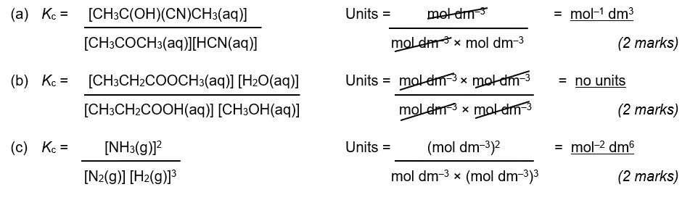
Calculations with K_{c}

(b) The temperature has been decreased. Therefore the equilibrium will shift in favour of the exothermic reaction (to the right) in order to oppose the temperature decrease. Therefore the value of K_{c} will increase.
(1 mark)

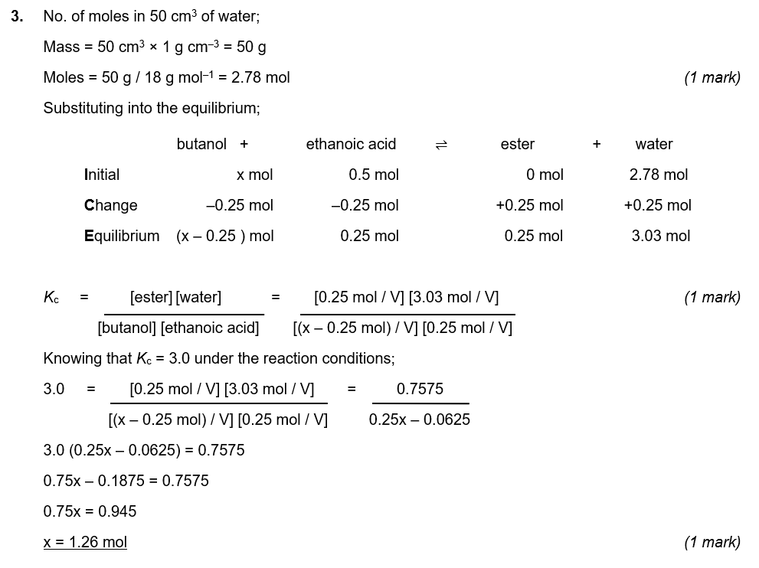
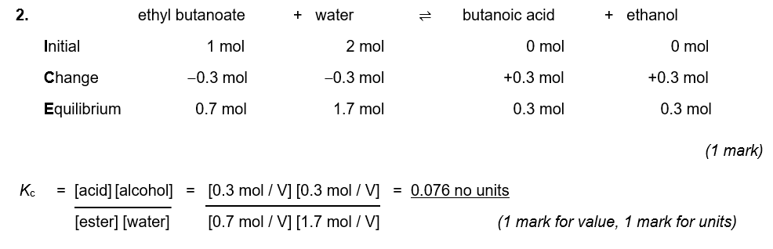
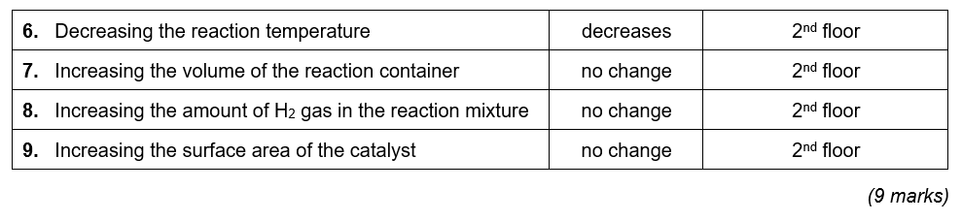
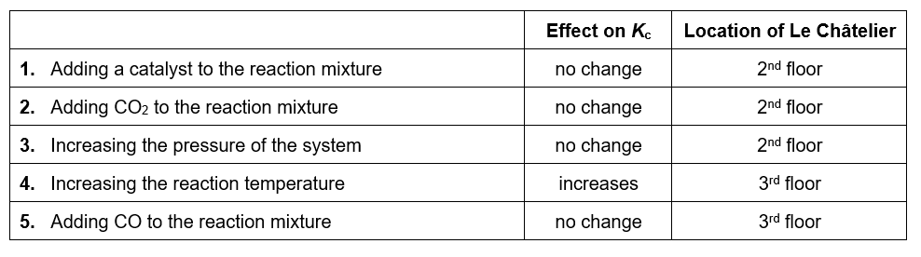
Le Châtelier and K_{c}
Le Châtelier can find his glasses on the 2nd floor …… they were in his office all along!
(1 mark)

The equilibrium constant, K_{p}
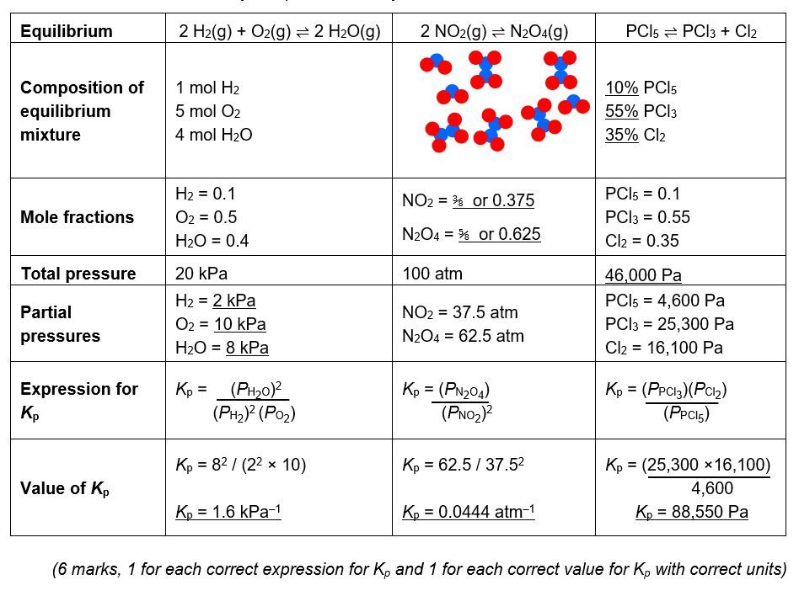
4 marks – one for each box fully completed correctly

The solubility product, K_{sp}
1. Homogeneous equilibrium = an equilibrium where all the substances are in the same phase.
e.g. CO(g) + H₂O(g) ⇌ CO₂(g) + H₂(g)

Heterogeneous equilibrium = an equilibrium where all the substances are not all in the same phase.
e.g. CaCO₃(s) ⇌ CaO(s) + CO₂(g) or PbI₂(s) ⇌ Pb²⁺(aq) + 2 I–(aq)

(2 marks for each correct definition with matching correct example from the table)
