- These six molecules include alkanes, alkenes and alcohols.

- State which molecules belong to which group.
Write your answer underneath each molecular structure.

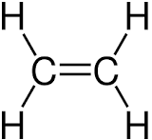 | 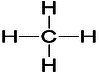 | 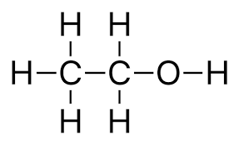

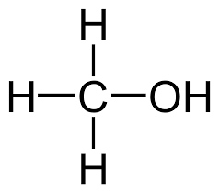 | 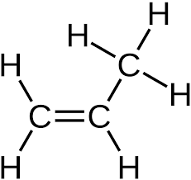 | 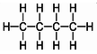
- Name each of the substances in part a).
Write your answer in the same boxes.
- Using one of the molecules shown, circle the alcohol functional group.

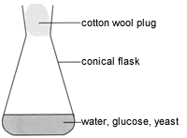
- Janice and Matt set up this equipment then waited for one week.
A chemical reaction takes place in which new substances are made.
- Complete the word equation for this reaction:

Glucose + carbon dioxide

- Complete the symbol equation for the reaction.

C₆H₁₂O₆(aq) 2 (aq) + 2 (g)
- What is the name given to the type of reaction taking place?

- Explain why yeast is used in the experiment.

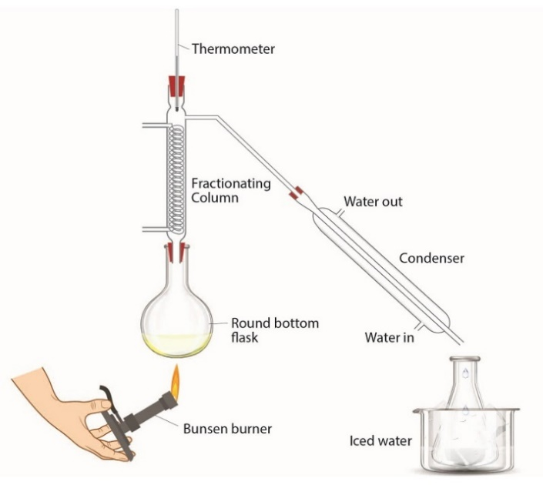
Janice and Matt then add the mixture from the conical flask to the round-bottom flask in a different experiment.
- What is the purpose of this new experiment?

- Explain how this experiment works.
Source: Royal Society of Chemistry

- What is the name of this technique or experiment?

- Give two uses of alcohols.

- Ravi carries out an experiment with a mixture of ethanol dissolved in water.
He leaves the ethanol open to the air for two weeks.
He notices that a very slow chemical reaction takes place.
He removes a few drops of his new mixture and adds some universal indicator solution.
He notices that the indicator turns orange.
- What type of substance has formed?

- What is the name of the new organic product formed?

- State the name of the chemical substance that reacts with ethanol in this reaction.

- What type of reaction has taken place?

- Ravi knows that a different chemical substance could be added to ethanol to make the same product, but a lot faster.
State the name of this substance.

- Complete the chemical equation that shows the reaction taking place:

C₂H₅OH + 2[O] + H₂O

- Complete the diagram to show the structure of the new organic product made.