Technicians in trouble! Which solutions are which? microscale activity – teacher and technician notes
Education in Chemistry
May 2021
rsc.li/3ckcZHX
Some solutions have been mixed up – help the technicians work out which is which
This activity offers a microscale approach the classic to ‘Technician in trouble!’ activity and is based on the original Technician in trouble! Which solutions are which? from ‘In Search of Solutions’.

Kit (per group)
- Two spotting tiles (4x3 wells)
- One set of labelled dropper bottles containing:
- A – 1.0 M hydrochloric acid
- B – distilled/deionised water
- C – 0.4 M sodium hydroxide [WARNING: Irritant]
- D – 0.5 M hydrochloric acid
- E – 0.1% phenolphthalein solution [WARNING: Flammable]

Time
30–60 minutes

Group size
2–3

Health and safety notes
Wear eye protection.
The hydrochloric acid solutions are not currently classified as hazardous.
The sodium hydroxide solution is irritant to skin and eyes
The phenolphthalein solution is flammable.
Because the solutions are contained within dropper bottles and small volumes are being used, the hazards of this activity are reduced relative to the original activity. If students are inexperienced with using dropper bottles to mix solutions, demonstrate and discuss before allowing them to proceed.
Ensure a suitable risk assessment is carried out and that you follow your employer’s risk assessment procedures. Refer to CLEAPSS/SSERC or other reputable sources for further safety information.

Disposal
Solutions can be rinsed off the spotting tiles with tap water.

Possible approaches
If students are not aware of phenolphthalein as an acid–base indicator, demonstrate the change in colour from colourless in acidic solution to pink in alkaline solution.
One sequence of steps that works is to mix a couple of drops of each solution separately with all other solutions. This will identify the sodium hydroxide and phenolphthalein pair, but not which is which.
A few drops of this mixture can then be analysed separately with the remaining three solutions. The water will just dilute the pink colour. The concentrated acid will change the pink to colourless with fewer drops than the dilute acid.
Sodium hydroxide and phenolphthalein can be distinguished by making separate mixtures of the two in unequal ratio. For example, 4 drops sodium hydroxide:1 drop phenolphthalein, and vice versa. Add the concentrated acid to both mixtures. The mixture with more drops of sodium hydroxide will take more drops of hydrochloric acid to turn colourless.
Students may find a flow chart or table useful when designing their problem-solving process.
Below are images from a trial of this activity.
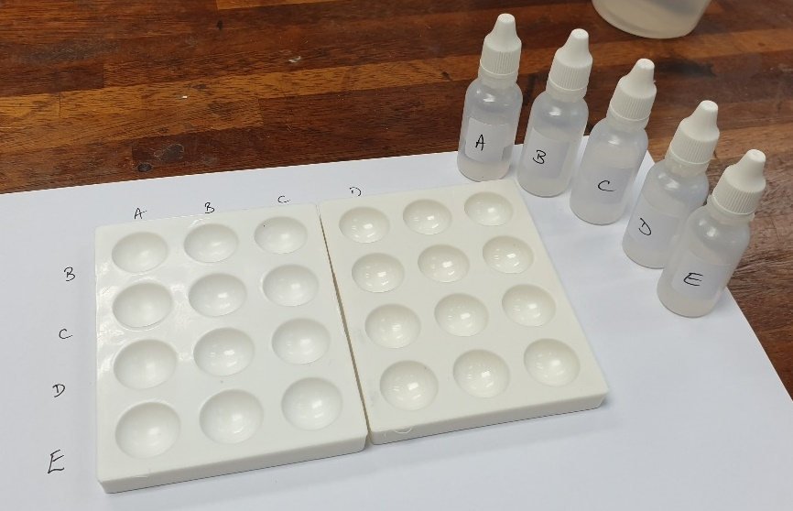
Initial setup
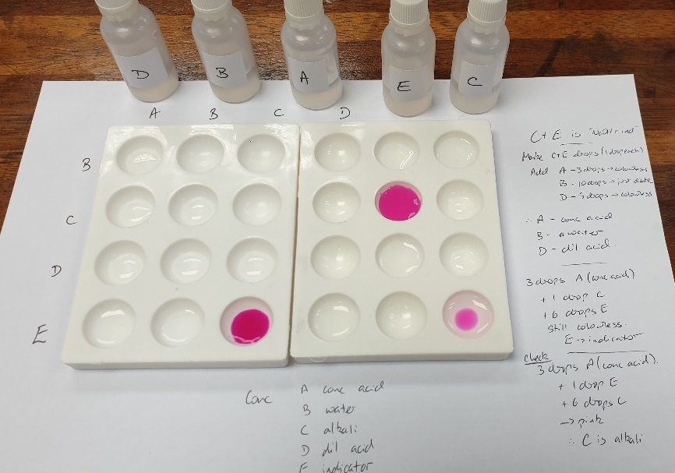
Final solution with workings

