Teaching rates of reaction post-16: teacher checklist
Education in Chemistry
July 2021
rsc.li/3gPjYvX
In order for your students to fully understand the threshold concept and determine the rate equation for a given reaction, they need a number of different skills. This checklist will support you in developing these skills.

Threshold concept
Students’ confidence in understanding reaction kinetics requires a good understanding of controlling variables and representing them graphically (seeing how concentration of reactants influences the rate of a reaction); the power series and their manipulation; and the concept of a rate determining step.

Checklist
- Collect data experimentally.
  - Initial rate or continuous rate method
  - Controlling variables
- Plot graphs.
- Interpret graphs.
- Determine rates from graphs.
  - Calculate the gradient of a graph
  - Calculate instantaneous rate by drawing tangents to the graph
- Determine the order from graphs.
  - Understand mathematical power series y = x⁰; y= x¹; y=x²
  - Relate the mathematical power series to the equation 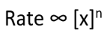
- Determine the order from looking at the table of data.
- Write rate equation.
- Understand the rate determining step.

Graphical representations
The following information summarises some of the important ideas met in rates of reaction.
- Can your students interpret what each graph is measuring?
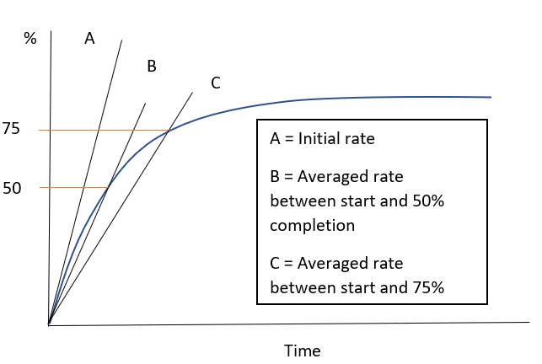
At post-16 students will need to become competent at plotting and interpreting graphical information. This graph summarises the information each line represents. Students will need to understand that although the steepness of the graph can be used to estimate how fast the reaction is occurring, we need to calculate the gradient (something changing in a given time) to quantify the rate of the reaction.

b) Can your students explain, using collision theory, why the gradients of graphs A, B, C and D change?
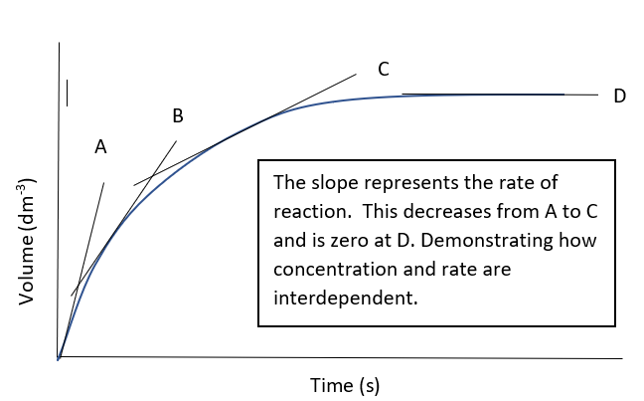

Students need to be able to calculate the initial rate for a reactant at a given initial concentration, line A (the initial rate method). They need to calculate the initial rate (gradient of A) at different initial concentrations for each reactant (independent variable), while the other/s are kept constant (controlled variables).
From this data, they can construct a rate versus concentration plot. The shape of the graph can be used to interpret the order of the reaction. Typical rate versus concentration graphs obtained are shown below.
c) Using graphs to represent the order of a reaction. Do you students understand the maths behind these graphs? Can they use the information to determine a rate equation?

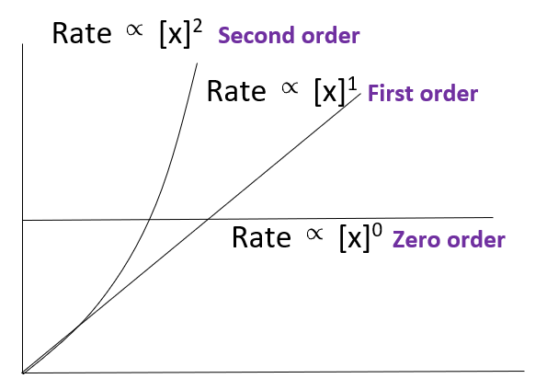
Rate (y-axis) is plotted against initial concentrations (x-axis)
If students are finding it difficult to make links between the shapes of the graphs and the chemistry ideas it might be worth looking at the maths first and then moving on to the chemistry. You could start by asking them to plot the follow graphs for x and y values 1-10 and describe the relationship between x and y.
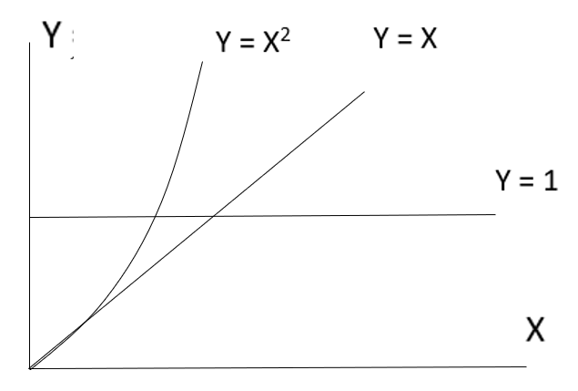

The rate equation
Relating the graphs to the rate equation
A horizontal line – rate is unaffected by changes in concentration or zero order.
Rate = k[x]⁰=k x 1 = k
A diagonal line shows that rate is directly proportional to concentration or first order.
Rate = k[x]¹= k[x]
A curved line indicates that the rate and concentration have a complex relationship or second order.
Rate = k[x]²
This is a mathematical expression that summarises what influences the rate of a reaction using the order of reaction and this helps us the determine the Rate Determining Step and possible mechanism for the reaction
.

Introducing the rate determining step (RDS)
The interpretation we make from the order of a reaction with respect to a reactant is vitally important when we want to understand the reaction mechanism. For example, if a reaction A + B C + D produces a zero order for reactant A and a first order for reactant B, we can deduce that the rate of the reaction is only influenced by reactant B. This doesn’t mean that A has not taken part in the reaction, it suggests that the RDS, or slowest aspect of the reaction, is not influenced by reactant A but is by reactant B.
Provide your students with an everyday example to get the idea of rate determining step across; such as buying and putting together a new bookcase.

Recommended student resource
Starters for 10: Advanced level 2 (16–18) – kinetics

