Organic synthesis quiz

This resource accompanies the article Teaching organic synthesis at post-16 in Education in Chemistry which can be viewed at: rsc.li/3Sn2tmU

Learning objectives
- Apply IUPAC nomenclature rules to a range of organic compounds.
- Recall reagents and conditions in single- and multi-stage organic pathways.
- Determine correct structures as intermediates or products in reaction sequences.

How to use

Quizzes are an excellent way to check understanding. Multiple-choice quizzes (MCQs) are engaging for classes and have a low barrier for participation. This MCQ has been designed to be similar to the questions learners aged 16–18 years may face in examinations. The quiz can be used to check understanding after completing the organic chemistry topics and for revision. The questions can also be used to start discussions with your class.

Further organic synthesis questions can be used to build on the answers and provide understanding. For example, ask your learners to draw the displayed formulae of named compounds, give them atom economy calculations to complete and mechanisms to draw.

The questions in the PowerPoint can be displayed on a screen or copied and pasted into an interactive quizzing tool. Exam specifications differ, so each question slide includes tags with topics in the notes section. There is also a feedback prompt for each question. All questions and notes can be edited.

Answers
- B – 2-methylpropan-1-ol

Feedback: sketch the skeletal formula of the compound and work backwards from that to the alcohol.

- A – but-2-ene

Feedback: sketch the skeletal formula of the amine mentioned and work backwards. Remember that addition to an alkene is regioselective (Markovnikov’s rule due to carbocation stability).

- D – oxidation

Feedback: look at the four options and visualise what the reaction types are.

- C – halogenation of propane

Feedback: we don’t tend to use words like halogenation in our everyday language, but you know what it means – adding a halogen atom.

- D – steam and concentrated phosphoric acid

Feedback: consider the role of each of the reagents you have been presented with in the answers. What do they need to react with to make an alcohol?

- C – chloropropane

Feedback: remember there are two types of polymerisation, addition and condensation. Consider which types of monomers are needed for each.

- C – addition

Feedback: visualise what each of the reaction types is and think about how many products they form.

- B – CH₃CH₂COCl and CH₃NH₂

Feedback: draw the mechanism for the formation of an amide if you need to.

- B – two

Feedback: try to remember what kind of reaction benzene does and consider how you could introduce nitrogen into a benzene ring.

- D – 3-bromo-3-methylpentane

Feedback: it is easier to figure out the answer here using a diagram. Sketch the starting material and work from there.

- B – aminomethane

Feedback: remember the definition of an electrophile and consider what features of a molecule allow this action.

- B – three

Feedback: drawing diagrams are helpful here.

- D – 2-methylpropanal is isolated

Feedback: check the nature of the alcohol functional group to determine whether it can be oxidised and what products it makes.

- B – CH₃CH₂COCl + CH₂CH₂OH

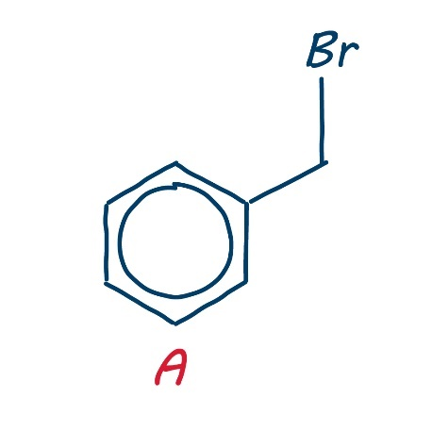
Feedback: look for the hints in the question; flavours and fragrances are an indicator of the ester functional group.

- A is incorrect

Feedback: just because a molecule contains a benzene ring doesn’t necessarily mean that the ring itself reacts. Remember, any side chains will react in predictable ways. Ask your students to draw the correct structure of A, shown to the right.

